SEC Form 4

FORM 4

Check this box if no longer subject to Section 16. Form 4 or Form 5 obligations may continue. See Instruction 1(b).

UNITED STATES SECURITIES AND EXCHANGE COMMISSION
Washington, D.C. 20549
 |  | OMB APPROVAL
STATEMENT OF CHANGES IN BENEFICIAL OWNERSHIP
 |  | OMB Number: | 3235-0287
 |  | Estimated average burden
Filed pursuant to Section 16(a) of the Securities Exchange Act of 1934 |  | hours per response: | 0.5
or Section 30(h) of the Investment Company Act of 1940
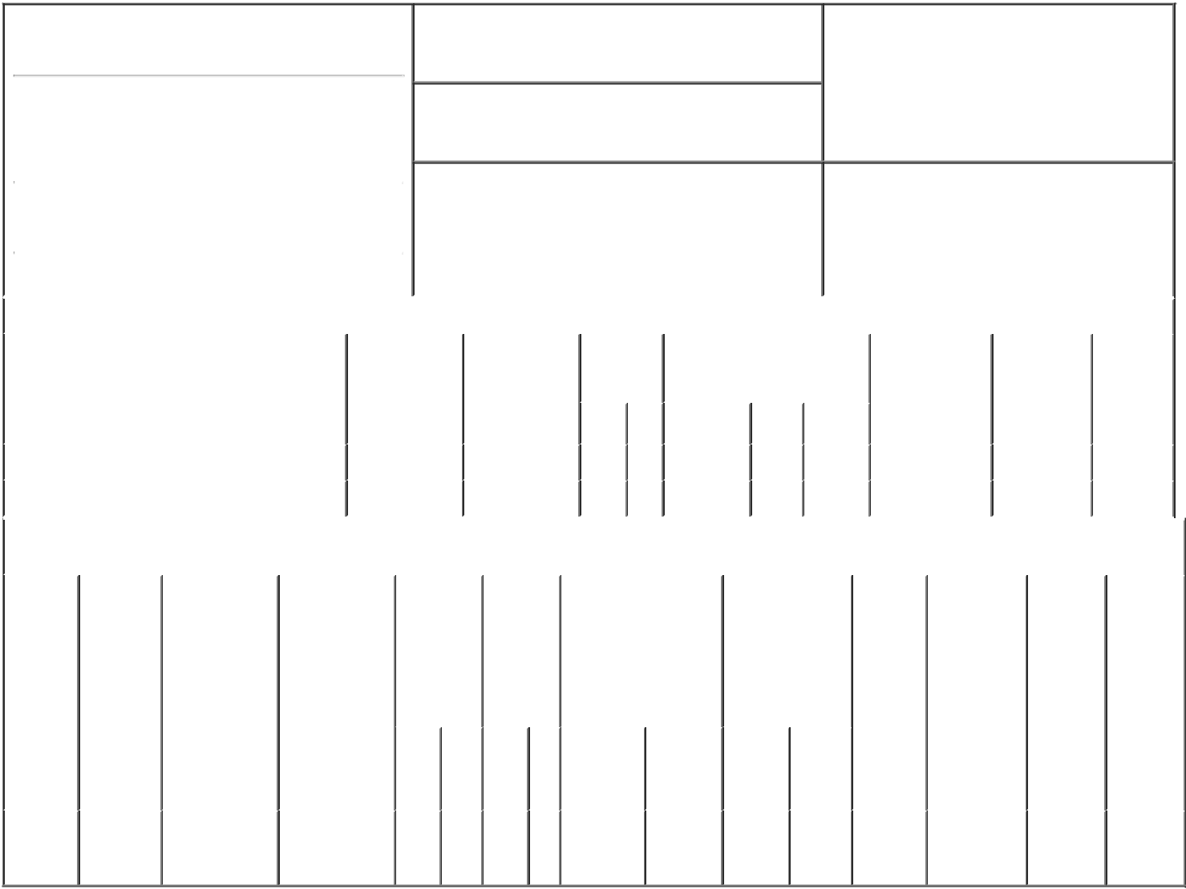

1. Name and Address of Reporting Person*
Niedzwiecki Daniel

(Last) (First) (Middle)

C/O LANTHEUS HOLDINGS, INC.

201 BURLINGTON ROAD, SOUTH BLDG

2. Issuer Name and Ticker or Trading Symbol

Lantheus Holdings, Inc. [ LNTH ]

3. Date of Earliest Transaction (Month/Day/Year)

03/02/2023

- Relationship of Reporting Person(s) to Issuer (Check all applicable)

 | Director | 10% Owner
X | Officer (give title | Other (specify
 | below) | below)

See Remarks

 |  |  |  |  |  |  |  | 4. If Amendment, Date of Original Filed (Month/Day/Year) |  |  |  |  |  |  |  |  |  | 6. Individual or Joint/Group Filing (Check Applicable
 | (Street) |  |  |  |  |  |  |  |  |  |  |  |  |  |  |  |  | Line)
 |  |  |  |  |  |  |  |  |  |  |  |  |  |  |  |  |  | X Form filed by One Reporting Person
 |  | BEDFORD |  | MA |  | 01730
 |  |  |  |  |  |  |  |  |  |  |  |  |  |  |  |  |  |  |  |  | Form filed by More than One Reporting
 |  |  |  |  |  |  |  |  |  |  |  |  |  |  |  |  |  |  |  |  | Person
 |  | (City) |  | (State) |  | (Zip)
 |  |  |  |  | Table I - Non-Derivative Securities Acquired, Disposed of, or Beneficially Owned
 | 1. Title of Security (Instr. 3) |  |  |  |  | 2. Transaction |  |  | 2A. Deemed |  |  | 3. |  |  | 4. Securities Acquired (A) or |  |  |  |  |  | 5. Amount of |  | 6. Ownership |  | 7. Nature
 |  |  |  |  |  | Date |  |  | Execution Date, |  |  |  | Transaction |  | Disposed Of (D) (Instr. 3, 4 and |  |  |  |  |  | Securities |  | Form: Direct |  | of Indirect
 |  |  |  |  |  | (Month/Day/Year) |  |  | if any |  |  |  | Code (Instr. |  | 5) |  |  |  |  |  | Beneficially |  | (D) or Indirect |  | Beneficial
 |  |  |  |  |  |  |  |  | (Month/Day/Year) 8) |  |  |  |  |  |  |  |  |  |  |  | Owned Following |  | (I) (Instr. 4) |  | Ownership
 |  |  |  |  |  |  |  |  |  |  |  |  |  |  |  |  |  |  |  |  | Reported |  |  |  | (Instr. 4)
 |  |  |  |  |  |  |  |  |  |  |  |  | Code V |  | Amount |  | (A) or | Price |  |  | Transaction(s)
 |  |  |  |  |  |  |  |  |  |  |  |  |  |  |  |  | (D) |  |  |  | (Instr. 3 and 4)
 | Common Stock |  |  |  |  | 03/02/2022 |  |  |  |  |  |  | _{A}(1) |  | 12,346 |  | A | $0.00 |  | 77,489 |  |  |  | D
 | Common Stock |  |  |  |  | 03/03/2023 |  |  |  |  |  |  | _{A}(2) |  | 7,515 |  | A | $0.00 |  | 85,004 |  |  |  | D
 |  |  |  |  | Table II - Derivative Securities Acquired, Disposed of, or Beneficially Owned
 |  |  |  |  |  | (e.g., puts, calls, warrants, options, convertible securities)
 | 1. Title of |  | 2. |  | 3. Transaction | 3A. Deemed | 4. |  |  | 5. Number |  | 6. Date Exercisable and |  |  |  | 7. Title and |  |  |  | 8. Price of |  | 9. Number of |  | 10. | 11. Nature
 | Derivative |  | Conversion |  | Date | Execution Date, | Transaction |  |  | of |  | Expiration Date |  |  |  | Amount of |  |  |  | Derivative |  | derivative |  | Ownership | of Indirect
 | Security |  | or Exercise |  | (Month/Day/Year) | if any | Code (Instr. |  |  | Derivative |  | (Month/Day/Year) |  |  |  | Securities |  |  |  | Security |  | Securities |  | Form: | Beneficial
 | (Instr. 3) |  | Price of |  |  | (Month/Day/Year) | 8) |  |  | Securities |  |  |  |  |  | Underlying |  |  |  | (Instr. 5) |  | Beneficially |  | Direct (D) | Ownership
 |  |  | Derivative |  |  |  |  |  |  | Acquired |  |  |  |  |  | Derivative Security |  |  |  |  |  | Owned |  | or Indirect | (Instr. 4)
 |  |  | Security |  |  |  |  |  |  | (A) or |  |  |  |  |  | (Instr. 3 and 4) |  |  |  |  |  | Following |  | (I) (Instr. 4)
 |  |  |  |  |  |  |  |  |  | Disposed |  |  |  |  |  |  |  |  |  |  |  | Reported
 |  |  |  |  |  |  |  |  |  | of (D) |  |  |  |  |  |  |  |  |  |  |  | Transaction(s)
 |  |  |  |  |  |  |  |  |  | (Instr. 3, 4 |  |  |  |  |  |  |  |  |  |  |  | (Instr. 4)
 |  |  |  |  |  |  |  |  |  | and 5)
 |  |  |  |  |  |  |  |  |  |  |  |  |  |  |  |  |  | Amount
 |  |  |  |  |  |  |  |  |  |  |  |  |  |  |  |  |  | or
 |  |  |  |  |  |  |  |  |  |  |  |  |  |  |  |  |  | Number
 |  |  |  |  |  |  |  |  |  |  |  | Date |  | Expiration |  |  |  | of
 |  |  |  |  |  |  | Code V |  |  | (A) | (D) | Exercisable |  | Date |  | Title |  | Shares
 | Stock
 | Option |  | $73.35 |  | 03/02/2023 |  |  | A |  | 7,196 |  | (3) |  | 03/02/2033 |  | Common |  | 7,196 |  | $0.00 |  | 7,196 |  | D
 | (right to |  |  |  |  |  |  |  |  |  |  |  |  |  |  |  | Stock
buy)

Explanation of Responses:

- Consists of 4,115 restricted stock units that vest in equal installments over a three-year period and 8,231 Total Shareholder Return performance-based restricted stock units ("PSUs") that cliff vest following a three-year performance period. The amount of PSUs included in this Report reflects the target award, however the ultimate award size can range from 0% to 200% of the target based on the actual performance achieved at the end of the performance period.

- The transaction reported in this Form 4 reflects additional shares of common stock issued by the Company to the reporting person upon the vesting of relative Total Shareholder Return PSUs that were previously granted and included in the Form 3 filed upon the reporting person becoming a Section 16 officer. The number of shares reported in the Form 3 reflected 100% of the target number of shares underlying the PSUs. The number of shares that actually vested under the PSUs equaled 200% of the target number of shares. Accordingly, the number of shares reported in this Form 4 reflects the difference between the number of shares that actually vested under the PSUs and the target number of shares originally included in the Form 3.

- The option vests in three equal annual installments beginning on March 2, 2024.

Remarks:

Senior Vice President, General Counsel and Corporate Secretary

/s/ Eric M. Green, attorney-in- |  |  | 03/06/2023
fact
** Signature of Reporting Person |  |  | Date

Reminder: Report on a separate line for each class of securities beneficially owned directly or indirectly.

* If the form is filed by more than one reporting person, see Instruction 4 (b)(v).

- Intentional misstatements or omissions of facts constitute Federal Criminal Violations See 18 U.S.C. 1001 and 15 U.S.C. 78ff(a). Note: File three copies of this Form, one of which must be manually signed. If space is insufficient, see Instruction 6 for procedure.
Persons who respond to the collection of information contained in this form are not required to respond unless the form displays a currently valid OMB Number.

