Table of Contents

UNITED STATES

SECURITIES AND EXCHANGE COMMISSION

WASHINGTON, D.C. 20549

FORM 10-Q

(Mark One)

- QUARTERLY REPORT PURSUANT TO SECTION 13 OR 15(d) OF THE SECURITIES EXCHANGE ACT OF 1934

For the quarterly period ended March 31, 2018

- TRANSITION REPORT PURSUANT TO SECTION 13 OR 15(d) OF THE SECURITIES EXCHANGE ACT OF 1934

For the transition period from to

Commission File Number 001-36569

LANTHEUS HOLDINGS, INC.

(Exact name of registrant as specified in its charter)

Delaware | 35-2318913
(State or other jurisdiction of incorporation or organization) |  |  | (IRS Employer Identification No.)
331 Treble Cove Road, North Billerica, MA | 01862
(Address of principal executive offices) |  |  | (Zip Code)
 | (978) 671-8001

(Registrant’s telephone number, including area code)

Not Applicable

(Former name, former address and former fiscal year, if changed since last report

Indicate by check mark whether the registrant (1) has filed all reports required to be filed by Section 13 or 15(d) of the Securities Exchange Act of 1934 during the preceding 12 months (or for such shorter period that the registrant was required to file such reports), and (2) has been subject to such filing requirements for the past 90 days. Yes ☑ No ☐

Indicate by check mark whether the registrant has submitted electronically and posted on its corporate Web site, if any, every Interactive Data File required to be submitted and posted pursuant to Rule 405 of Regulation S-T (§ 232.405 of this chapter) during the preceding 12 months (or for such shorter period that the registrant was required to submit and post such files). Yes ☑ No ☐

Indicate by check mark whether the registrant is a large accelerated filer, an accelerated filer, a non-accelerated filer, smaller reporting company, or an emerging growth company. See the definitions of “large accelerated filer,” “accelerated filer,” “smaller reporting company,” and “emerging growth company” in Rule 12b-2 of the Exchange Act.

Large accelerated filer | ☐ | Accelerated filer | ☑
Non-accelerated filer | ☐ (Do not check if a smaller reporting company) | Smaller reporting company | ☐
 |  | Emerging Growth Company | ☑

If an emerging growth company, indicate by check mark if the registrant has elected not to use the extended transition period for complying with any new or revised financial accounting standards provided pursuant to Section 13(a) of the Exchange Act. ☑

Indicate by check mark whether the registrant is a shell company (as defined by Rule 12b-2 of the Act) Yes ☐ No ☑ The registrant had 38,280,637 shares of common stock, $0.01 par value, outstanding as of April 27, 2018.

Table of Contents

LANTHEUS HOLDINGS, INC.

TABLE OF CONTENTS

PART I. FINANCIAL INFORMATION

Item 1. Financial Statements (Unaudited)

Condensed Consolidated Balance Sheets as of March 31, 2018 and December 31, 2017

Condensed Consolidated Statements of Operations for the Three Months Ended March 31, 2018 and 2017

Condensed Consolidated Statements of Comprehensive Income for the Three Months Ended March 31, 2018 and 2017

Condensed Consolidated Statements of Cash Flows for the Three Months Ended March 31, 2018 and 2017

Notes to Condensed Consolidated Financial Statements

Item 2. Management’s Discussion and Analysis of Financial Condition and Results of Operations

Item 3. Quantitative and Qualitative Disclosures About Market Risk

Item 4. Controls and Procedures

PART II. OTHER INFORMATION

Page

1

2

3

4

5

16

28

28

Item 1. |  |  |  |  | Legal Proceedings |  |  |  |  |  |  | 29
 | Item 1A. |  |  |  | Risk Factors |  |  |  |  |  |  | 29
 | Item 2. |  |  |  | Unregistered Sales of Equity Securities and Use of Proceeds |  |  |  |  |  |  | 29
 | Item 3. |  |  |  | Defaults Upon Senior Securities |  |  |  |  |  |  | 30
 | Item 4. |  |  |  | Mine Safety Disclosures |  |  |  |  |  |  | 30
 | Item 5. |  |  |  | Other Information |  |  |  |  |  |  | 30
 | Item 6. |  |  |  | Exhibits |  |  |  |  |  |  | 30
SIGNATURES |  |  |  |  |  |  |  |  |  |  |  | 31

Table of Contents
PART I. FINANCIAL INFORMATION
Item 1. Financial Statements (Unaudited)
 |  | Lantheus Holdings, Inc.
 |  | Condensed Consolidated Balance Sheets
 |  | (Unaudited)
 |  | (in thousands, except par value)
 |  |  |  | March 31, |  |  | December 31,
 |  |  |  | 2018 |  |  | 2017
 | Assets
 | Current assets
 | Cash and cash equivalents |  | $ | 73,739 |  | $ | 76,290
 | Accounts receivable, net |  |  | 47,834 |  |  | 40,259
 | Inventory |  |  | 32,086 |  |  | 26,080
 | Other current assets |  |  | 5,598 |  |  | 5,221
 | Total current assets |  |  | 159,257 |  |  | 147,850
 | Property, plant & equipment, net |  |  | 93,777 |  |  | 92,999
 | Intangibles, net |  |  | 11,106 |  |  | 11,798
 | Goodwill |  |  | 15,714 |  |  | 15,714
 | Deferred tax assets, net |  |  | 83,655 |  |  | 87,010
 | Other long-term assets |  |  | 29,080 |  |  | 28,487
 | Total assets |  | $ | 392,589 |  | $ | 383,858
 | Liabilities and stockholders’ equity
 | Current liabilities
 | Current portion of long-term debt |  | $ | 2,750 |  | $ | 2,750
 | Revolving line of credit |  |  | — |  |  | —
 | Accounts payable |  |  | 21,012 |  |  | 17,464
 | Accrued expenses and other liabilities |  |  | 21,634 |  |  | 26,536
 | Total current liabilities |  |  | 45,396 |  |  | 46,750
 | Asset retirement obligations |  |  | 10,702 |  |  | 10,412
 | Long-term debt, net |  |  | 264,972 |  |  | 265,393
 | Other long-term liabilities |  |  | 37,855 |  |  | 38,012
 | Total liabilities |  |  | 358,925 |  |  | 360,567
 | Commitments and contingencies (See Note 13)
 | Stockholders’ equity
 | Preferred stock ($0.01 par value, 25,000 shares authorized; no shares issued and outstanding) |  |  | — |  |  | —
 | Common stock ($0.01 par value, 250,000 shares authorized; 37,997 and 37,765 shares issued
 | and outstanding, respectively) |  |  | 380 |  |  | 378
 | Additional paid-in capital |  |  | 234,765 |  |  | 232,960
 | Accumulated deficit |  |  | (200,447) |  |  | (209,013)
 | Accumulated other comprehensive loss |  |  | (1,034) |  |  | (1,034)
 | Total stockholders’ equity |  |  | 33,664 |  |  | 23,291
 | Total liabilities and stockholders’ equity |  | $ | 392,589 |  | $ | 383,858

The accompanying notes are an integral part of these condensed consolidated financial statements.

1

Table of Contents

Lantheus Holdings, Inc.

Condensed Consolidated Statements of Operations

(Unaudited)

(in thousands, except per share data)

Three Months Ended

March 31,

 | 2018 |  |  |  | 2017
Revenues | $ | 82,630 |  | $ | 81,359
Cost of goods sold |  | 40,321 |  |  | 41,597
Gross profit |  | 42,309 |  |  | 39,762
Operating expenses
Sales and marketing |  | 10,640 |  |  | 10,214
General and administrative |  | 12,543 |  |  | 12,270
Research and development |  | 3,989 |  |  | 5,351
Total operating expenses |  | 27,172 |  |  | 27,835
Operating income |  | 15,137 |  |  | 11,927
Interest expense |  | 4,050 |  |  | 5,420
Loss on extinguishment of debt |  | — |  |  | 2,161
Other income |  | (920) |  |  | (577)
Income before income taxes |  | 12,007 |  |  | 4,923
Income tax expense |  | 3,796 |  |  | 785
Net income | $ | 8,211 |  | $ | 4,138
Net income per common share:
Basic | $ | 0.22 |  | $ | 0.11
Diluted
Diluted | $ | 0.21 |  | $ | 0.11
Weighted-average common shares outstanding:
Basic |  | 37,886 |  |  | 36,889
Diluted |  | 39,493 |  |  | 38,601

The accompanying notes are an integral part of these condensed consolidated financial statements.

2

Table of Contents

Lantheus Holdings, Inc.

Condensed Consolidated Statements of Comprehensive Income

(Unaudited)

(in thousands)

Three Months Ended

March 31,

 | 2018 |  |  |  | 2017
Net income | $ | 8,211 |  | $ | 4,138
Other comprehensive loss:
Foreign currency translation |  | — |  |  | (4)
Total other comprehensive loss |  | — |  |  | (4)
Comprehensive income | $ | 8,211 |  | $ | 4,134

The accompanying notes are an integral part of these condensed consolidated financial statements.

3

Table of Contents
 |  | Lantheus Holdings, Inc.
 |  | Condensed Consolidated Statements of Cash Flows
 |  | (Unaudited)
 |  | (in thousands)
 |  |  |  | Three Months Ended
 |  |  |  | March 31,
 |  |  |  | 2018 |  |  | 2017
 | Operating activities
 | Net income |  | $ | 8,211 |  | $ | 4,138
 | Adjustments to reconcile net income to net cash flows from operating activities:
 | Depreciation, amortization and accretion |  |  | 3,596 |  |  | 6,160
 | Amortization of debt related costs |  |  | 320 |  |  | 360
 | Provision for bad debt |  |  | 195 |  |  | 62
 | Provision for excess and obsolete inventory |  |  | 1,220 |  |  | 285
 | Stock-based compensation |  |  | 1,796 |  |  | 945
 | Loss on extinguishment of debt and debt retirement costs |  |  | — |  |  | 2,161
 | Deferred taxes |  |  | 2,923 |  |  | —
 | Long-term income tax receivable |  |  | (841) |  |  | (490)
 | Long-term income tax payable and other long-term liabilities |  |  | 854 |  |  | 769
 | Other |  |  | (46) |  |  | (58)
 | Increases (decreases) in cash from operating assets and liabilities:
 | Accounts receivable |  |  | (7,816) |  |  | (3,135)
 | Inventory |  |  | (6,579) |  |  | (2,427)
 | Other current assets |  |  | (1,003) |  |  | (1,250)
 | Accounts payable |  |  | 2,160 |  |  | 1,200
 | Accrued expenses and other liabilities |  |  | (5,656) |  |  | (3,196)
 | Net cash (used in) provided by operating activities |  |  | (666) |  |  | 5,524
 | Investing activities
 | Capital expenditures |  |  | (2,135) |  |  | (4,899)
 | Proceeds from sale of assets |  |  | 1,000 |  |  | 335
 | Net cash used in investing activities |  |  | (1,135) |  |  | (4,564)
 | Financing activities
 | Proceeds from issuance of long-term debt |  |  | — |  |  | 274,313
 | Payments on long-term debt |  |  | (715) |  |  | (284,551)
 | Deferred financing costs |  |  | — |  |  | (1,219)
 | Payments for public offering costs |  |  | — |  |  | (74)
 | Proceeds from stock option exercises |  |  | 514 |  |  | 632
 | Proceeds from issuance of common stock |  |  | 206 |  |  | —
 | Payments for minimum statutory tax withholding related to net share settlement of equity awards |  |  | (709) |  |  | (355)
 | Net cash used in financing activities |  |  | (704) |  |  | (11,254)
 | Effect of foreign exchange rates on cash and cash equivalents |  |  | (46) |  |  | (2)
 | Net decrease in cash and cash equivalents |  |  | (2,551) |  |  | (10,296)
 | Cash and cash equivalents, beginning of period |  |  | 76,290 |  |  | 51,178
 | Cash and cash equivalents, end of period |  | $ | 73,739 |  | $ | 40,882

The accompanying notes are an integral part of these condensed consolidated financial statements.

4

Table of Contents

Lantheus Holdings, Inc.

Notes to Condensed Consolidated Financial Statements

(Unaudited)

Note Regarding Company References and Trademarks

Unless the context otherwise requires, references to the “Company” and “Lantheus” refer to Lantheus Holdings, Inc. and its direct and indirect wholly-owned subsidiaries, references to “Holdings” refer to Lantheus Holdings, Inc. and not to any of its subsidiaries, and references to “LMI” refer to Lantheus Medical Imaging, Inc., the direct subsidiary of Holdings. Solely for convenience, the Company refers to trademarks, service marks and trade names without the ™, SM and ® symbols. Those references are not intended to indicate, in any way, that the Company will not assert, to the fullest extent permitted under applicable law, its rights to its trademarks, service marks and trade names.

1. Basis of Presentation

The accompanying unaudited condensed consolidated financial statements include the accounts of Lantheus Holdings, Inc. and its direct and indirect wholly-owned subsidiaries and have been prepared in accordance with generally accepted accounting principles for interim financial information and with the instructions to Form 10-Q and Article 10 of Regulation S-X. Accordingly, these condensed consolidated financial statements do not include all of the information and notes required by generally accepted accounting principles in the United States of America (“U.S. GAAP”) for complete financial statements. In the opinion of management, all adjustments (consisting of normal and recurring adjustments) considered necessary for a fair statement have been included. The results of operations for the three months ended March 31, 2018 are not necessarily indicative of the results that may be expected for the year ended December 31, 2018 or any future period.

The condensed consolidated balance sheet at December 31, 2017 has been derived from the audited consolidated financial statements at that date but does not include all of the information and notes required by U.S. GAAP for complete financial statements. These condensed consolidated financial statements and accompanying notes should be read in conjunction with the consolidated financial statements and notes thereto included in Item 8 of the Company’s most recent Annual Report on Form 10-K for the year ended December 31, 2017 filed with the Securities Exchange Commission (“SEC”) on February 26, 2018. Certain immaterial amounts in the prior period condensed consolidated statement of cash flows have been reclassified to conform to the current period financial statement presentation.

2. Summary of Significant Accounting Policies

Recent Accounting Pronouncements

The following table provides a description of recent accounting pronouncements that may have a material effect on the Company’s condensed consolidated financial statements:

Standard | Description | Effective Date | Effect on the Condensed Consolidated Financial
Standard | Description | for Company | Statements
Recently Issued Accounting Standards Not Yet Adopted
ASU 2016-02, Leases (Topic | This ASU supersedes existing guidance on accounting for leases in | January 1, 2019 | The Company is currently assessing the impact that
842) | “Leases (Topic 840)” and generally requires all leases to be recognized |  | this standard will have on its consolidated financial
 | in the statement of financial position. The provisions of ASU 2016-02 |  | statements.
 | are effective for annual reporting periods beginning after December 15,
 | 2018; early adoption is permitted. The provisions of this ASU are to be
 | applied using a modified retrospective approach.

5

Table of Contents

Standard | Description | Effective Date | Effect on the Condensed Consolidated Financial
Standard | Description | for Company | Statements
Accounting Standards Adopted During the Three Months Ended March 31, 2018
ASU 2017-09, Compensation | This ASU clarifies when to account for a change to the terms or | January 1, 2018 | The adoption of this standard did not have a
—Stock Compensation | conditions of a share–based payment award as a modification. Under |  | material impact on the Company’s condensed
(Topic 718): Scope of | the new guidance, modification accounting is required only if the fair |  | consolidated financial statements.
Modification Accounting | value, vesting conditions or classification of the award (as equity or
 | liability) changes as a result of the change in terms or conditions.
 | The new guidance will be applied prospectively to awards modified on
 | or after the adoption date. The guidance is effective for annual periods,
 | and interim periods within those annual periods, beginning after
 | December 15, 2017 for all entities.
ASU 2014-09, Revenue from | This ASU and related amendments affect any entity that either enters | January 1, 2018 | See Note 3, "Revenue from Contracts with
Contracts with Customers | into contracts with customers to transfer goods or services or enters into |  | Customers" for the required disclosures related to
(Topic 606) and related | contracts for the transfer of nonfinancial assets, unless those contracts |  | the impact of adopting this standard.
amendments | are within the scope of other standards. The guidance in this ASU
 | supersedes the revenue recognition requirements in Topic 605, Revenue |  | The adoption of this standard did not have a
 | Recognition and most industry-specific guidance. The core principle of |  | material impact on the Company’s condensed
 | the guidance is that an entity should recognize revenue upon the transfer |  | consolidated balance sheets and statements of
 | of promised goods or services to customers in an amount that reflects |  | operations.
 | the consideration to which the entity expects to be entitled in exchange
 | for those goods or services.

3. Revenue from Contracts with Customers

Adoption of ASC Topic 606, “Revenue from Contracts with Customers”

The Company adopted ASC 606 on January 1, 2018 using the modified retrospective method for all contracts not completed as of the date of adoption. The reported results for 2018 reflect the application of ASC 606 guidance while the reported results for 2017 were prepared under the guidance of ASC 605, Revenue Recognition (“ASC 605”). For the Company’s accounting policy for revenue recognition under ASC 605, refer to Item 8 of the Annual Report on Form 10-K for the year ended December 31, 2017. The adoption of ASC 606 did not have a material impact on the Company’s consolidated financial position, results of operations, equity or cash flows as of the adoption date or for the periods presented.

Revenue Recognition

In accordance with ASC 606, revenue is recognized when a customer obtains control of promised goods or services. The amount of revenue recognized reflects the consideration to which the Company expects to be entitled to receive in exchange for these goods or services. To achieve this core principle, the Company applies the following five steps: (1) identify the contracts with a customer; (2) identify the performance obligations in the contract; (3) determine the transaction price; (4) allocate the transaction price to the performance obligations in the contract; and (5) recognize revenue when (or as) the Company satisfies a performance obligation.

Disaggregation of Revenue

The following table summarizes revenue by revenue source for the three months ended March 31, 2018:

 |  |  |  | Reportable Segments
Major Products/Service Lines (in thousands) |  |  | U.S. |  |  | International |  |  |  | Total
Product revenue, net⁽¹⁾ |  | $ | 71,488 | $ |  | 10,580 |  |  | $ | 82,068
License and royalty revenues |  |  | — |  |  | 562 |  |  |  | 562
Total revenues |  | $ | 71,488 | $ |  | 11,142 |  |  | $ | 82,630
________________________________
- The Company’s principal products include DEFINITY, TechneLite and Xenon and are categorized within product revenue, net. The Company applies the same revenue recognition policies and judgments for all of its principal products.

Product Revenue, Net

The Company sells its products principally to distributors, radiopharmacies and directly to hospitals and clinics. The Company considers customer purchase orders, which in some cases are governed by master sales or group purchasing organization agreements, to be the contracts with a customer.

6

Table of Contents

For each contract, the Company considers the promise to transfer products, each of which is distinct, to be the identified performance obligations. In determining the transaction price, the Company evaluates whether the price is subject to refund or adjustment to determine the net consideration to which the Company expects to be entitled.

The Company typically invoices customers upon satisfaction of identified performance obligations. As the Company’s standard payment terms are 30 to 60 days from invoicing, the Company has elected to use the significant financing component practical expedient under ASC 606-10-32-18.

The Company allocates the transaction price to each distinct product based on their relative standalone selling price. The product price as specified on the purchase order is considered the standalone selling price as it is an observable input which depicts the price as if sold to a similar customer in similar circumstances.

Revenue is recognized when control of the product is transferred to the customer (i.e., when the Company’s performance obligation is satisfied), which typically occurs upon delivery to the customer. Further, in determining whether control has transferred, the Company considers if there is a present right to payment and legal title, along with risks and rewards of ownership having transferred to the customer.

Frequently, the Company receives orders for products to be delivered over multiple dates that may extend across several reporting periods. The

Company invoices for each delivery upon shipment and recognizes revenues for each distinct product delivered, assuming transfer of control has occurred.

The Company generally does not separately charge customers for shipping and handling costs, but any shipping and handling costs charged to customers are included in product revenue, net. Taxes collected from customers relating to product sales and remitted to governmental authorities are excluded from revenues.

Variable Consideration

Revenues from product sales are recorded at the net sales price (transaction price), which includes estimates of variable consideration for which reserves are established for discounts, returns, rebates and allowances that are offered within contracts between the Company and its customers. These reserves are based on the amounts earned or to be claimed on the related sales and are classified as a current liability. Where appropriate, these estimates take into consideration a range of possible outcomes which are probability-weighted for relevant factors such as the Company’s historical experience, current contractual and statutory requirements, specific known market events and trends, industry data and forecasted customer buying and payment patterns. Overall, these reserves reflect the Company’s best estimates of the amount of consideration to which it is entitled based on the terms of the contract. The amount of variable consideration which is included in the transaction price may be constrained, and is included in the net sales price only to the extent that it is probable that a significant reversal in the amount of the cumulative revenue recognized will not occur in a future period. Actual amounts of consideration ultimately received may differ from the Company’s estimates. If actual results in the future vary from the Company’s estimates, the Company adjusts these estimates, which would affect product revenue and earnings in the period such variances become known.

Rebates and Allowances: The Company provides certain customers with rebates and allowances that are explicitly stated in the Company’s contracts and are recorded as a reduction of revenue in the period the related product revenue is recognized. The Company establishes a liability for such amounts, which is included in accrued expenses in the accompanying condensed consolidated balance sheets. These rebates and allowances result from performance-based offers that are primarily based on attaining contractually specified sales volumes and administrative fees the Company is required to pay to group purchasing organizations. The Company estimates the amount of rebates and allowances that are explicitly stated in the Company’s contracts based on a combination of actual purchases and an estimate of the customer’s buying patterns.

Product Returns: The Company generally offers customers a limited right of return due to non-conforming product. The Company estimates the amount of its product sales that may be returned by its customers and records this estimate as a reduction of revenue in the period the related product revenue is recognized. The Company currently estimates product return liabilities using its historical product return information and considers other factors that it believes could significantly impact its expected returns, including product recalls. Reserves for product returns are not significant to the Company due to the nature of its products including radiopharmaceutical products with limited half-lives.

7

Table of Contents

The following table summarizes activity for reserves relating to rebate and allowances (including group purchasing organization administrative fees and returns) for the three months ended March 31, 2018:

 |  |  |  | Rebates and
(in thousands) |  |  |  | Allowances
 | Balance, January 1, 2018 |  | $ | 2,860
 | Provision related to current period revenues |  |  | 3,027
 | Adjustments relating to prior period revenues |  |  | (121)
 | Payments or credits made during the period |  |  | (2,776)
 | Balance, March 31, 2018 |  | $ | 2,990

License and Royalty Revenues

The Company has entered into licensing agreements, which are within the scope of ASC 606, under which it licenses certain rights to third parties. The terms of these arrangements typically include payment to the Company of one or more of the following: non-refundable, up-front license fees; development, regulatory and commercial milestone payments; and royalties on net sales of licensed products. The Company also has distribution licenses which are treated as combined performance obligations with the delivery of its products and are classified as product revenue, net.

In determining the appropriate amount of revenue to be recognized as it fulfills its obligations under each of its agreements, the Company performs the five-step approach stated earlier. The Company uses judgment in determining the number of performance obligations in a license agreement by assessing whether the license is distinct or should be combined with another performance obligation, as well as the nature of the license. As part of the accounting for these arrangements, the Company must develop assumptions that require judgment to determine the stand-alone selling price for each performance obligation identified in the contract. The Company uses key assumptions to determine the stand-alone selling price, which may include market conditions, reimbursement rates for personnel costs, development timelines and probabilities of regulatory success.

Licenses of intellectual property: If the license to the Company’s intellectual property is determined to be distinct from the other performance obligations identified in the arrangement, the Company recognizes revenues from non-refundable, up-front fees allocated to the license when the license is transferred to the customer and the customer is able to use and benefit from the license. For licenses that are bundled with other promises, the Company utilizes judgment to assess the nature of the combined performance obligation to determine whether the combined performance obligation is satisfied over time or at a point in time and, if over time, the appropriate method of measuring progress for purposes of recognizing revenue from non-refundable, up-front fees. The Company evaluates the measure of progress each reporting period and, if necessary, adjusts the measure of performance and related revenue recognition.

Milestone Payments: At the inception of each arrangement that includes development milestone payments, the Company evaluates whether the milestones are considered probable of being reached and estimates the amount to be included in the transaction price using the most likely amount method. If it is probable that a significant revenue reversal would not occur, the associated milestone value is included in the transaction price. Milestone payments that are not within the control of the Company or the licensee, such as regulatory approvals, are not considered probable of being achieved until those approvals are received. The transaction price is then allocated to each performance obligation on a relative stand-alone selling price basis, for which the Company recognizes revenue as or when the performance obligations under the contract are satisfied. At the end of each subsequent reporting period, the Company re-evaluates the probability of achievement of such development milestones and any related constraint, and if necessary, adjusts its estimate of the overall transaction price. Any such adjustments are recorded on a cumulative catch-up basis, which would affect license and royalty revenues and earnings in the period of adjustment. At March 31, 2018, the Company is constraining variable consideration related to milestone payments requiring regulatory approvals.

Royalty Revenues: For arrangements that include sales-based royalties, including milestone payments based on the level of sales, and the license is deemed to be the predominant item to which the royalties relate, the Company recognizes revenue at the later of (i) when the related sales occur, or (ii) when the performance obligation to which some or all of the royalty has been allocated has been satisfied (or partially satisfied).

Contract Costs

The Company recognizes an asset for incremental costs of obtaining a contract with a customer if it expects to recover those costs. The Company’s sales incentive compensation plans qualify for capitalization since these plans are directly related to sales achieved during a period of time. However, the Company has elected the practical expedient under ASC 340-40-25-4 to expense the costs as they are incurred within selling and marketing expenses since the amortization period is less than one year.

8

Table of Contents
During the three months ended March 31, 2018, the Company recognized the following revenues:
 | (in thousands) |  |  |  | Amount
 | Remainder of amounts included in the contract liability at the beginning of the period |  |  | $ | 8
 | Performance obligations satisfied (or partially satisfied) in previous periods |  |  | $ | —

The Company’s performance obligations are typically part of contracts that have an original expected duration of one year or less. As such, under the optional exemption provided by ASC 606-10-50-14, the Company is not disclosing the aggregate amount of the transaction price allocated to performance obligations that are unsatisfied (or partially satisfied) as of the end of the reporting period.

4. Fair Value of Financial Instruments

Fair value is defined as the price that would be received to sell an asset or paid to transfer a liability in an orderly transaction between market participants at the measurement date. In order to increase consistency and comparability of fair value measurements, financial instruments are categorized based on a hierarchy that prioritizes observable and unobservable inputs used to measure fair value into three broad levels, which are described below:

- Level 1 — Inputs are unadjusted quoted prices in active markets for identical assets or liabilities that the Company has the ability to access at the measurement date.

- Level 2 — Inputs include quoted prices for similar assets and liabilities in active markets, quoted prices for identical or similar assets or liabilities in markets that are not active, inputs other than quoted prices that are observable for the asset or liability (i.e., interest rates, yield curves, etc.) and inputs that are derived principally from or corroborated by observable market data by correlation or other means (market corroborated inputs).

- Level 3 — Unobservable inputs that reflect a Company’s estimates about the assumptions that market participants would use in pricing the asset or liability. The Company develops these inputs based on the best information available, including its own data.

The Company’s financial assets measured at fair value on a recurring basis consist of money market funds. The Company invests excess cash from its operating cash accounts in overnight investments and reflects these amounts in cash and cash equivalents in the condensed consolidated balance sheets at fair value using quoted prices in active markets for identical assets.

The table below presents information about the Company’s assets and liabilities measured at fair value on a recurring basis:

 |  |  |  |  |  |  | March 31, 2018
 |  |  |  | Total Fair
(in thousands) |  |  |  | Value |  |  | Level 1 |  |  | Level 2 |  |  | Level 3
Money market |  |  | $ | 10,624 |  | $ | 10,624 |  | $ | — |  | $ | —
 | Total |  | $ | 10,624 |  | $ | 10,624 |  | $ | — |  | $ | —
 |  |  |  |  |  |  | December 31, 2017
 |  |  |  | Total Fair
(in thousands) |  |  |  | Value |  |  | Level 1 |  |  | Level 2 |  |  | Level 3
Money market |  |  | $ | 8,700 |  | $ | 8,700 |  | $ | — |  | $ | —
 | Total |  | $ | 8,700 |  | $ | 8,700 |  | $ | — |  | $ | —

Nonrecurring Fair Value Measurements

As of December 31, 2017, the Company wrote down the value of land held for sale in the U.S. segment to its fair value, less estimated costs to sell, using level 3 inputs. See Note 7, “Property, Plant & Equipment, Net” for further discussion regarding land held for sale.

5. Income Taxes

The Company provides for income taxes at the end of each interim period based on the estimated effective tax rate for the full year, adjusted for any discrete events which are recorded in the period they occur. The Company’s effective tax rate in fiscal 2018 differs from the U.S. federal statutory rate of 21% principally due to the impact of state taxes, uncertain tax positions, and losses in certain foreign jurisdictions for which no tax benefit is recorded. The Company’s effective rate in fiscal 2017 was impacted by the valuation allowance the Company had on all its U.S. deferred tax assets until the fourth quarter of fiscal 2017. Cumulative adjustments

9

Table of Contents

to the tax provision are recorded in the interim period in which a change in the estimated annual effective tax rate is determined. The Company’s income tax expense was $3.8 million and $0.8 million for the three months ended March 31, 2018 and 2017, respectively.

On December 22, 2017, the United States enacted the Tax Cuts and Jobs Act of 2017 (the “Act”). The Act is significant and has wide-ranging effects.

The Company is still studying all of the ramifications of the Act, but expects the primary material impact of the Act to be the remeasurement of the Company’s deferred tax assets which was recorded in fiscal 2017 as a result of the reduction in U.S. corporate tax rates from 35% to 21%. As
of December 31, 2017, the Company determined it had no accumulated unrepatriated foreign earnings, and therefore had recorded no liability for the repatriation transition tax. No changes have been made to these estimates.

The Company is continuing to evaluate other changes resulting from the Act, including the impact of Global Intangible Low Tax Income, Base Erosion and Anti-abuse Tax and revisions to Section 162(m). The Company has incorporated estimates of these items in its fiscal 2018 effective tax rate and expects to complete its accounting for these items within the prescribed measurement period.

The Company regularly assesses its ability to realize its deferred tax assets. Assessing the realizability of deferred tax assets requires significant management judgment. In determining whether its deferred tax assets are more-likely-than-not realizable, the Company evaluated all available positive and negative evidence, and weighed the objective evidence and expected impact.The Company released its full valuation allowance recorded against its domestic deferred tax assets during the year ended December 31, 2017. The Company continues to record a partial valuation allowance against its foreign net deferred tax assets.

In connection with the Company’s acquisition of the medical imaging business from Bristol Myers Squibb (“BMS”) in 2008, the Company entered into a tax indemnification agreement with BMS related to certain tax obligations arising prior to the acquisition of the Company, for which the Company has the primary legal obligation. A long-term receivable is recorded to account for the expected value to the Company of future indemnification payments, net of actual U.S. federal tax benefits. The tax indemnification receivable is recognized within other long-term assets. The changes in the tax indemnification asset are recognized within other income in the condensed consolidated statement of operations. In accordance with the Company’s accounting policy, the change in the tax liability and penalties and interest associated with these obligations (net of any offsetting federal or state benefit) is recognized within income tax expense. Accordingly, as these reserves change, adjustments are included in income tax expense while the offsetting adjustment is included in other income. Assuming that the receivable from BMS continues to be considered recoverable by the Company, there will be minimal net effect on earnings and net cash outflows related to these liabilities.

6. Inventory
Inventory consisted of the following:
 |  |  |  |  | March 31, |  |  | December 31,
 | (in thousands) |  |  |  | 2018 |  |  | 2017
 | Raw materials |  |  | $ | 11,178 |  | $ | 10,447
 | Work in process |  |  |  | 10,310 |  |  | 5,509
 | Finished goods |  |  |  | 10,598 |  |  | 10,124
 |  | Total inventory |  | $ | 32,086 |  | $ | 26,080

As of March 31, 2018 and December 31, 2017, the Company had $0.5 million and $1.1 million, respectively, of inventory classified within other long-term assets, which represent raw materials not expected to be used by the Company during the next twelve months.

10

Table of Contents
7. Property, Plant & Equipment, Net
Property, plant & equipment, net, consisted of the following:
 |  |  |  |  | March 31, |  |  | December 31,
 |  | (in thousands) |  |  | 2018 |  |  | 2017
 |  | Land |  | $ | 13,450 |  | $ | 13,450
 |  | Buildings |  |  | 63,689 |  |  | 76,059
 |  | Machinery, equipment and fixtures |  |  | 69,330 |  |  | 71,870
 |  | Computer software |  |  | 20,280 |  |  | 20,271
 |  | Construction in progress |  |  | 9,816 |  |  | 7,622
 |  |  |  |  | 176,565 |  |  | 189,272
 |  | Less: accumulated depreciation and amortization |  |  | (82,788) |  |  | (96,273)
 |  | Total property, plant & equipment, net |  | $ | 93,777 |  | $ | 92,999

Depreciation and amortization expense related to property, plant & equipment, net, was $2.6 million and $5.1 million for the three months ended March 31, 2018 and 2017, respectively.

Long-Lived Assets Held for Sale

During the fourth quarter of 2017, the Company committed to a plan to sell a portion of its land in the U.S. segment. This event qualified for held for sale accounting and the land was written down to its fair value, less estimated costs to sell, which is classified in other current assets at December 31, 2017. During the three months ended March 31, 2018, the Company completed the sale of the land for proceeds of $1.0 million.

8. Asset Retirement Obligations

The Company considers its legal obligation to remediate its facilities upon a decommissioning of its radioactive-related operations as an asset retirement obligation. The Company has production facilities which manufacture and process radioactive materials at its North Billerica, Massachusetts and San Juan, Puerto Rico sites.

The Company is required to provide the U.S. Nuclear Regulatory Commission and Massachusetts Department of Public Health financial assurance demonstrating the Company’s ability to fund the decommissioning of its North Billerica, Massachusetts production facility upon closure, although the Company does not intend to close the facility. The Company has provided this financial assurance in the form of a $28.2 million surety bond.

The fair value of a liability for asset retirement obligations is recognized in the period in which the liability is incurred. As of March 31, 2018, the liability is measured at the present value of the obligation expected to be incurred, of approximately $26.9 million, and is adjusted in subsequent periods as accretion expense is recorded. The corresponding asset retirement costs are capitalized as part of the carrying values of the related long-lived assets and depreciated over the assets’ useful lives.

The following table provides a summary of the changes in the Company’s asset retirement obligations:

(in thousands) |  |  |  |  | Amount
Balance at December 31, 2017 |  |  | $ |  | 10,412
 | Accretion expense |  |  |  | 290
Balance at March 31, 2018 |  |  | $ |  | 10,702
 |  |  | 11

Table of Contents

9. Financing Arrangements

On March 30, 2017, the Company refinanced its previous $365 million seven-year term loan agreement (the facility thereunder, the “2015 Term Facility”) with a new five-year $275 million term loan facility (the “2017 Term Facility” and the loans thereunder, the “Term Loans”). In addition, the Company replaced its previous $50 million five-year asset based loan facility (the “ABL Facility”) with a new $75 million five-year revolving credit facility (the “2017 Revolving Facility” and, together with the 2017 Term Facility, the “2017 Facility”). The terms of the 2017 Facility are set forth in that certain Amended and Restated Credit Agreement, dated as of March 30, 2017 (the “Credit Agreement”), by and among Holdings, the Company, the lenders from time to time party thereto and JPMorgan Chase Bank, N.A., as administrative agent and collateral agent. The 2017 Term Facility was issued net of a $0.7 million discount. The Company has the right to request an increase to the 2017 Term Facility or request the establishment of one or more new incremental term loan facilities, in an aggregate principal amount of up to $75.0 million, plus additional amounts, in certain circumstances.

The net proceeds of the 2017 Term Facility, together with approximately $15.3 million of cash on hand, were used to refinance in full the aggregate remaining principal amount of the loans outstanding under the 2015 Term Facility and pay related interest, transaction fees and expenses. No amounts were outstanding under the ABL Facility at that time. The Company accounted for the refinancing as both a debt extinguishment and debt modification by evaluating the refinancing on a creditor by creditor basis. The Company recorded a loss on extinguishment of debt of $2.2 million related to the write-off of unamortized debt issuance costs and incurred general and administrative expenses of $1.7 million related to third-party costs associated with the modified debt. In addition, the Company incurred and capitalized $1.6 million of new debt issuance costs related to the refinancing.

On November 29, 2017, the Company entered into Amendment No. 1 (the “Repricing Amendment”) to the 2017 Facility to, among other things, (i) reduce the applicable interest rate margins with respect to the LIBOR and Base Rate Term Loans (as defined in the Credit Agreement) and (ii) reduce the applicable interest rate margins with respect to the LIBOR and Base Rate Revolving Loans (as defined in the Credit Agreement). The Company accounted for the Repricing Amendment as both a debt extinguishment and debt modification by evaluating the refinancing on a creditor by creditor basis.

2017 Term Facility

The Term Loans under the 2017 Term Facility bear interest, with pricing based from time to time at the Company’s election at (i) LIBOR plus a spread of 3.75% or (ii) the Base Rate (as defined in the Credit Agreement) plus a spread of 2.75%. Interest is payable (i) with respect to LIBOR Term Loans, at the end of each Interest Period (as defined in the Credit Agreement) and (ii) with respect to Base Rate Term Loans, at the end of each quarter. At March 31, 2018, the Company’s interest rate under the 2017 Term Facility was 5.6%.

The Company is permitted to voluntarily prepay the Term Loans, in whole or in part. The 2017 Term Facility requires the Company to make mandatory prepayments of the outstanding Term Loans in certain circumstances. The 2017 Term Facility amortizes at 1.00% per year until its June 30, 2022 maturity date.

The Company’s maturities of principal obligations under the 2017 Term Facility are as follows as of March 31, 2018:

(in thousands) |  |  |  |  | Amount
Remainder of 2018 |  |  | $ |  | 2,063
2019 |  |  |  |  | 2,750
2020 |  |  |  |  | 2,750
2021 |  |  |  |  | 2,750
2022 |  |  |  |  | 261,937
 | Total principal outstanding |  |  |  | 272,250
Unamortized debt discount |  |  |  |  | (1,923)
Unamortized debt issuance costs |  |  |  |  | (2,605)
 | Total |  |  |  | 267,722
Less: current portion |  |  |  |  | (2,750)
 | Total long-term debt |  | $ |  | 264,972
 |  |  | 12

Table of Contents

2017 Revolving Facility

Under the terms of the 2017 Revolving Facility, the lenders thereunder agreed to extend credit to the Company from time to time until March 30, 2022 (the “Revolving Termination Date”) consisting of revolving loans (the “Revolving Loans” and, together with the Term Loans, the “Loans”) in an aggregate principal amount not to exceed $75 million (the “Revolving Commitment”) at any time outstanding. The 2017 Revolving Facility includes a $20 million sub-facility for the issuance of letters of credit (the “Letters of Credit”). The Letters of Credit and the borrowings under the 2017 Revolving Facility are expected to be used for working capital and other general corporate purposes.

The Revolving Loans under the 2017 Revolving Facility bear interest, with pricing based from time to time at the Company’s election at (i) LIBOR plus a spread of 3.00% or (ii) the Base Rate (as defined in the Credit Agreement) plus a spread of 2.00%. The 2017 Revolving Facility also includes an unused line fee, which is set at 0.38% while the Company’s secured leverage ratio (as defined in the Credit Agreement) is greater than 3.00 to 1.00 and 0.25% when the Company’s secured leverage ratio is less than or equal to 3.00 to 1.00.

The Company is permitted to voluntarily prepay the Revolving Loans, in whole or in part, or reduce or terminate the Revolving Commitment, in each case, without premium or penalty. On any business day on which the total amount of outstanding Revolving Loans and Letters of Credit exceeds the total Revolving Commitment, the Company must prepay the Revolving Loans in an amount equal to such excess. As of March 31, 2018, there were no outstanding borrowings under the 2017 Revolving Facility.

2017 Facility Covenants

The 2017 Facility contains a number of affirmative, negative, reporting and financial covenants, in each case subject to certain exceptions and materiality thresholds. The 2017 Facility requires the Company to be in quarterly compliance, measured on a trailing four quarter basis, with a financial covenant. The maximum consolidated leverage ratio permitted by the financial covenant is displayed in the table below:

 | Consolidated
Period | Leverage Ratio
Q2 2018 through Q1 2019 | 4.75 to 1.00
Thereafter | 4.50 to 1.00

The 2017 Facility contains usual and customary restrictions on the ability of the Company and its subsidiaries to: (i) incur additional indebtedness

- create liens; (iii) consolidate, merge, sell or otherwise dispose of all or substantially all of its assets; (iv) sell certain assets; (v) pay dividends on, repurchase or make distributions in respect of capital stock or make other restricted payments; (vi) make certain investments; (vii) repay subordinated indebtedness prior to stated maturity; and (viii) enter into certain transactions with its affiliates.

Upon an event of default, the administrative agent under the Credit Agreement will have the right to declare the Loans and other obligations outstanding immediately due and payable and all commitments immediately terminated or reduced.

The 2017 Facility is guaranteed by Holdings and Lantheus MI Real Estate, LLC (“LMI-RE”), and obligations under the 2017 Facility are generally secured by first priority liens over substantially all of the assets of each of LMI, Holdings and LMI-RE (subject to customary exclusions set forth in the transaction documents) owned as of March 30, 2017 or thereafter acquired.

10. Stock-Based Compensation

The following table presents stock-based compensation expense recognized in the Company’s accompanying condensed consolidated statements of operations:

 |  |  |  |  | Three Months Ended
 |  |  |  |  | March 31,
(in thousands) |  |  |  |  | 2018 |  |  | 2017
Cost of goods sold |  |  | $ |  | 229 |  | $ | 139
Sales and marketing |  |  |  |  | 302 |  |  | 124
General and administrative |  |  |  |  | 980 |  |  | 551
Research and development |  |  |  |  | 285 |  |  | 131
 | Total stock-based compensation expense |  | $ |  | 1,796 |  | $ | 945
 |  |  | 13

Table of Contents

During the first quarter of 2018, the Company granted approximately 207,000 total stockholder return restricted stock awards (“TSR Awards”) that include a three-year market condition where the performance measurement period is three years. Vesting of the TSR Awards is based on the Company’s level of attainment of specified TSR targets relative to a specified index of companies for the respective three-year period and is also subject to the continued employment of the grantees. The number of shares that can be earned over the performance period ranges from 0% to 200% of the initial award. The fair value of these awards are based on a Monte Carlo simulation valuation model.

11. Net Income Per Common Share
A summary of net income per common share is presented below:
 |  |  |  |  |  |  |  |  |  |  | Three Months Ended
 |  |  |  |  |  |  |  |  |  |  | March 31,
 | (in thousands, except per share amounts) |  |  |  |  |  |  |  |  |  | 2018 |  |  |  |  | 2017
 | Net income |  |  |  |  |  | $ |  |  |  | 8,211 | $ |  |  |  | 4,138
 | Basic weighted-average common shares outstanding |  |  |  |  |  |  |  |  |  | 37,886 |  |  |  |  | 36,889
 | Effect of dilutive stock options |  |  |  |  |  |  |  |  |  | 150 |  |  |  |  | 303
 | Effect of dilutive restricted stock |  |  |  |  |  |  |  |  |  | 1,457 |  |  |  |  | 1,409
 | Diluted weighted-average common shares outstanding |  |  |  |  |  |  |  |  |  | 39,493 |  |  |  |  | 38,601
 | Basic income per common share |  |  |  |  |  | $ |  |  |  | 0.22 | $ |  |  |  | 0.11
 | Diluted income per common share |  |  |  |  |  | $ |  |  |  | 0.21 | $ |  |  |  | 0.11
 | Antidilutive securities excluded from diluted net income per common share |  |  |  |  |  |  |  |  |  | 86 |  |  |  |  | 387
12. Other Income
Other income consisted of the following:
 |  |  |  |  |  |  | Three Months Ended
 |  |  |  |  |  |  | March 31,
 |  | (in thousands) |  |  |  |  | 2018 |  |  |  | 2017
 |  | Foreign currency gains |  |  |  | $ | 72 |  |  | $ |  | 85
 |  | Tax indemnification income |  |  |  |  | 841 |  |  |  | 490
 |  | Other |  |  |  |  | 7 |  |  |  |  | 2
 |  |  | Total other income |  |  | $ | 920 |  |  | $ | 577

13. Legal Proceedings and Contingencies

From time to time, the Company is a party to various legal proceedings arising in the ordinary course of business. In addition, the Company has in the past been, and may in the future be, subject to investigations by governmental and regulatory authorities, which expose it to greater risks associated with litigation, regulatory or other proceedings, as a result of which the Company could be required to pay significant fines or penalties. The costs and outcome of litigation, regulatory or other proceedings cannot be predicted with certainty, and some lawsuits, claims, actions or proceedings may be disposed of unfavorably to the Company. In addition, intellectual property disputes often have a risk of injunctive relief which, if imposed against the Company, could materially and adversely affect its financial condition or results of operations.

As of March 31, 2018, the Company has no material ongoing litigation in which the Company was a party or any material ongoing regulatory or other proceedings and had no knowledge of any investigations by government or regulatory authorities in which the Company is a target that could have a material adverse effect on its current business.

14

Table of Contents

The Company is currently in arbitration with Pharmalucence in connection with a Manufacturing and Supply Agreement, dated November 12, 2013, under which Pharmalucence agreed to manufacture and supply DEFINITY for the Company. The commercial arrangement contemplated by that agreement was repeatedly delayed and ultimately never successfully realized. After extended settlement discussions between Sun Pharma, the ultimate parent of Pharmalucence, and the Company, which did not lead to a mutually acceptable outcome, on November 10, 2017, the Company filed an arbitration demand (and later an amended arbitration demand) with the American Arbitration Association against Pharmalucence, alleging breach of contract, breach of the covenant of good faith and fair dealing, tortious misrepresentation and violation of the Massachusetts Consumer Protection Law, also known as Chapter 93A. The Company is seeking monetary damages but cannot predict the outcome of this dispute resolution proceeding and whether the Company will be able to obtain any financial recovery as a result of this proceeding.

14. Segment Information

The Company reports two operating segments, U.S. and International, based on geographic customer base. The results of these operating segments are regularly reviewed by the Company’s chief operating decision maker, the President and Chief Executive Officer. The Company’s segments derive revenues through the manufacture, marketing, selling and distribution of medical imaging products, focused primarily on cardiovascular diagnostic imaging. All goodwill has been allocated to the U.S. operating segment. The Company does not identify or allocate assets to its segments.

Selected information regarding the Company’s segments is provided as follows:

 |  |  |  |  | Three Months Ended
 |  |  |  |  | March 31,
 | (in thousands) |  |  |  | 2018 |  |  | 2017
 | Revenues from external customers
 | U.S. |  | $ |  | 71,488 |  | $ | 71,027
 | International |  |  |  | 11,142 |  |  | 10,332
 | Total revenues from external customers |  |  | $ | 82,630 | — | $ | 81,359
 | Operating income
 | U.S. |  | $ |  | 14,156 |  | $ | 11,168
 | International |  |  |  | 981 |  |  | 759
 | Total operating income |  |  |  | 15,137 |  |  | 11,927
 | Interest expense |  |  |  | 4,050 |  |  | 5,420
 | Loss on extinguishment of debt |  |  |  | — |  |  | 2,161
 | Other income |  |  |  | (920) |  |  | (577)
 | Income before income taxes |  |  | $ | 12,007 |  | $ | 4,923
 |  |  | 15

Table of Contents

Item 2. Management’s Discussion and Analysis of Financial Condition and Results of Operations

Cautionary Note Regarding Forward-Looking Statements

Some of the statements contained in this Quarterly Report on Form 10-Q are forward-looking statements within the meaning of Section 27A of the Securities Act of 1933, as amended, and Section 21E of the Securities Exchange Act of 1934, as amended (the “Exchange Act”). These forward-looking statements, including, in particular, statements about our plans, strategies, prospects and industry estimates are subject to risks and uncertainties. These statements identify prospective information and include words such as “anticipates,” “intends,” “plans,” “seeks,” “believes,” “estimates,” “expects,” “should,” “could,” “predicts,” “hopes” and similar expressions. Examples of forward-looking statements include, but are not limited to, statements we make regarding:

- our outlook and expectations including, without limitation, in connection with continued market expansion and penetration for our commercial products, particularly DEFINITY in the face of increased segment competition and potential generic competition as a result of future patent and regulatory exclusivity expirations; (ii) our outlook and expectations in connection with future performance of Xenon in the face of increased competition; and (iii) our outlook and expectations related to products manufactured at Jubilant HollisterStier (“JHS”) and global isotope supply. Forward-looking statements are based on our current expectations and assumptions regarding our business, the economy and other future conditions. Because forward-looking statements relate to the future, such statements are subject to inherent uncertainties, risks and changes in circumstances that are difficult to predict. Our actual results may differ materially from those contemplated by the forward-looking statements. Such statements are neither statements of historical fact nor guarantees or assurances of future performance. The matters referred to in the forward-looking statements contained in this Quarterly Report on Form 10-Q may not in fact occur. We caution you therefore, against relying on any of these forward-looking statements. Important factors that could cause actual results to differ materially from those in the forward-looking statements include regional, national or global political, economic, business, competitive, market and regulatory conditions and the following:

  - Our ability to continue to grow the appropriate use of DEFINITY in suboptimal echocardiograms in the face of increased segment competition from other echocardiography contrast agents, including Optison from GE Healthcare Limited (“GE Healthcare”) and Lumason from Bracco Diagnostics Inc. (“Bracco”), and potential generic competition as a result of future patent and regulatory exclusivity expirations;

  - Risks associated with revenues and unit volumes for Xenon in pulmonary studies as a result of competition from Curium and potentially others;

  - Our dependence on key customers for our medical imaging products, and our ability to maintain and profitably renew our contracts with those key customers, including Cardinal Health (“Cardinal”), United Pharmacy Partners (“UPPI”), GE Healthcare and Jubilant Drax Image Radiopharmaceuticals (“JDI”) d/b/a Triad Isotopes, Inc. (“Triad”);

  - Our dependence upon third parties for the manufacture and supply of a substantial portion of our products, including DEFINITY at JHS;

  - Risks associated with the technology transfer programs to secure production of our products at additional contract manufacturer sites, including an alternative microbubble formulation at Samsung BioLogics (“SBL”) in South Korea;

  - The instability of the global Molybdenum-99 (“Moly”) supply, including recent regulatory issues at the NTP Radioisotopes (“NTP”) processing facility in South Africa, resulting in our inability to fill all of the demand for our TechneLite generators on certain manufacturing days;

  - Risks associated with our lead agent in development, flurpiridaz F 18, including:

    - The ability of GE Healthcare to successfully complete the Phase 3 development program;

    - The ability to obtain Food and Drug Administration (“FDA”) approval; and

    - The ability to gain post-approval market acceptance and adequate reimbursement;

  - Risks associated with our two new internal clinical development programs - DEFINITY for an ejection fraction (“EF”) indication and LMI 1195 for heart failure patient risk stratification;

  - Risks associated with the manufacturing and distribution of our products and the regulatory requirements related thereto;

  - Risks associated with our investment in, and construction of, additional specialized manufacturing capabilities at our North Billerica, Massachusetts facility;

  - The dependence of certain of our customers upon third-party healthcare payors and the uncertainty of third-party coverage and reimbursement rates;

  - Uncertainties regarding the impact of on-going U.S. healthcare reform proposals on our business, including related reimbursements for our current and potential future products;

  - Our being subject to extensive government regulation and our potential inability to comply with those regulations;

16

Table of Contents

- Potential liability associated with our marketing and sales practices;

- The occurrence of any serious or unanticipated side effects with our products;

- Our exposure to potential product liability claims and environmental liability;

- The extensive costs, time and uncertainty associated with new product development, including further product development relying on external development partners or potentially developed internally;

- Our inability to introduce new products and adapt to an evolving technology and diagnostic landscape;

- Our inability to identify and in-license or acquire additional products to grow our business;

- Our inability to protect our intellectual property and the risk of claims that we have infringed on the intellectual property of others;

- Risks associated with prevailing economic or political conditions and events and financial, business and other factors beyond our control;

- Risks associated with our international operations;

- Our inability to adequately protect our facilities, equipment and technology infrastructure;

- Our inability to hire or retain skilled employees and key personnel;

- Our inability to utilize, or limitations in our ability to utilize, net operating loss carryforwards to reduce our future tax liability;

- Risks related to our outstanding indebtedness and our ability to satisfy those obligations;

- Costs and other risks associated with the Sarbanes-Oxley Act and the Dodd-Frank Act, including in connection with potentially becoming a large accelerated filer;

- Risks related to the ownership of our common stock; and

- Other factors that are described in Part I, Item 1A. “Risk Factors” in our Annual Report on Form 10-K for the year ended December 31, 2017.

Factors that could cause or contribute to such differences include, but are not limited to, those that are discussed in other documents we file with the Securities and Exchange Commission (“SEC”). Any forward-looking statement made by us in this Quarterly Report on Form 10-Q speaks only as of the date on which it is made. Factors or events that could cause our actual results to differ may emerge from time to time, and it is not possible for us to predict all of them. We undertake no obligation to publicly update any forward-looking statement, whether as a result of new information, future developments or otherwise, except as may be required by law.

Available Information

Our global Internet site is www.lantheus.com. We routinely make available important information, including copies of our Annual Reports on Form 10-K, Quarterly Reports on Form 10-Q, Current Reports on Form 8-K and amendments to those reports filed or furnished pursuant to Section 13(a) or 15(d) of the Securities Exchange Act of 1934, as soon as reasonably practicable after such reports are electronically filed with, or furnished to, the SEC, free of charge on our website at www.investor.lantheus.com. We recognize our website as a key channel of distribution to reach public investors and as a means of disclosing material non-public information to comply with our disclosure obligations under SEC Regulation FD. Information contained on our website shall not be deemed incorporated into, or to be part of, this Quarterly Report on Form 10-Q, and any website references are not intended to be made through active hyperlinks.

The public may read and copy any materials we file with the SEC at the SEC’s Public Reference Room at 100 F Street, N.E., Washington, D.C. 20549. The public may obtain information on the operation of the Public Reference Room by calling the SEC at 1-800-SEC-0330. Our reports filed with, or furnished to, the SEC are also available on the SEC’s website at www.sec.gov, and for Annual Reports on Form 10-K and Quarterly Reports on Form 10-Q, in an XBRL (Extensible Business Reporting Language) format. XBRL is an electronic coding language used to create interactive financial statement data over the Internet. The information on our website is neither part of nor incorporated by reference in this Quarterly Report on Form 10-Q.

The following discussion and analysis of our financial condition and results of operations should be read together with the condensed consolidated financial statements and the related notes included in Item 1 of this Quarterly Report on Form 10-Q as well as the other factors described in Part I, Item 1A. “Risk Factors” in our Annual Report on Form 10-K for the year ended December 31, 2017.

17

Table of Contents

Overview

Our Business

We are a global leader in the development, manufacture and commercialization of innovative diagnostic medical imaging agents and products that assist clinicians in the diagnosis and treatment of cardiovascular and other diseases. Clinicians use our imaging agents and products across a range of imaging modalities, including echocardiography and nuclear imaging. We believe that the resulting improved diagnostic information enables healthcare providers to better detect and characterize, or rule out, disease, potentially achieving improved patient outcomes, reducing patient risk and limiting overall costs for payers and the entire healthcare system.

Our commercial products are used by cardiologists, nuclear physicians, radiologists, internal medicine physicians, technologists and sonographers working in a variety of clinical settings. We sell our products to radiopharmacies, integrated delivery networks, hospitals, clinics and group practices.

We sell our products globally and have operations in the U.S., Puerto Rico and Canada and third party distribution relationships in Europe, Canada, Australia, Asia-Pacific and Latin America.

Our Product Portfolio

Our product portfolio includes an ultrasound contrast agent and nuclear imaging products. Our principal products include the following:

- DEFINITY is an ultrasound contrast agent used in ultrasound exams of the heart, also known as echocardiography exams. DEFINITY contains perflutren-containing lipid microspheres and is indicated in the U.S. for use in patients with suboptimal echocardiograms to assist in imaging the left ventricular chamber and left endocardial border of the heart in ultrasound procedures. We launched DEFINITY in 2001, and in the U.S., an Orange Book-listed composition of matter patent will expire in 2019, a manufacturing patent will expire in 2021, a new Orange Book-listed method of use patent will expire in 2037 and another manufacturing patent will expire in 2037. In numerous foreign jurisdictions, patent protection or regulatory exclusivity will currently expire in 2019.

- TechneLite is a Technetium generator that provides the essential nuclear material used by radiopharmacies to radiolabel Cardiolite, Neurolite and other Technetium-based radiopharmaceuticals used in nuclear medicine procedures. TechneLite uses Moly as its active ingredient.

- Xenon is a radiopharmaceutical gas that is inhaled and used to assess pulmonary function and also for imaging cerebral blood flow. Xenon is manufactured by a third party and is processed and finished by us.

Sales of our contrast agent, DEFINITY, are made in the U.S. and Canada through a DEFINITY direct sales team. In the U.S., our nuclear imaging products, including TechneLite, Xenon, Neurolite and Cardiolite, are primarily distributed through commercial radiopharmacies, the majority of which are controlled by or associated with Cardinal, UPPI, GE Healthcare and Triad. A small portion of our nuclear imaging product sales in the U.S. are made through our direct sales force to hospitals and clinics that maintain their own in-house radiopharmaceutical capabilities. Outside the U.S., we own one radiopharmacy in Puerto Rico, where we sell our own products as well as products of third parties to end-users.

We also maintain our own direct sales force in Canada so that we can control the importation, marketing, distribution and sale of our imaging agents in Canada. In Europe, Australia, Asia-Pacific and Latin America, we rely on third-party distributors to market, sell and distribute our nuclear imaging and contrast agent products, either on a country-by-country basis or on a multi-country regional basis.

The following table sets forth our revenues derived from our principal products:

 |  |  |  |  |  | Three Months Ended
 |  |  |  |  |  | March 31,
 |  |  |  |  |  | % of |  |  |  |  | % of
 | (in thousands) |  |  | 2018 |  | Revenues |  |  | 2017 |  | Revenues
 | DEFINITY |  | $ | 44,655 |  | 54.0% |  | $ | 37,712 |  | 46.4%
 | TechneLite |  |  | 21,395 |  | 25.9% |  |  | 26,825 |  | 33.0%
 | Xenon |  |  | 7,927 |  | 9.6% |  |  | 8,060 |  | 9.9%
 | Other |  |  | 8,653 |  | 10.5% |  |  | 8,762 |  | 10.7%
 | Total revenues |  | $ | 82,630 |  | 100.0% |  | $ | 81,359 |  | 100.0%
 |  |  |  |  |  | 18

Table of Contents

Key Factors Affecting Our Results

Our business and financial performance have been, and continue to be, affected by the following:

Growth of DEFINITY and Our Microbubble Franchise Strategy

We believe the market opportunity for our contrast agent, DEFINITY, remains significant. DEFINITY is currently our fastest growing and highest margin commercial product. We believe that DEFINITY sales will continue to grow and that DEFINITY will constitute a greater share of our overall product mix. As we better educate the physician and healthcare provider community about the benefits and risks of this product, we believe we will be able to continue to grow the appropriate use of DEFINITY in suboptimal echocardiograms.

There are three echocardiography contrast agents approved by the FDA for sale in the U.S.—DEFINITY which we estimated as having over 80% of the U.S. market for contrast agents in echocardiography procedures as of December 31, 2017, Optison from GE Healthcare and Lumason from Bracco. As part of our microbubble franchise strategy, we continue to actively pursue additional patents in connection with DEFINITY, alternative microbubble formulations and related technology. We also plan to initiate additional clinical trials with DEFINITY in the second half of 2018 to pursue expansion of the current DEFINITY indication to include EF. However, we can give no assurance that our microbubble franchise strategy will be successful or that new patents or approvals will protect the agent or be defensible in the face of potential generic competition. See Part I, Item 1A. “Risk Factors—The growth of our business is substantially dependent on our ability to continue to grow the appropriate use of DEFINITY in suboptimal echocardiograms in the face of increased segment competition from other existing echocardiography agents and potential generic competitors as a result of future patent and regulatory exclusivity expirations” of our Annual Report on Form 10-K for the year ended December 31, 2017.

Competition for Xenon

Xenon gas for lung ventilation diagnosis is our third largest product by revenues. In order to increase the predictability of our Xenon business, we have entered into Xenon supply agreements with customers at committed volumes and reduced prices. These steps have resulted in more predictable Xenon unit volumes. Historically, several companies, including Curium, sold packaged Xenon as a pulmonary imaging agent in the U.S., but from 2010 through the first quarter of 2016, we were the only supplier of this imaging agent in the U.S. In March 2016, Curium received regulatory approval from the FDA to again sell packaged Xenon in the U.S. and began to do so. Depending upon the pricing, extent of availability and market penetration of Curium’s offering, we believe we are at risk for volume loss and price erosion from those customers that are not subject to price or volume commitments with us. In addition to competition from Curium, other imaging agents and modalities could potentially compete with, or displace, packaged Xenon in pulmonary studies. If there is an increase in the use of other imaging agents or modalities in place of packaged Xenon, our current sales volumes would decrease, which could have a negative effect on our business, results of operations, financial condition and cash flows. See Part I, Item 1A. “Risk Factors—We face revenue and unit volume risk for Xenon in pulmonary studies as a result of competition from Curium and potentially others” of our Annual Report on Form 10-K for the year ended December 31, 2017.

Inventory Supply

We obtain a substantial portion of our imaging agents from third-party suppliers. JHS is currently our sole source manufacturer of DEFINITY, Neurolite, Cardiolite and evacuation vials, the latter being an ancillary component for our TechneLite generators. We are currently seeking approval from certain foreign regulatory authorities for JHS to manufacture certain of our products. Until we receive these approvals, we will face continued limitations on where we can sell those products outside of the U.S.

In addition to JHS, we are also currently working to secure additional alternative suppliers for our key products as part of our ongoing supply chain diversification strategy. We have ongoing development and technology transfer activities for an alternative microbubble formulation with SBL, which is located in South Korea, but we cannot give any assurances as to if and when those technology transfer activities will be completed and when we will begin to receive supply of an alternative microbubble formulation from SBL. We have also commenced an extensive, multi-year effort to add specialized manufacturing capabilities at our North Billerica, Massachusetts facility. This project is part of a larger strategy to create a competitive advantage in specialized manufacturing, which will also allow us to optimize our costs and reduce our supply chain risk. As part of this project, we plan to retrofit an underutilized manufacturing and storage building to house our proposed manufacturing facility. We can give no assurance that we will be successful in these efforts or that we will be able to successfully manufacture any additional commercial products at our North Billerica, Massachusetts facility. See Part I, Item 1A. “Risk Factors—Our dependence upon third parties for the manufacture and supply of a substantial portion of our products could prevent us from delivering our products to our customers in the required quantities, within the required timeframes, or at all, which could result in order cancellations and decreased revenues” of our Annual Report on Form 10-K for the year ended December 31, 2017.

Radiopharmaceuticals are decaying radioisotopes with half-lives ranging from a few hours to several days. These products cannot be kept in inventory because of their limited shelf lives and are subject to just-in-time manufacturing, processing and distribution, which takes place at our North Billerica, Massachusetts facility.

19

Table of Contents

Global Isotope Supply

We currently have Moly supply agreements with NTP of South Africa, for itself and on behalf of its subcontractor ANSTO of Australia, running through December 31, 2020, and with IRE, running through December 31, 2018, renewable by us on a year-to-year basis thereafter. We also have a Xenon supply agreement with IRE which runs through June 30, 2019, also subject to extensions.

Historically, our largest supplier of Moly was Nordion, which relied on the National Research Universal (“NRU”) reactor in Canada for its supply of Moly. As a result of a decision by the Government of Canada, the NRU reactor exited the medical isotope business in November 2016. ANSTO has already significantly increased its Moly production capacity from its existing facility in August 2016 and has under construction, in cooperation with NTP, a new Moly processing facility that ANSTO believes will expand its production capacity, which is expected to be in commercial operation in the second half of 2018. In addition, IRE received approval from its regulator to expand its production capability by up to 50% of its former capacity. The combined ANSTO and IRE production capacity is expected to replace what was the NRU’s most recent routine production.

We believe we are generally well-positioned with ANSTO, IRE and NTP to have a secure supply of Moly, including low-enriched uranium-based Moly produced from targets containing less than 20% of Uranium-235. However, we still have challenges from to time to time in our Moly supply chain. For example, due to regulatory issues, the NTP processing facility was off-line from late November 2017 until mid-February 2018, and we were forced to rely on Moly supply from only ANSTO and IRE during this period, resulting in our inability to fill all of the demand for our TechneLite generators on certain manufacturing days and consequently decreasing revenue and cash flow from this product line during this period as compared to prior periods.

We are receiving bulk unprocessed Xenon from IRE, which we are processing and finishing for our customers. We believe we are well-positioned to supply Xenon to our customers. See Part I, Item 1A. “Risk Factors—The global supply of Moly is fragile and not stable. Our dependence on a limited number of third party suppliers for Moly could prevent us from delivering some of our products to our customers in the required quantities, within the required timeframe, or at all, which could result in order cancellations and decreased revenues” and “—Our dependence upon third parties for the manufacture and supply of a substantial portion of our products could prevent us from delivering our products to our customers in the required quantities, within the required timeframes, or at all, which could result in order cancellations and decreased revenues” of our Annual Report on Form 10-K for the year ended December 31, 2017.

Research and Development Expenses

To remain a leader in the marketplace, we have historically made substantial investments in new product development. As a result, the positive contributions of those internally funded research and development programs have been a key factor in our historical results and success. On April 25, 2017, we announced entering into a definitive, exclusive Collaboration and License Agreement with GE Healthcare for the continued Phase 3 development and worldwide commercialization of flurpiridaz F 18. As part of our microbubble franchise strategy, in the second half of 2018, we plan to initiate additional clinical trials with DEFINITY to pursue expansion of the current DEFINITY indication to include EF. In addition, by year end 2018, we currently anticipate entering into a single Phase 3 clinical trial for LMI 1195 to demonstrate improved risk stratification of ischemic heart failure patients. Our investments in these additional clinical activities will increase our operating expenses and impact our results of operations and cash flow.

Segments

We report our results of operations in two operating segments: U.S. and International. We generate a greater proportion of our revenues and net income in the U.S. segment, which consists of all regions of the U.S. with the exception of Puerto Rico.

Executive Overview

Our results for the three months ended March 31, 2018 as compared to the corresponding period in 2017 reflect the following:

- increased revenues for DEFINITY in the suboptimal echocardiogram segment as a result of our continued focused sales efforts;

- decreased revenues for TechneLite primarily as a result of a temporary supplier disruption;

- decreased depreciation expense as a result of the scheduled decommissioning of certain long-lived assets during the prior year period;

- decreases in general and administrative expense of $1.7 million incurred in connection with the refinancing of our debt, as well as a related $2.2 million loss on the extinguishment of debt during the prior year period;

- decreased interest expense of $1.4 million due to the refinancing, and subsequent repricing, of our debt; and

- increased tax expense due to the profit generated during the three months ended March 31, 2018 and the fact that we no longer record a valuation allowance against our domestic deferred tax assets.

20

Table of Contents

Results of Operations

The following is a summary of our consolidated results of operations:

 |  |  |  |  |  |  |  |  |  |  | Three Months Ended
 |  |  |  |  |  |  |  |  |  |  |  | March 31,
 |  | (in thousands) |  |  |  |  |  |  | 2018 |  |  |  |  |  |  | 2017
 |  | Revenues |  |  |  |  |  |  | $ |  | 82,630 |  | $ |  |  | 81,359
 |  | Cost of goods sold |  |  |  |  |  |  |  |  | 40,321 |  |  |  |  | 41,597
 |  | Gross profit |  |  |  |  |  |  |  |  | 42,309 |  |  |  |  | 39,762
 |  | Operating expenses
 |  | Sales and marketing |  |  |  |  |  |  |  |  | 10,640 |  |  |  |  | 10,214
 |  | General and administrative |  |  |  |  |  |  |  |  | 12,543 |  |  |  |  | 12,270
 |  | Research and development |  |  |  |  |  |  |  |  | 3,989 |  |  |  |  | 5,351
 |  | Total operating expenses |  |  |  |  |  |  |  |  | 27,172 |  |  |  |  | 27,835
 |  |  | Operating income |  |  |  |  |  |  |  | 15,137 |  |  |  |  | 11,927
 |  | Interest expense |  |  |  |  |  |  |  |  | 4,050 |  |  |  |  | 5,420
 |  | Loss on extinguishment of debt |  |  |  |  |  |  |  |  |  | — |  |  |  | 2,161
 |  | Other income |  |  |  |  |  |  |  |  | (920) |  |  |  |  | (577)
 |  | Income before income taxes |  |  |  |  |  |  |  |  | 12,007 |  |  |  |  | 4,923
 |  | Income tax expense |  |  |  |  |  |  |  |  | 3,796 |  |  |  |  | 785
 |  | Net income |  |  |  |  |  |  |  | $ | 8,211 |  | $ |  |  | 4,138
Comparison of the Periods Ended March 31, 2018 and 2017
Revenues
Segment revenues are summarized by product as follows:
 |  |  |  |  |  |  |  |  | Three Months Ended
 |  |  |  |  |  |  |  |  |  | March 31,
 |  |  |  |  |  |  |  |  |  |  |  | Change |  |  |  | Change
 | (in thousands) |  |  |  |  | 2018 |  |  | 2017 |  | $ |  |  |  |  | %
 | U.S.
 | DEFINITY |  |  |  | $ | 43,506 |  | $ | 36,923 |  | $ |  | 6,583 |  |  | 17.8 %
 | TechneLite |  |  |  |  | 18,063 |  |  | 23,308 |  |  |  | (5,245) |  |  | (22.5)%
 | Xenon |  |  |  |  | 7,927 |  |  | 8,058 |  |  |  | (131) |  |  | (1.6)%
 | Other |  |  |  |  | 1,992 |  |  | 2,738 |  |  |  | (746) |  |  | (27.2)%
 | Total U.S. revenues |  |  |  |  | 71,488 |  |  | 71,027 |  |  |  | 461 |  |  | 0.6 %
 | International
 | DEFINITY |  |  |  |  | 1,149 |  |  | 789 |  |  |  | 360 |  |  | 45.6 %
 | TechneLite |  |  |  |  | 3,332 |  |  | 3,517 |  |  |  | (185) |  |  | (5.3)%
 | Xenon |  |  |  |  | — |  |  | 2 |  |  |  | (2) |  |  | (100.0)%
 | Other |  |  |  |  | 6,661 |  |  | 6,024 |  |  |  | 637 |  |  | 10.6 %
 | Total International revenues |  |  |  |  | 11,142 |  |  | 10,332 |  |  |  | 810 |  |  | 7.8 %
 | Total revenues |  |  |  | $ | 82,630 |  | $ | 81,359 |  | $ |  | 1,271 |  |  | 1.6 %

The increase in the U.S. segment revenues for the three months ended March 31, 2018, as compared to the prior year period is primarily due to a

$6.6 million increase in DEFINITY revenues as a result of higher unit volumes. This was offset, in part by a $5.2 million decrease in TechneLite revenues

primarily as a result of lower unit volumes due to a temporary supplier disruption and a $0.7 million increase in rebate and allowance provisions.

The increase in the International segment revenues for the three months ended March 31, 2018, as compared to the prior year period is primarily due to a $0.4 million increase in DEFINITY revenues as a result of higher unit volumes and $0.4 million as a result of higher Thallium volumes.

21

Table of Contents

Rebates and Allowances

Estimates for rebates and allowances represent our estimated obligations under contractual arrangements with third parties. Rebate accruals and allowances are recorded in the same period the related revenue is recognized, resulting in a reduction to other revenue and the establishment of a liability which is included in accrued expenses. These rebates and allowances result from performance-based offers that are primarily based on attaining contractually specified sales volumes and growth, Medicaid rebate programs for our products, administrative fees of group purchasing organizations, royalties and certain distributor related commissions. The calculation of the accrual for these rebates and allowances is based on an estimate of the third-party’s buying patterns and the resulting applicable contractual rebate or commission rate(s) to be earned over a contractual period.

An analysis of the amount of, and change in, reserves is summarized as follows:

 |  |  |  |  |  |  |  |  |  |  |  |  |  | Rebates and
 | (in thousands) |  |  |  |  |  |  |  |  |  |  |  |  | Allowances
 | Balance, January 1, 2018 |  |  |  |  |  |  |  |  |  |  |  | $ | 2,860
 | Provision related to current period revenues |  |  |  |  |  |  |  |  |  |  |  |  | 3,027
 | Adjustments relating to prior period revenues |  |  |  |  |  |  |  |  |  |  |  |  | (121)
 | Payments or credits made during the period |  |  |  |  |  |  |  |  |  |  |  |  | (2,776)
 | Balance, March 31, 2018 |  |  |  |  |  |  |  |  |  |  |  | $ | 2,990
Gross Profit
Gross profit is summarized by segment as follows:
 |  |  |  |  |  |  |  |  | Three Months Ended
 |  |  |  |  |  |  |  |  | March 31,
 |  |  |  |  |  |  |  |  |  |  |  | Change |  | Change
 |  | (in thousands) |  |  |  | 2018 |  |  | 2017 |  |  | $ |  | %
 |  | U.S. |  |  | $ | 39,873 |  | $ | 37,969 |  | $ | 1,904 |  | 5.0%
 |  | International |  |  |  | 2,436 |  |  | 1,793 |  |  | 643 |  | 35.9%
 |  | Total gross profit |  |  | $ | 42,309 |  | $ | 39,762 |  | $ | 2,547 |  | 6.4%

The increase in the U.S. segment gross profit for the three months ended March 31, 2018 over the prior year period is primarily due to higher DEFINITY unit volumes. This was offset by lower TechneLite unit volumes as a result of a temporary supplier disruption and an increase in excess and obsolete inventory reserves of other materials.

The increase in the International segment gross profit for the three months ended March 31, 2018 over the prior year period is primarily due to higher DEFINITY unit volumes.

Sales and Marketing

Sales and marketing expenses consist primarily of salaries and other related costs for personnel in field sales, marketing, business development and customer service functions. Other costs in sales and marketing expenses include the development and printing of advertising and promotional material, professional services, market research and sales meetings.

Sales and marketing expense is summarized by segment as follows:

 |  |  |  |  |  |  | Three Months Ended
 |  |  |  |  |  |  | March 31,
 |  |  |  |  |  |  |  |  |  | Change |  | Change
 | (in thousands) |  |  | 2018 |  |  | 2017 |  |  | $ |  | %
 | U.S. |  | $ | 9,987 |  | $ | 9,566 |  | $ | 421 |  | 4.4%
 | International |  |  | 653 |  |  | 648 |  |  | 5 |  | 0.8%
 | Total sales and marketing |  | $ | 10,640 |  | $ | 10,214 |  | $ | 426 |  | 4.2%

The increase in the U.S. segment sales and marketing expenses for the three months ended March 31, 2018 over the prior year period is primarily due to employee-related expenses.

22

Table of Contents

General and Administrative

General and administrative expenses consist of salaries and other related costs for personnel in executive, finance, legal, information technology and human resource functions. Other costs included in general and administrative expenses are professional fees for information technology services, external legal fees, consulting and accounting services as well as bad debt expense, certain facility and insurance costs, including director and officer liability insurance.

General and administrative expense is summarized by segment as follows:

 |  |  |  |  |  |  | Three Months Ended
 |  |  |  |  |  |  | March 31,
 |  |  |  |  |  |  |  |  |  | Change |  | Change
 | (in thousands) |  |  | 2018 |  |  | 2017 |  |  | $ |  | %
 | U.S. |  | $ | 12,387 |  | $ | 12,106 |  | $ | 281 |  | 2.3 %
 | International |  |  | 156 |  |  | 164 |  |  | (8) |  | (4.9)%
 | Total general and administrative |  | $ | 12,543 |  | $ | 12,270 |  | $ | 273 |  | 2.2 %

The increase in the U.S. segment general and administrative expenses for the three months ended March 31, 2018 over the prior year period was primarily due to higher employee-related expenses, campus consolidation costs and higher information technology and legal costs, which were partially offset by non-recurrence of $1.7 million of debt refinancing costs incurred in the prior year period.

Research and Development

Research and development expenses relate primarily to the development of new products to add to our portfolio and costs related to our medical affairs, medical information and regulatory functions. We do not allocate research and development expenses incurred in the U.S. to our International segment.

Research and development expense is summarized by segment as follows:

 |  |  |  |  |  |  | Three Months Ended
 |  |  |  |  |  |  | March 31,
 |  |  |  |  |  |  |  |  |  | Change |  | Change
(in thousands) |  |  |  | 2018 |  |  | 2017 |  |  | $ |  | %
U.S. |  |  | $ | 3,343 |  | $ | 5,129 |  | $ | (1,786) |  | (34.8)%
International |  |  |  | 646 |  |  | 222 |  |  | 424 |  | 191.0 %
 | Total research and development |  | $ | 3,989 |  | $ | 5,351 |  | $ | (1,362) |  | (25.5)%

The decrease in the U.S. segment research and development expenses for the three months ended March 31, 2018 over the prior year period is primarily due to a decrease in depreciation expense resulting from the scheduled decommissioning of certain long-lived assets associated with research and development operations partially offset by higher employee-related expenses.

The increase in the International segment research and development expenses for the three months ended March 31, 2018 over the prior year period is driven by a European Phase 4 study for one of our products.

Interest Expense

Interest expense decreased by approximately $1.4 million for the three months ended March 31, 2018 as compared to the prior year period due to comparatively lower outstanding principal balances and effective interest rates on our long-term debt during the period as a result of our March 2017 refinancing and November 2017 repricing.

Loss on Extinguishment of Debt

For the three months ended March 31, 2017, we incurred a $2.2 million loss on extinguishment of debt in connection with the refinancing of our existing indebtedness with the new term loan and revolving credit facilities, see Note 9, “Financing Arrangements” to our condensed consolidated financial statements.

23

Table of Contents

Income Tax Expense

Income tax expense for the periods presented is summarized as follows:

 |  |  |  |  |  |  | Three Months Ended
 |  |  |  |  |  |  | March 31,
 |  |  |  |  |  |  |  |  |  | Change |  | Change
(in thousands) |  |  |  | 2018 |  |  | 2017 |  |  | $ |  | %
Income tax expense |  |  | $ | 3,796 |  | $ | 785 |  | $ | 3,011 |  | 383.6%

We recorded income tax expense of $3.8 million for the three months ended March 31, 2018, compared to $0.8 million as compared to the same period in 2017. We provide for income tax expense based on the estimated effective tax rate for the full year, adjusted for any discrete events which are recorded in the period they occur.

Our effective tax rate for the periods presented are as follows:

Three Months Ended

March 31,

 | 2018 |  | 2017
Effective tax rate | 31.6% |  | 15.9%

Our effective tax rate in fiscal 2018 differs from the U.S. statutory rate of 21% principally due to the impact of U.S. state taxes, uncertain tax positions, and losses in certain jurisdictions for which no tax benefit can be recorded.

The increase in effective income tax rate for the three months ended March 31, 2018 was due to the fact that we were maintaining a full valuation allowance on our domestic and most of our foreign net deferred tax assets prior to December 31, 2017, at which time the valuation allowance related to our domestic net deferred tax assets was released.

As a result, the income tax provision for the three months ended March 31, 2018 was primarily due to the income generated in the period and interest associated with uncertain tax positions. The income tax provision for the three months ended March 31, 2017 was primarily from interest associated with uncertain tax positions and taxes due in certain foreign jurisdictions where we generated taxable income.

We regularly assess our ability to realize our deferred tax assets. Assessing the realizability of deferred tax assets requires significant management judgment. In determining whether our deferred tax assets are more-likely-than-not realizable, we evaluate all available positive and negative evidence, and weigh the objective evidence and expected impact. We released our full valuation allowance recorded against our domestic deferred tax assets during the year ended December 31, 2017. We continue to record a partial valuation allowance against our foreign net deferred tax assets.

Liquidity and Capital Resources
Cash Flows
The following table provides information regarding our cash flows:
 |  |  |  | Three Months Ended
 |  |  |  | March 31,
 | (in thousands) |  |  | 2018 |  |  | 2017
 | Net cash (used in) provided by operating activities |  | $ | (666) |  | $ | 5,524
 | Net cash used in investing activities |  | $ | (1,135) |  | $ | (4,564)
 | Net cash used in financing activities |  | $ | (704) |  | $ | (11,254)

Net Cash Provided by Operating Activities

Net cash used in operating activities of $0.7 million in the three months ended March 31, 2018 was driven primarily by net decreases of $18.9 million related to movements in our working capital accounts during the period, which were primarily driven by higher accounts receivable related to increases in revenues to certain major customers, timing of inventory purchases during the period and the payment of prior year annual bonuses. Offsetting these net uses of cash were net income of $8.2 million, depreciation, amortization and accretion expense of $3.6 million, changes in deferred taxes of $2.9 million, stock-based compensation expense of $1.8 million, and provision for excess and obsolete inventory of $1.2 million.

24

Table of Contents

Cash provided by operating activities of $5.5 million for the three months ended March 31, 2017 was driven primarily by net income of $4.1 million

plus $6.2 million of depreciation, amortization and accretion expense, $0.9 million of stock-based compensation expense and a $2.2 million loss on debt

extinguishment. These net sources of cash were offset by a decrease in cash from working capital. Our working capital decrease was driven primarily by a

$3.2 million decrease in accrued expenses and other liabilities due to the payment of prior year annual bonuses, a $3.1 million decrease in accounts receivable

due to increases in certain major customer balances, a $2.4 million decrease due to inventory movements during the period, offset by a $1.2 million increase

in accounts payable as a result of the timing of payment runs.

Net Cash Used in Investing Activities

Net cash used in investing activities during the three months ended March 31, 2018 reflected $2.1 million in capital expenditures offset by the cash proceeds of $1.0 million received from the sale of land.

Net cash used in investing activities during the three months ended March 31, 2017 reflected $4.9 million in capital expenditures offset by the cash proceeds of $0.3 million received from the sale of assets from our Australian radiopharmacy business during the third quarter of 2016.

Net Cash Used in Financing Activities

Net cash used in financing activities during the three months ended March 31, 2018 reflected payments on long-term debt of $0.7 million, payments for minimum statutory tax withholding related to net share settlement of equity awards of $0.7 million, offset by proceeds of $0.5 million from the exercise of stock options.

Net cash used in financing activities during the three months ended March 31, 2017 was primarily related to the net outflow of $11.5 million in connection with our refinancing of our previous $365.0 million seven-year term loan agreement with a new five-year $275.0 million term loan facility.

External Sources of Liquidity

In March 2017, we refinanced our 2015 $365 million seven-year term loan facility with a new five-year $275 million term loan facility (the “2017 Term Facility” and the loans thereunder, the “Term Loans”). In addition, we replaced our revolving facility with a new $75 million five-year revolving credit facility (the “2017 Revolving Facility” and, together with the 2017 Term Facility, the “2017 Facility”). The terms of the 2017 Facility are set forth in that certain Amended and Restated Credit Agreement, dated as of March 30, 2017 (the “Credit Agreement”), by and among us, the lenders from time to time party thereto and JPMorgan Chase Bank, N.A., as administrative agent and collateral agent. The 2017 Term Facility was issued net of a $0.7 million discount. We have the right to request an increase to the 2017 Term Facility or request the establishment of one or more new incremental term loan facilities, in an aggregate principal amount of up to $75.0 million, plus additional amounts, in certain circumstances.

On November 29, 2017, we entered into Amendment No. 1 (the “Repricing Amendment”) to the 2017 Facility to, among other things, (i) reduce the applicable interest rate margins with respect to the LIBOR and Base Rate Term Loans (as defined in the Credit Agreement) and (ii) reduce the applicable interest rate margins with respect to the LIBOR and Base Rate Revolving Loans (as defined in the Credit Agreement).

The Term Loans under the 2017 Term Facility bear interest, with pricing based from time to time at our election at (i) LIBOR plus a spread of 3.75% or

- the Base Rate plus a spread of 2.75%. Interest is payable (i) with respect to LIBOR Term Loans, at the end of each Interest Period (as defined in the Credit Agreement) and (ii) with respect to Base Rate Term Loans, at the end of each quarter. At March 31, 2018, our interest rate under the 2017 Term Facility was 5.6%. As of March 31, 2018, the principal balance outstanding on our 2017 Term Facility was $272.3 million.

We are permitted to voluntarily prepay the Term Loans, in whole or in part. The 2017 Term Facility requires us to make mandatory prepayments of the outstanding Term Loans in certain circumstances. The 2017 Term Facility amortizes at 1.00% per year until its June 30, 2022 maturity date.

Under the terms of the 2017 Revolving Facility, the lenders thereunder agreed to extend credit to us from time to time until March 30, 2022 (the “Revolving Termination Date”) consisting of revolving loans (the “Revolving Loans” and, together with the Term Loans, the “Loans”) in an aggregate principal amount not to exceed $75 million (the “Revolving Commitment”) at any time outstanding. The 2017 Revolving Facility includes a $20 million sub-facility for the issuance of letters of credit (the “Letters of Credit”). The Letters of Credit and the borrowings under the 2017 Revolving Facility are expected to be used for working capital and other general corporate purposes.

25

Table of Contents

The Revolving Loans under the 2017 Revolving Facility bear interest, with pricing based from time to time at our election at (i) LIBOR plus a spread of 3.00% or (ii) the Base Rate (as defined in the Credit Agreement) plus a spread of 2.00%. The 2017 Revolving Facility also includes an unused line fee, which is set at 0.38% while our secured leverage ratio (as defined in the Credit Agreement) is greater than 3.00 to 1.00 and 0.25% when our secured leverage ratio is less than or equal to 3.00 to 1.00.

We are permitted to voluntarily prepay the Revolving Loans, in whole or in part, or reduce or terminate the Revolving Commitment, in each case, without premium or penalty. On any business day on which the total amount of outstanding Revolving Loans and Letters of Credit exceeds the total Revolving Commitment, we must prepay the Revolving Loans in an amount equal to such excess. The 2017 Facility contains a number of affirmative, negative, reporting and financial covenants, in each case subject to certain exceptions and materiality thresholds. The 2017 Facility requires us to be in quarterly compliance, measured on a trailing four quarter basis, with a financial covenant. The maximum consolidated leverage ratio permitted by the financial covenant is displayed in the table below:

 | Consolidated
Period | Leverage Ratio
Q2 2018 through Q1 2019 | 4.75 to 1.00
Thereafter | 4.50 to 1.00

The 2017 Facility contains usual and customary restrictions on our ability and that of our subsidiaries to: (i) incur additional indebtedness (ii) create liens; (iii) consolidate, merge, sell or otherwise dispose of all or substantially all of our assets; (iv) sell certain assets; (v) pay dividends on, repurchase or make distributions in respect of capital stock or make other restricted payments; (vi) make certain investments; (vii) repay subordinated indebtedness prior to stated maturity; and (viii) enter into certain transactions with our affiliates.

Upon an event of default, the administrative agent under the Credit Agreement will have the right to declare the Loans and other obligations outstanding immediately due and payable and all commitments immediately terminated or reduced.

The 2017 Facility is guaranteed by Holdings and Lantheus MI Real Estate, LLC (“LMI-RE”), and obligations under the 2017 Facility are generally secured by first priority liens over substantially all of the assets of each of LMI, Holdings and LMI-RE (subject to customary exclusions set forth in the transaction documents) owned as of March 30, 2017 or thereafter acquired.

Our ability to fund our future capital needs will be affected by our ability to continue to generate cash from operations and may be affected by our ability to access the capital markets, money markets or other sources of funding, as well as the capacity and terms of our financing arrangements.

We may from time to time repurchase or otherwise retire our debt and take other steps to reduce our debt or otherwise improve our balance sheet. These actions may include prepayments of our term loans or other retirements or refinancing of outstanding debt, privately negotiated transactions or otherwise. The amount of debt that may be retired, if any, would be decided at the sole discretion of our Board of Directors and will depend on market conditions, our cash position and other considerations.

Funding Requirements

Our future capital requirements will depend on many factors, including:

- The pricing environment and the level of product sales of our currently marketed products, particularly DEFINITY and any additional products that we may market in the future;

- Revenue mix shifts and associated volume and selling price changes that could result from contractual status changes with key customers and additional competition;

- Our investment in the further clinical development and commercialization of existing products and development candidates;

- The costs of investing in our facilities, equipment and technology infrastructure;

- The extent to which we acquire or invest in new products, businesses and technologies;

- The costs and timing of establishing manufacturing and supply arrangements for commercial supplies of our products;

- Our ability to have product manufactured and released from JHS and other manufacturing sites in a timely manner in the future;

- The costs of further commercialization of our existing products, particularly in international markets, including product marketing, sales and distribution and whether we obtain local partners to help share such commercialization costs;

26

Table of Contents

- The extent to which we choose to establish collaboration, co-promotion, distribution or other similar arrangements for our marketed products;

- The legal costs relating to maintaining, expanding and enforcing our intellectual property portfolio, pursuing insurance or other claims and defending against product liability, regulatory compliance or other claims; and

- The cost of interest on any additional borrowings which we may incur under our financing arrangements.

Until we successfully become dual sourced for our principal products, we are vulnerable to future supply shortages. Disruption in the financial performance could also occur if we experience significant adverse changes in product or customer mix, broad economic downturns, adverse industry or company conditions or catastrophic external events, including natural disasters and political or military conflict. If we experience one or more of these events in the future, we may be required to implement additional expense reductions, such as a delay or elimination of discretionary spending in all functional areas, as well as scaling back select operating and strategic initiatives.

If our capital resources become insufficient to meet our future capital requirements, we would need to finance our cash needs through public or private equity offerings, assets securitizations, debt financings, sale-leasebacks or other financing or strategic alternatives, to the extent such transactions are permissible under the covenants of our Credit Agreement. Additional equity or debt financing, or other transactions, may not be available on acceptable terms, if at all. If any of these transactions require an amendment or waiver under the covenants in our Credit Agreement, which could result in additional expenses associated with obtaining the amendment or waiver, we will seek to obtain such a waiver to remain in compliance with those covenants. However, we cannot be assured that such an amendment or waiver would be granted, or that additional capital will be available on acceptable terms, if at all.

At March 31, 2018, our only current committed external source of funds is our borrowing availability under our 2017 Revolving Facility. We had $73.7 million of cash and cash equivalents at March 31, 2018. Our 2017 Facility contains a number of affirmative, negative, reporting and financial covenants, in each case subject to certain exceptions and materiality thresholds. Incremental borrowings under the 2017 Revolving Facility may affect our ability to comply with the covenants in the 2017 Facility, including the financial covenant restricting consolidated net leverage. Accordingly, we may be limited in utilizing the full amount of our 2017 Revolving Facility as a source of liquidity.

Based on our current operating plans, we believe that our existing cash and cash equivalents, results of operations and availability under our 2017 Revolving Facility will be sufficient to continue to fund our liquidity requirements for the foreseeable future.

Critical Accounting Policies and Estimates

The discussion and analysis of our financial position and results of operations is based on our condensed consolidated financial statements, which have been prepared in accordance with generally accepted accounting principles in the United States of America (“U.S. GAAP”). The preparation of these condensed consolidated financial statements in accordance with U.S. GAAP requires us to make estimates and judgments that may affect the reported amounts of assets, liabilities, revenues and expenses, and related disclosure of contingent assets and liabilities. On an ongoing basis, we evaluate our estimates and judgments, including those related to revenue recognition and related allowances, inventory, impairments of long-lived assets including intangible assets, impairments of goodwill, income taxes including the valuation allowance for deferred tax assets. Actual results may differ materially from these estimates under different assumptions and conditions. In addition, our reported financial condition and results of operations could vary due to a change in the application of a particular accounting standard.

There have been no other significant changes to our critical accounting policies or in the underlying accounting assumptions and estimates used in such policies in the three months ended March 31, 2018, except as set forth below. For further information, refer to our summary of significant accounting policies and estimates in our Annual Report on Form 10-K filed for the year ended December 31, 2017.

Revenue from Contracts with Customers

On January 1, 2018, we adopted Financial Accounting Standards Board Accounting Standards Codification Topic 606, Revenue from Contracts with Customers (“ASC 606”) using the modified retrospective method applied to those contracts which were not completed as of January 1, 2018. The provisions of ASC 606 supersedes the revenue recognition requirements in Topic 605 “Revenue Recognition”, and requires entities to recognize revenue when control of the promised goods or services is transferred to customers at an amount that reflects the consideration to which the entity expects to be entitled to in exchange for those goods or services. The adoption of ASC 606 requires us to provide expanded disclosures related to our contracts with customers but did not have a material impact on the Company’s consolidated financial position, results of operations, equity or cash flows as of the adoption date or for the periods presented.

27

Table of Contents

Revenue is measured based on a consideration specified in a contract with a customer, and excludes any sales incentives and amounts collected on behalf of third parties. We recognize revenue when we satisfy our performance obligations by transferring control over products or services to our customers. The amount of revenue we recognize reflects the consideration to which we expect to be entitled to receive in exchange for these goods or services. To achieve this core principle, we apply the following five steps: (1) identify the contracts with a customer; (2) identify the performance obligations in the contract; (3) determine the transaction price; (4) allocate the transaction price to the performance obligations in the contract; and (5) recognize revenue when (or as) we satisfies performance obligations.

We derive our revenues through arrangements with customers for product sales as well as licensing and royalty arrangements. We sell our products principally to distributors, radiopharmacies and directly to hospitals and clinics and we consider customer purchase orders, which in some cases are governed by master sales or group purchasing organization agreements, to be contracts with our customers. In addition to these arrangements, we also enter into licensing agreements under which we license certain rights to third parties. The terms of these arrangements typically include payment to us of one or more of the following: non-refundable, up-front license fees; development, regulatory and commercial milestone payments; and royalties on net sales of licensed products. We analyze various factors requiring management judgment when applying the five-step model to our contracts with customers.

Our product revenues are recorded at the net sales price (transaction price), which represents our sales price less estimates related to reserves which are established for items such as discounts, returns, rebates and allowances that may be provided for in certain contracts with our customers. Judgment is used in determining and updating our reserves on an on-going basis, and where appropriate, these estimates take into consideration a range of possible outcomes which are probability-weighted for relevant factors such as our historical experience, current contractual and statutory requirements, specific known market events and trends, industry data and forecasted customer buying and payment patterns. Overall, these reserves reflect the Company’s best estimates of the amount of consideration to which it is entitled based on the terms of the contract. Actual amounts of consideration ultimately received may differ from the Company’s estimates.

For our licensing and royalty arrangements, we use judgment in determining the number of performance obligations in a license agreement by assessing whether the license is distinct or should be combined with another performance obligation as well as the nature of the license. As part of the accounting for these arrangements, we develop assumptions that require judgment to determine the stand-alone selling price for each performance obligation identified in a contract. These key assumptions may include market conditions, reimbursement rates for personnel costs, development timelines and probabilities of regulatory success.

Off-Balance Sheet Arrangements

We are required to provide the U.S. Nuclear Regulatory Commission and Massachusetts Department of Public Health financial assurance demonstrating our ability to fund the decommissioning of our North Billerica, Massachusetts production facility upon closure, though we do not intend to close the facility. We have provided this financial assurance in the form of a $28.2 million surety bond.

Since inception, we have not engaged in any other off-balance sheet arrangements, including structured finance, special purpose entities or variable interest entities.

Item 3. Quantitative and Qualitative Disclosures About Market Risk

For quantitative and qualitative disclosures about market risk, see Part II, Item 7A, “Quantitative and Qualitative Disclosures About Market Risk,” of our Annual Report on Form 10-K for the year ended December 31, 2017. Our exposures to market risk have not changed materially since December 31, 2017.

Item 4. Controls and Procedures

Disclosure Controls and Procedures

The Company’s management, with the participation of the Company’s Chief Executive Officer (“CEO”) and Chief Financial Officer (“CFO”), its principal executive officer and principal financial officer, respectively, has evaluated the effectiveness of the Company’s disclosure controls and procedures as defined in Rule 13a-15(e) and 15d-15(e) of the Exchange Act. Based on that evaluation, the Company’s CEO and CFO concluded that the Company’s disclosure controls and procedures (as defined in Exchange Act Rules 13a-15(e) and 15d-15(e)) were effective as of the period covered by this report.

Changes in Internal Controls Over Financial Reporting

There were no changes in our internal control over financial reporting during the quarter ended March 31, 2018 that have materially affected, or are reasonably likely to materially affect, our internal control over financial reporting. There were no significant changes to our internal control over financial reporting due to the adoption of ASC 606.

28

Table of Contents

PART II. OTHER INFORMATION

Item 1. Legal Proceedings

From time to time, we are a party to various legal proceedings arising in the ordinary course of business. In addition, we have in the past been, and may in the future be, subject to investigations by governmental and regulatory authorities which expose us to greater risks associated with litigation, regulatory or other proceedings, as a result of which we could be required to pay significant fines or penalties. The costs and outcome of litigation, regulatory or other proceedings cannot be predicted with certainty, and some lawsuits, claims, actions or proceedings may be disposed of unfavorably to us. In addition, intellectual property disputes often have a risk of injunctive relief which, if imposed against us, could materially and adversely affect our financial condition or results of operations.

As of March 31, 2018, we had no material ongoing litigation in which we were a party or any material ongoing regulatory or other proceeding and had no knowledge of any investigations by governmental or regulatory authorities in which we are a target that could have a material adverse effect on our current business.

We are currently in arbitration with Pharmalucence in connection with a Manufacturing and Supply Agreement, dated November 12, 2013, under which Pharmalucence agreed to manufacture and supply DEFINITY for us. The commercial arrangement contemplated by that agreement was repeatedly delayed and ultimately never successfully realized. After extended settlement discussions between Sun Pharma, the ultimate parent of Pharmalucence, and us, which did not lead to a mutually acceptable outcome, on November 10, 2017, we filed an arbitration demand (and later an amended arbitration demand) with the American Arbitration Association against Pharmalucence, alleging breach of contract, breach of the covenant of good faith and fair dealing, tortious misrepresentation and violation of the Massachusetts Consumer Protection Law, also known as Chapter 93A. We are seeking monetary damages but cannot predict the outcome of this dispute resolution proceeding and whether we will be able to obtain any financial recovery as a result of this proceeding.

Item 1A. Risk Factors

There have been no material changes to the risk factors set forth in our Annual Report on Form 10-K for the year ended December 31, 2017. For further information, refer to Part I, Item 1A. “Risk Factors” in our Annual Report on Form 10-K for the year ended December 31, 2017.

Item 2. Unregistered Sales of Equity Securities and Use of Proceeds

Repurchases

The following table presents information with respect to purchases of common stock we made during the quarter ended March 31, 2018. The Company does not currently have a share repurchase program in effect. The 2015 Equity Incentive Plan, adopted by the Company on June 24, 2015, as amended on April 26, 2016 and as further amended on April 27, 2017 (the “2015 Plan”), provides for the withholding of shares to satisfy minimum statutory tax withholding obligations. It does not specify a maximum number of shares that can be withheld for this purpose. The shares of common stock withheld to satisfy minimum tax withholding obligations may be deemed to be “issuer purchases” of shares that are required to be disclosed pursuant to this Item 2.

 |  |  |  |  |  |  |  |  | Approximate Dollar
 |  |  |  |  |  |  | Total Number of |  | Value of Shares that
 |  |  |  |  |  |  | Shares Purchased as |  | May Yet Be Purchased
 |  | Total Number of |  | Average Price Paid |  |  | Part of Publicly |  | Under
Period |  | Shares Purchased |  |  | per Share |  | Announced Programs |  | the Program
January 2018** |  | 2,384 | $ |  | 23.38 |  | * | *
February 2018** |  | 32,923 | $ |  | 19.80 |  | * | *
March 2018** |  | 556 | $ |  | 16.30 |  | * | *
Total |  | 35,863 |  |  |  |  | *

________________________________

* These amounts are not applicable as the Company does not have a share repurchase program in effect.

- Reflects shares withheld to satisfy minimum statutory tax withholding amounts due from employees related to the receipt of stock, which resulted from the exercise of vesting of equity awards.

29

Table of Contents

Dividend Policy

We did not declare or pay any dividends, and we do not currently intend to pay dividends in the foreseeable future. We currently expect to retain future earnings, if any, for the foreseeable future, to repay indebtedness and to finance the growth and development of our business. Our ability to pay dividends are restricted by our financing arrangements. See Part I, Item 2. “Management’s Discussion and Analysis of Financial Condition and Results of Operations-Liquidity and Capital Resources-External Sources of Liquidity” for further information.

Item 3. Defaults Upon Senior Securities

None.

Item 4. Mine Safety Disclosures

Not applicable.

Item 5. Other Information

None.

Item 6. Exhibits

 |  |  |  |  |  |  |  |  |  |  |  |  |  |  |  | INCORPORATED BY REFERENCE
 | EXHIBIT |  |  |  |  | DESCRIPTION OF EXHIBITS |  |  |  |  |  |  |  |  | FORM |  |  | FILE |  | EXHIBIT |  | FILING
 | NUMBER |  |  |  |  |  |  |  |  |  |  |  |  |  | FORM |  |  | NUMBER |  | EXHIBIT |  | DATE
 | 31.1* |  |  | Certification of Chief Executive Officer pursuant to Exchange Act Rule 13a-14(a).
 | 31.2* |  |  | Certification of Chief Financial Officer pursuant to Exchange Act Rule 13a-14(a).
 | 32.1** |  |  | Certification pursuant to 18 U.S.C. Section 1350.
 | 10.1*** |  |  | Sales Agreement, dated as of April 1, 2009, between Lantheus Medical Imaging, Inc. and NTP
 |  |  |  | Radioisotopes (Pty) Ltd.
 | 10.2*** |  |  | Amendment No. 1 to Sales Agreement, dated as of January 1, 2010, between Lantheus Medical
 |  |  |  | Imaging, Inc. and NTP Radioisotopes (Pty) Ltd.
 | 10.3*** |  |  | Amendment No. 2 to Sales Agreement, dated as of January 1, 2010, between Lantheus Medical
 |  |  |  | Imaging, Inc. and NTP Radioisotopes (Pty) Ltd.
 | 10.4*** |  |  | Amendment No. 3, effective as of October 1, 2012, to Sales Agreement between Lantheus Medical
 |  |  |  | Imaging, Inc. and NTP Radioisotopes (Pty) Ltd.
 | 101.INS* |  |  | XBRL Instance Document
 | 101.SCH* |  |  | XBRL Taxonomy Extension Schema Document
 | 101.CAL* |  |  | XBRL Taxonomy Extension Calculation Linkbase Document
 | 101.DEF* |  |  | XBRL Taxonomy Extension Definition Linkbase Document
 | 101.LAB* |  |  | XBRL Taxonomy Extension Label Linkbase Document
 | 101.PRE* |  |  | XBRL Taxonomy Extension Presentation Linkbase Document

- Filed herewith

- Furnished herewith

- This exhibit is being filed following expiration of the confidential treatment period previously granted by the Securities and Exchange Commission. Certain terms of the agreement with NTP Radioisotopes (Pty) Ltd., including pricing, volume commitments and other economic terms, are no longer applicable and have been replaced by the terms contained in Amendment No. 4 to Sales Agreement dated effective as of December 29, 2017, which has been filed as Exhibit 10.65 to the Company’s Annual Report on Form 10-K for the fiscal year ended December 31, 2017 and for which confidential treatment has been requested as to certain portions.

30

Table of Contents

SIGNATURES

Pursuant to the requirements of the Securities Exchange Act of 1934, the registrant has duly caused this report to be signed on its behalf by the undersigned, thereunto duly authorized.

LANTHEUS HOLDINGS, INC.

By: | /s/ MARY ANNE HEINO
Name:
Name: | Mary Anne Heino
Title: | President and Chief Executive Officer
 | (Principal Executive Officer)
Date: | May 2, 2018
LANTHEUS HOLDINGS, INC.
By: | /s/ JOHN W. CROWLEY
Name:
Name: | John W. Crowley
Title: | Chief Financial Officer and Treasurer
 | (Principal Financial Officer and Principal
 | Accounting Officer)
Date: | May 2, 2018

31

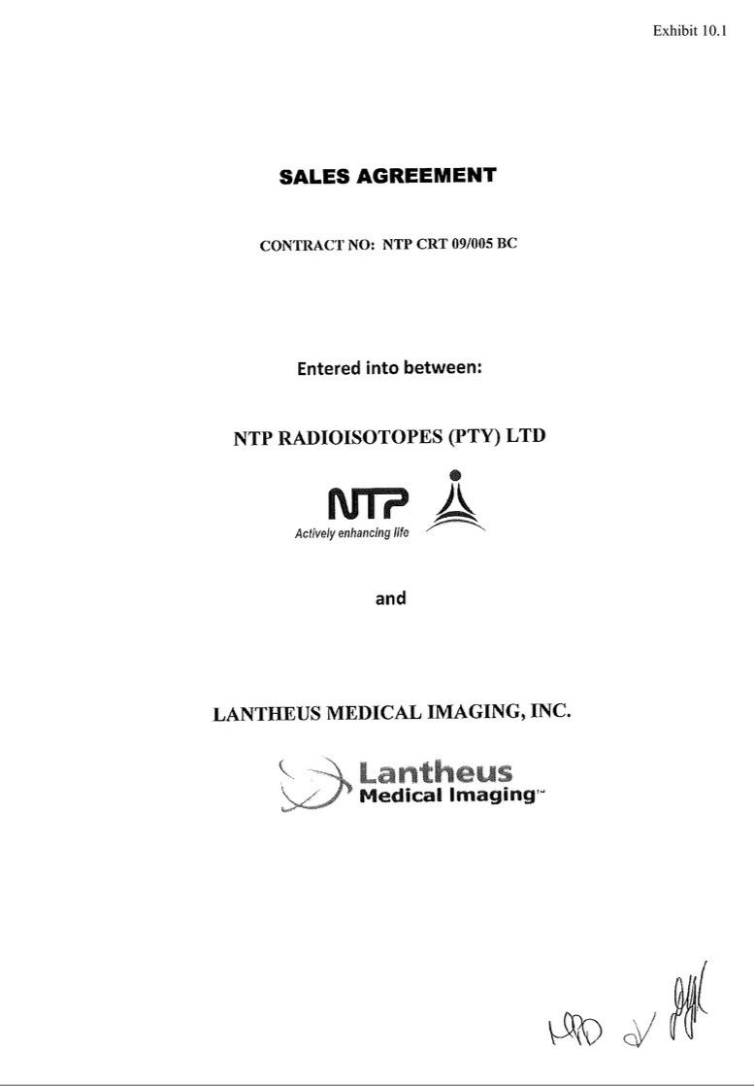

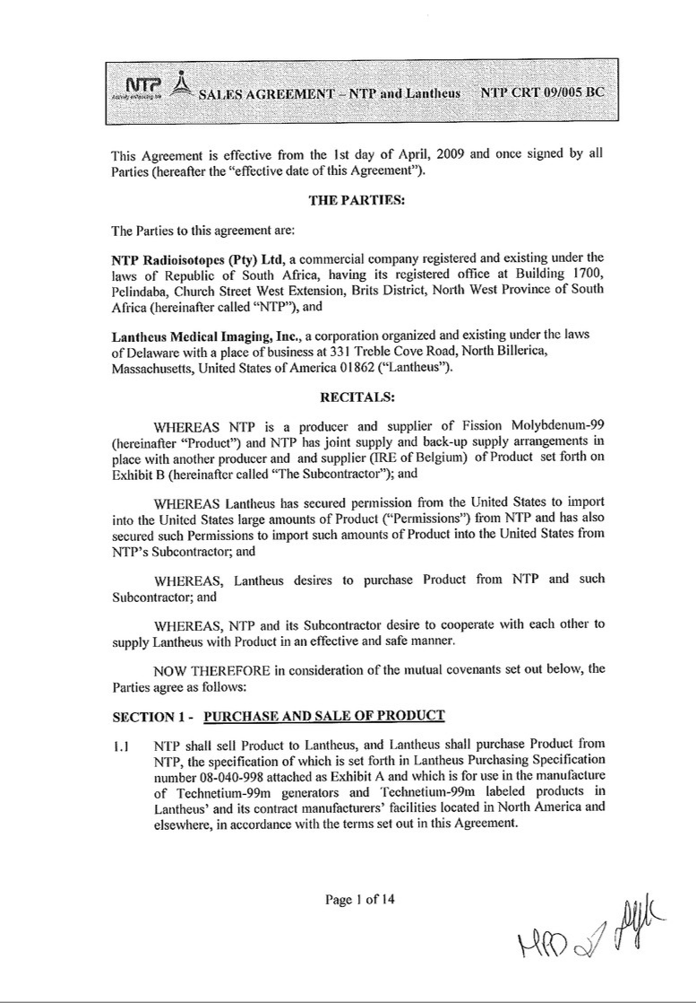

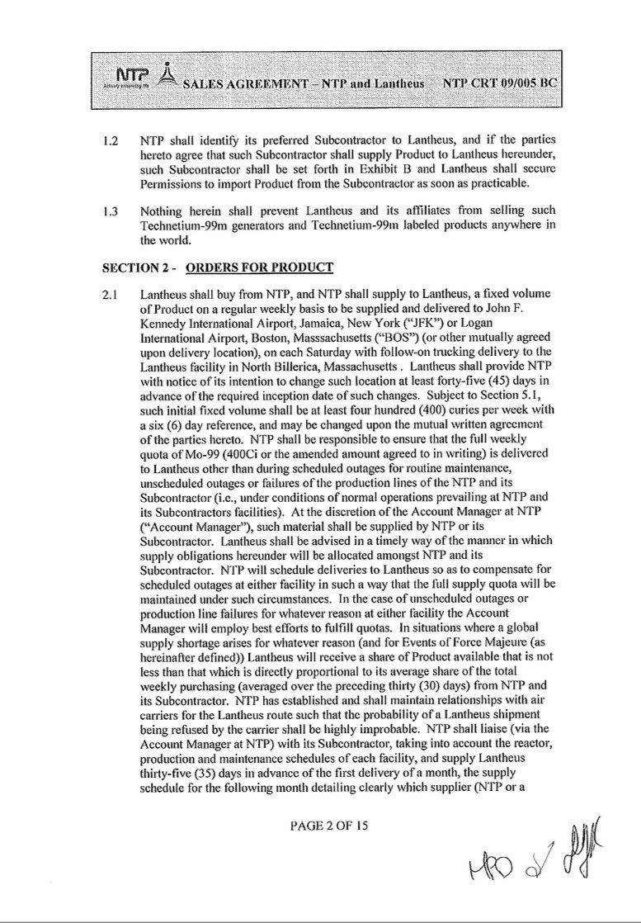

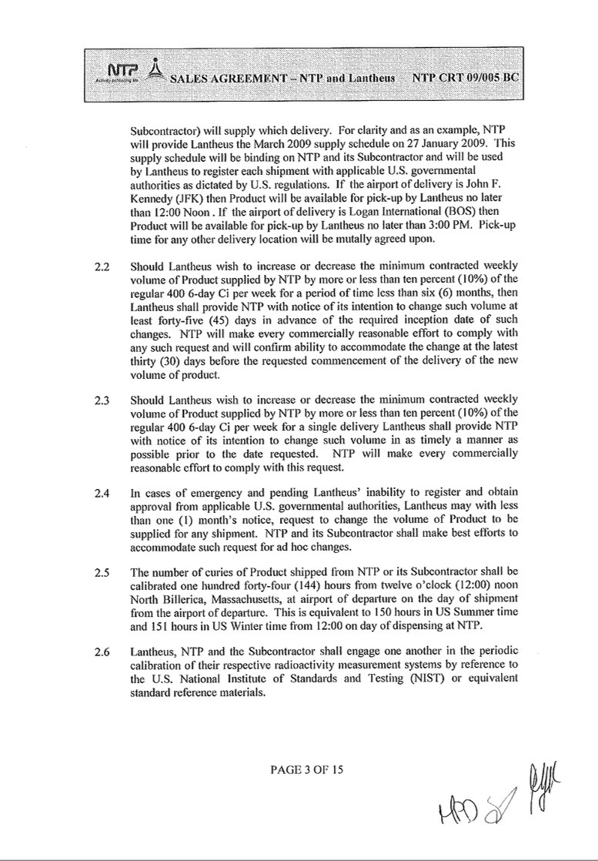

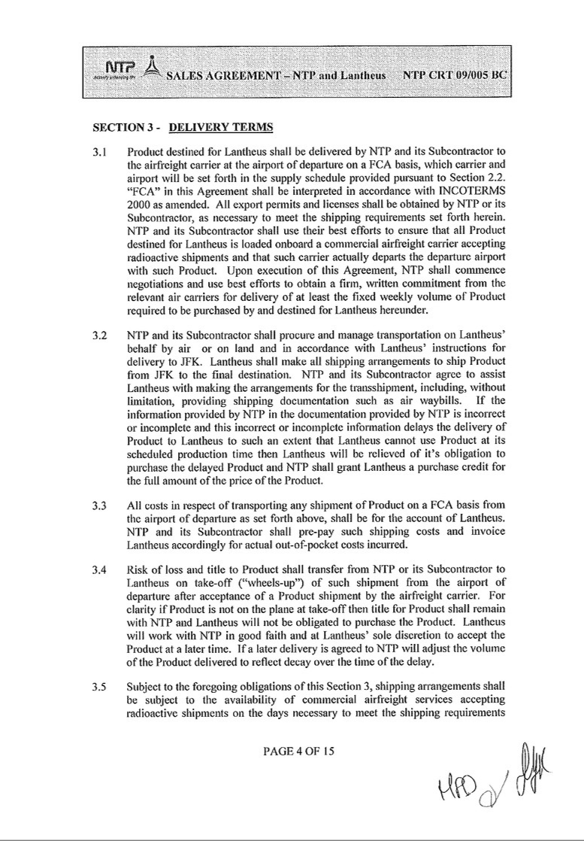

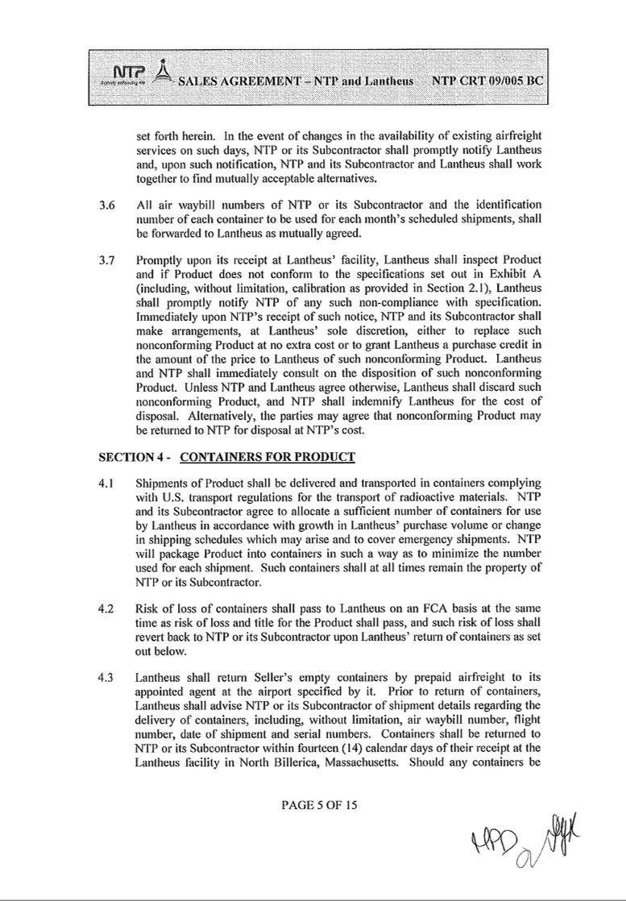

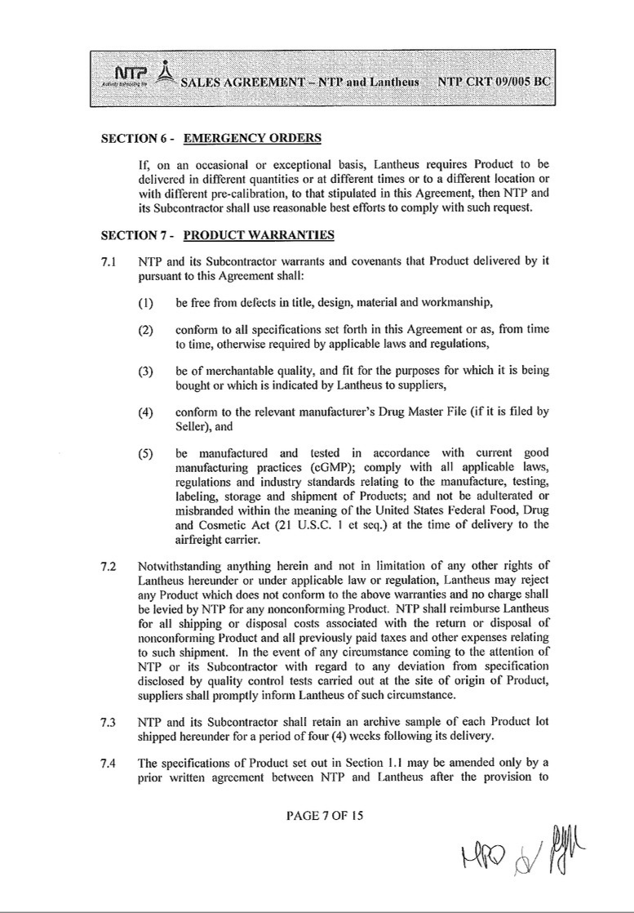

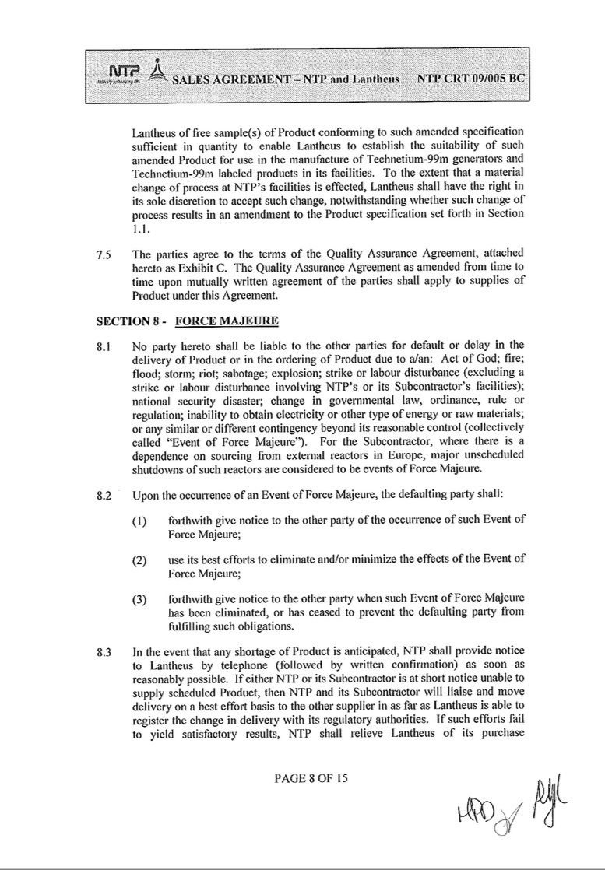

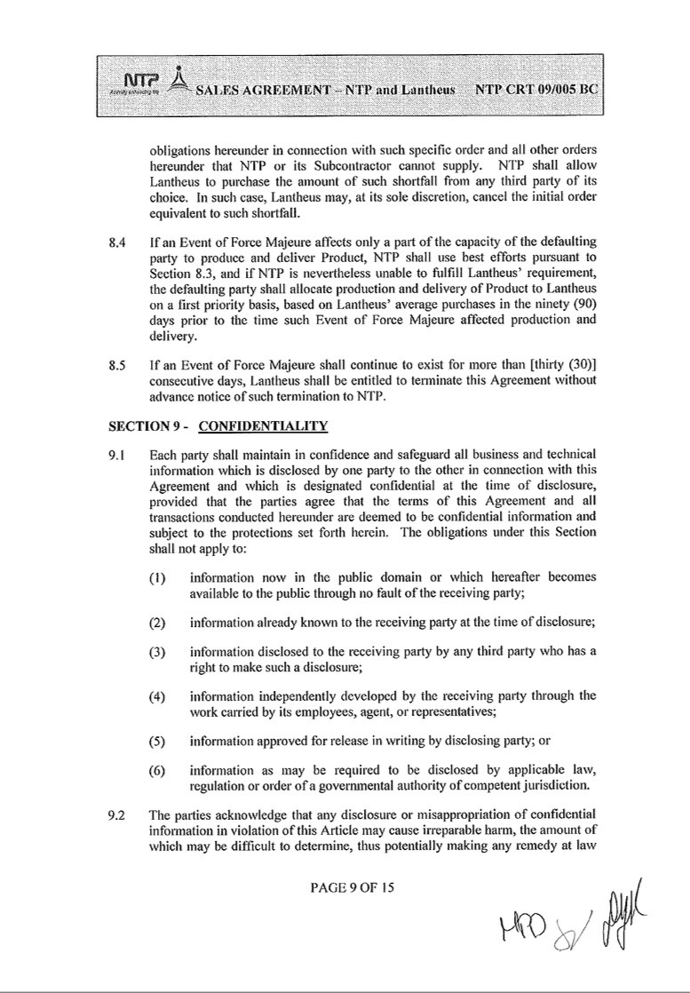

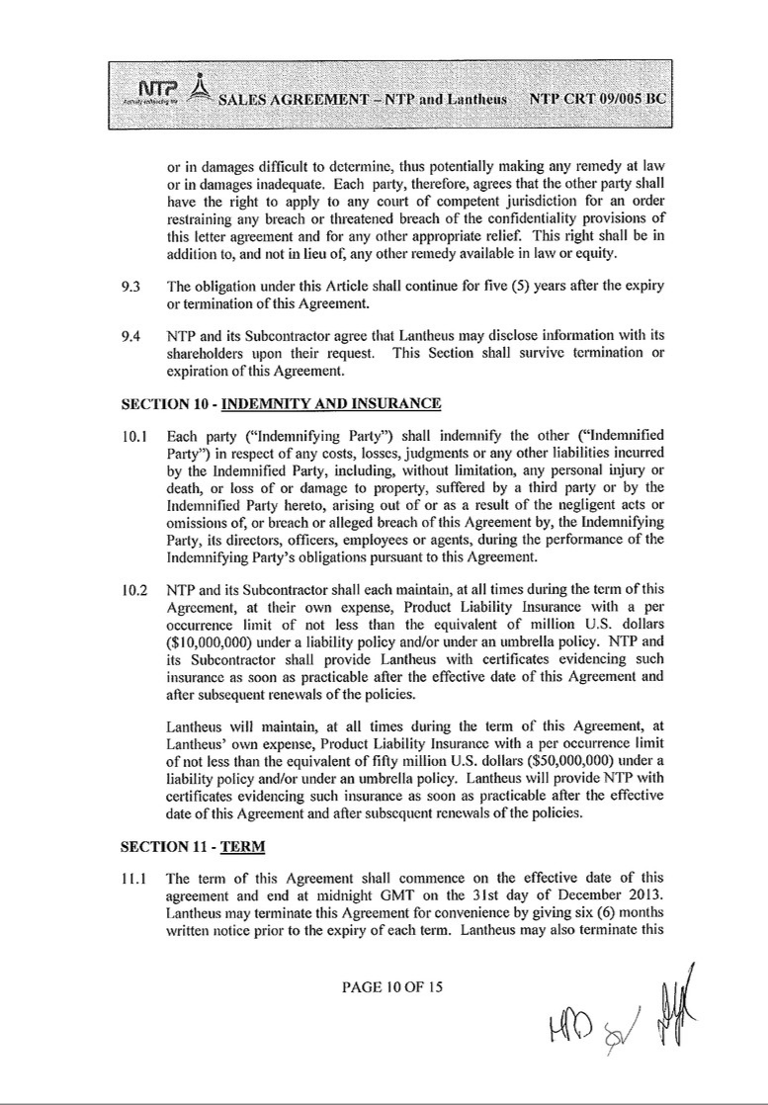

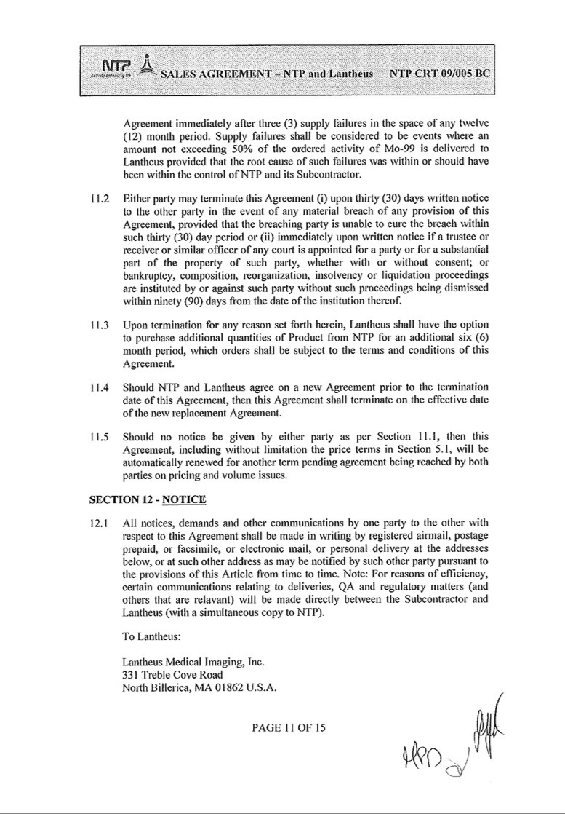

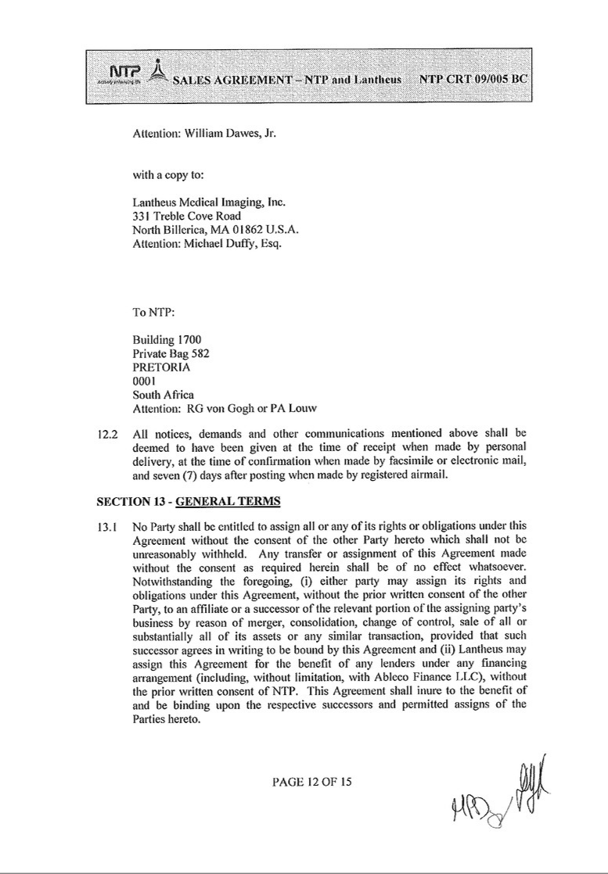

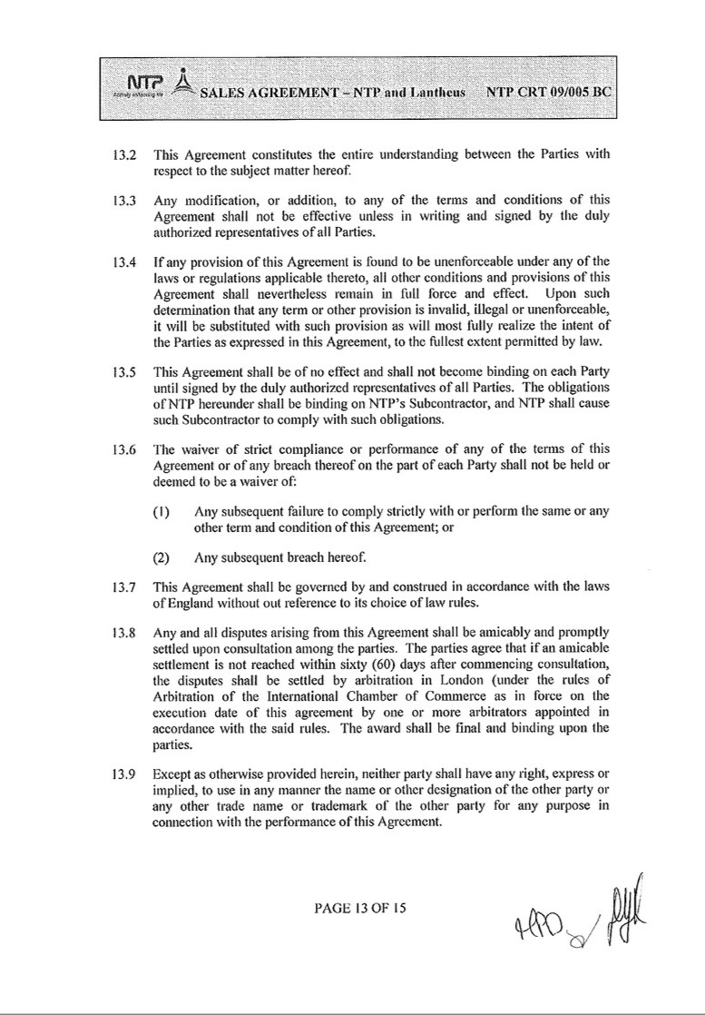

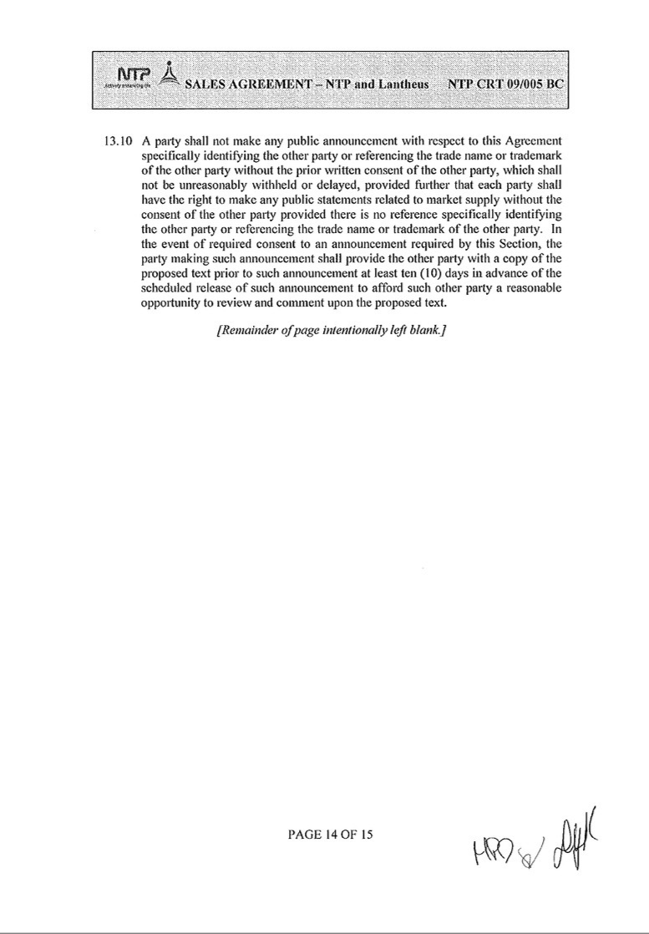

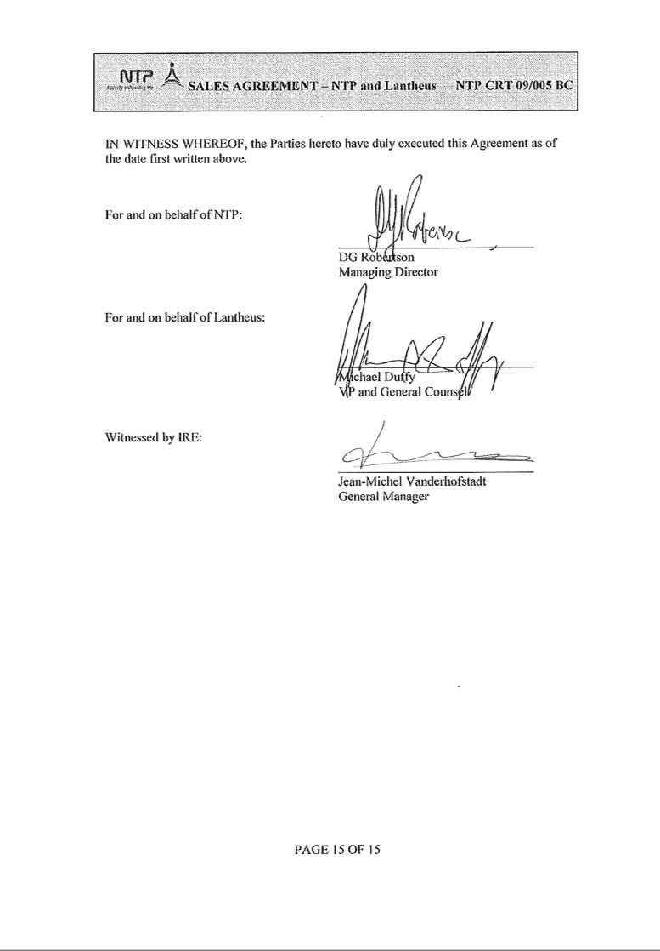



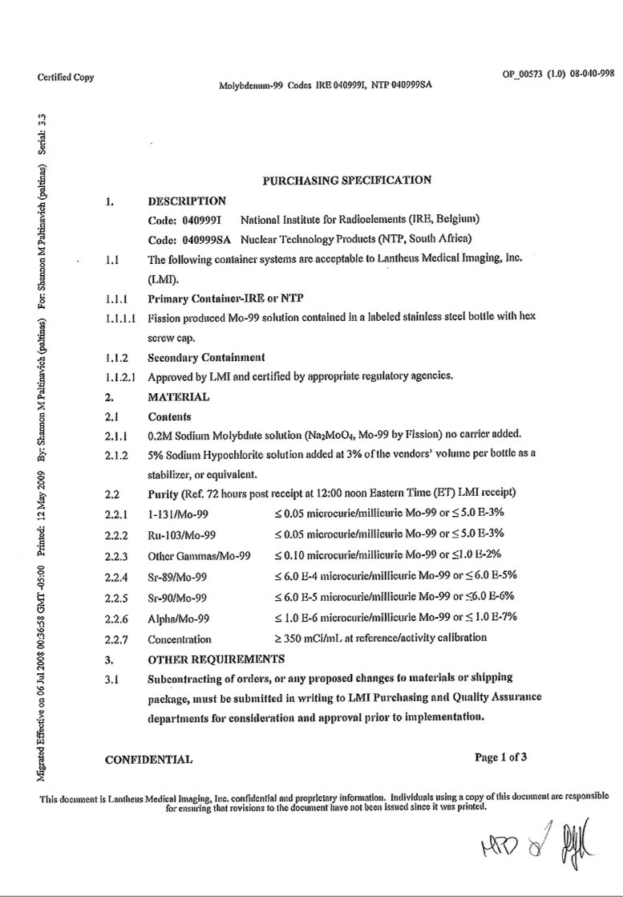

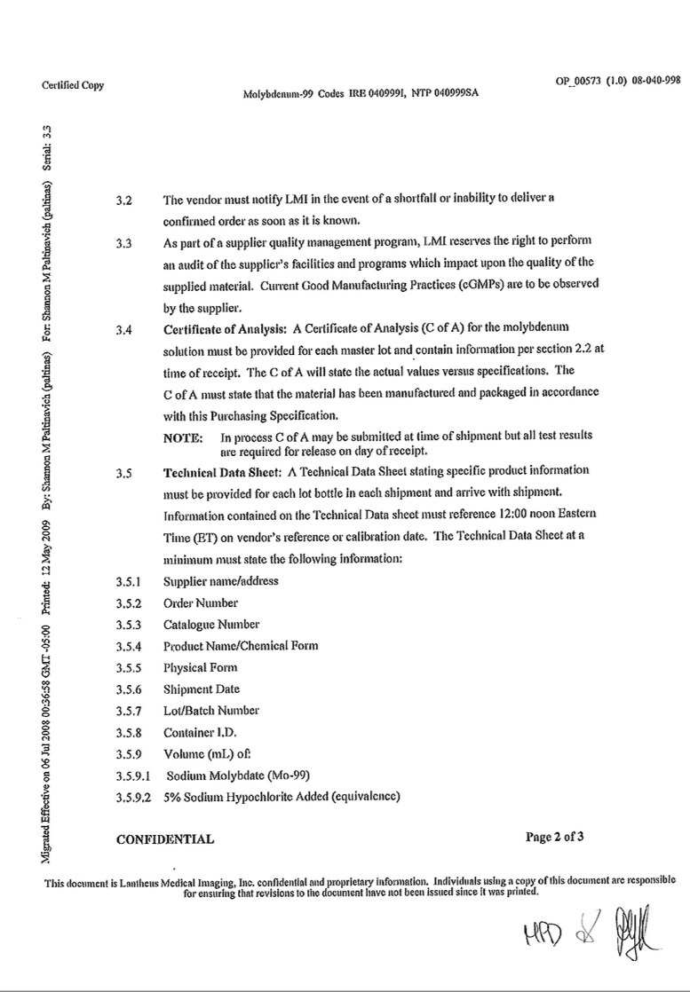

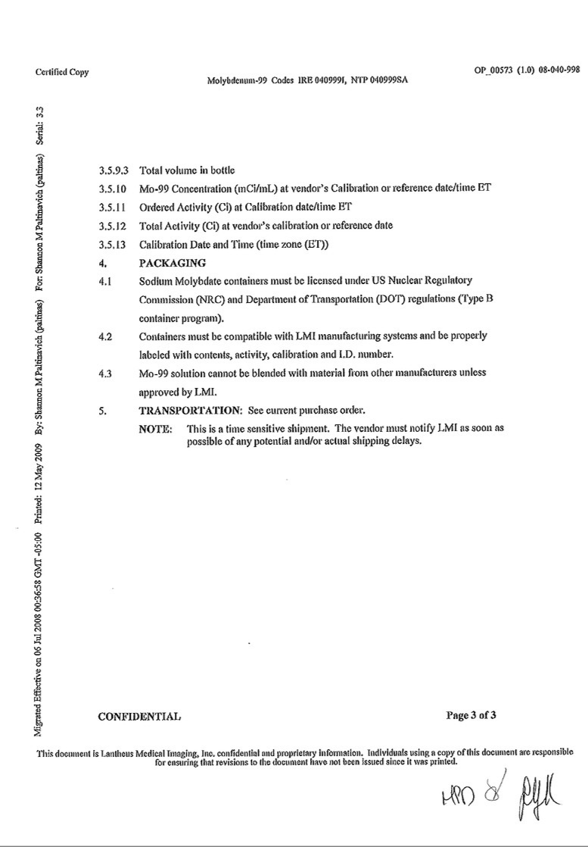

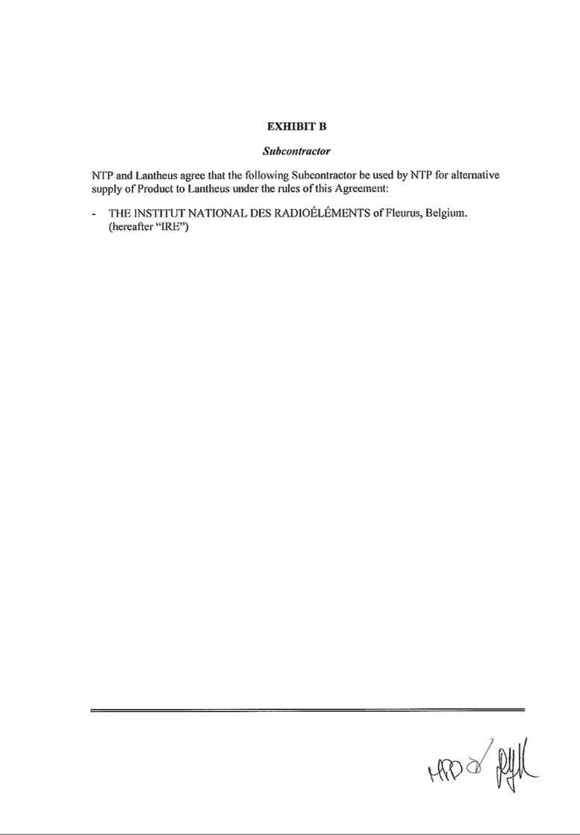



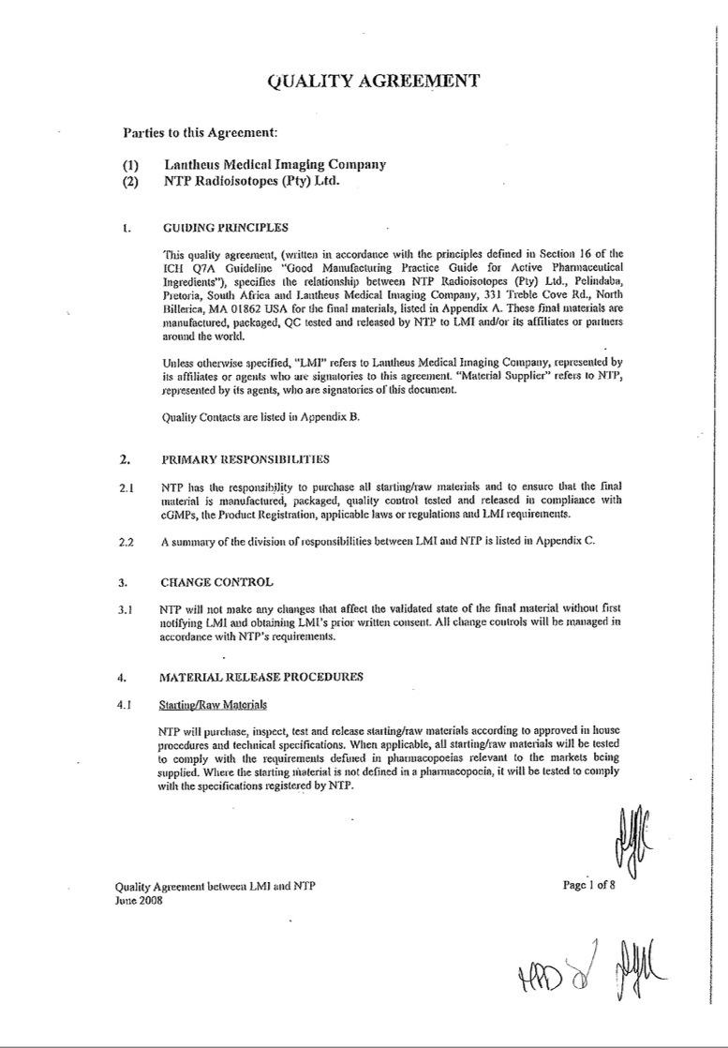

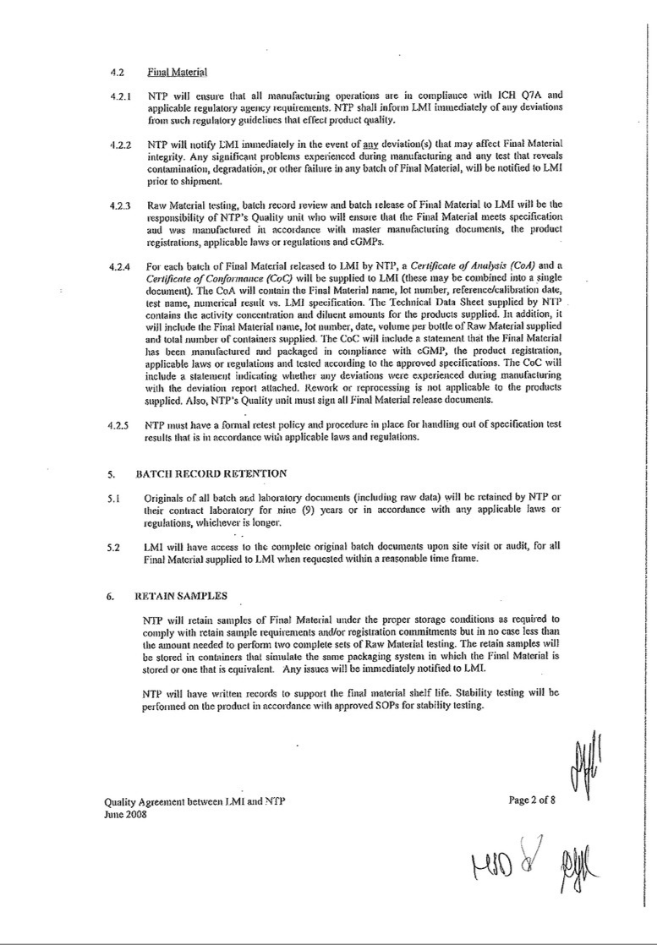

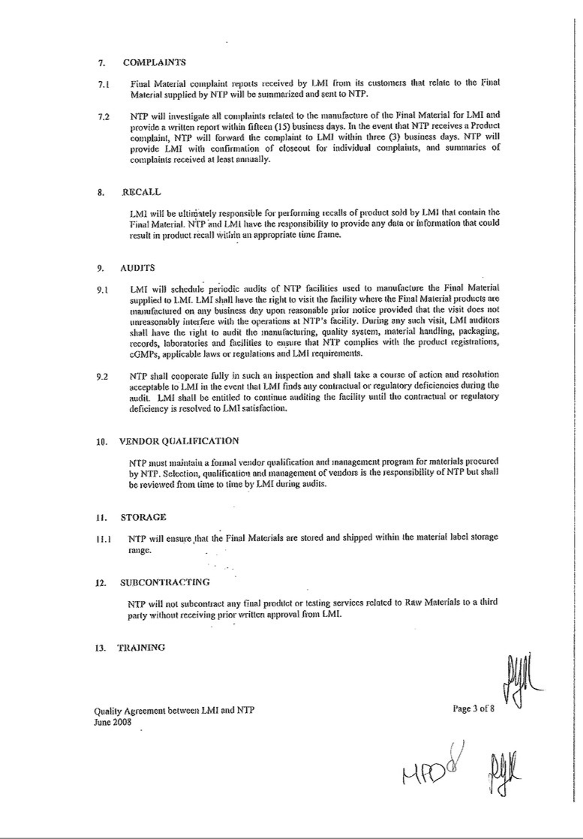

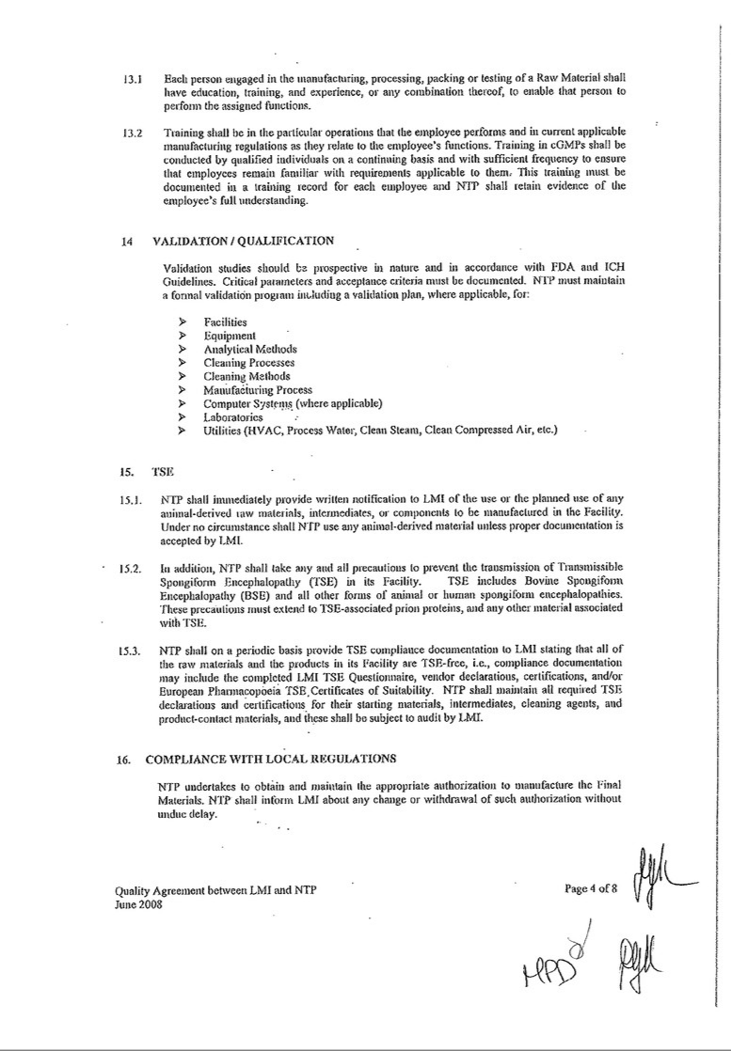

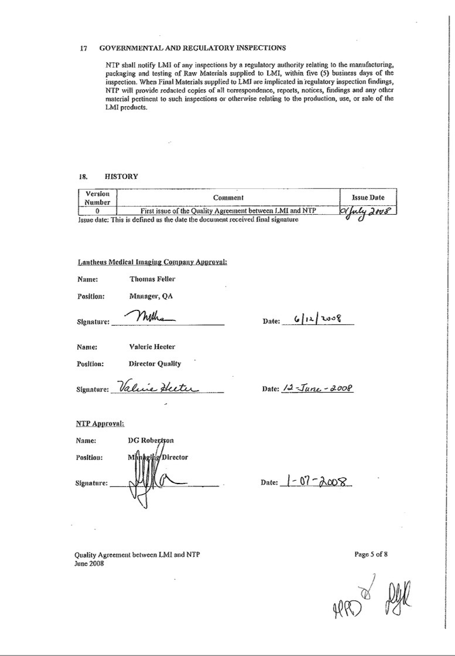

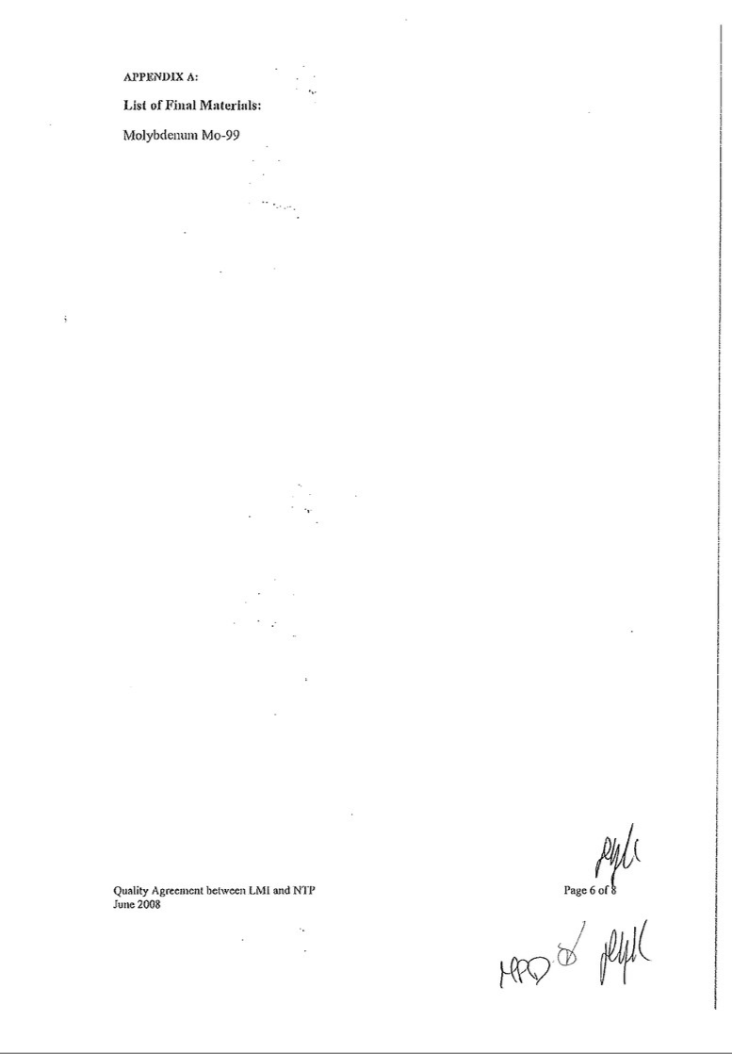

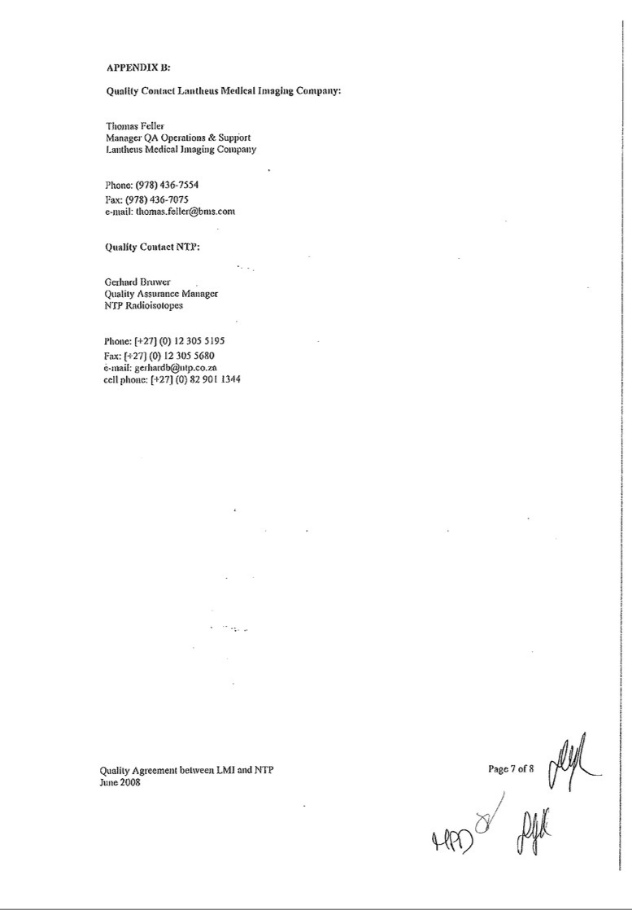

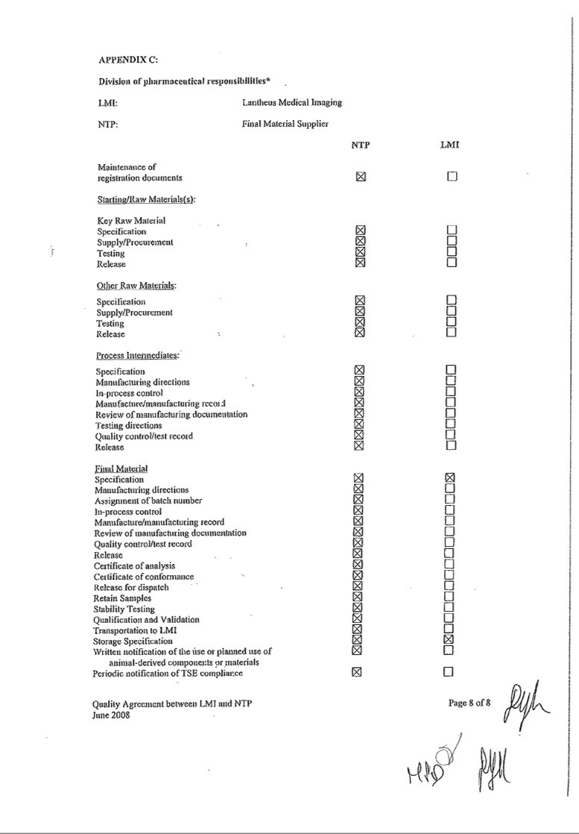

Exhibit 10.2

Amendment No. 1 to Sales Agreement

THIS AMENDMENT NO. 1 TO SALES AGREEMENT (this “Amendment”) is made effective as of January 1, 2010 by and between NTP Radioisotopes (Pty) Ltd., a commercial company registered and existing under the laws of the Republic of South Africa, having its registered office at Building 1700, Pelindaba, Church Street West Extension, Brits District, North West Province of South Africa (“NTP”), and Lantheus Medical Imaging, Inc., a corporation organized and existing under the laws of Delaware with a place of business at 331 Treble Cove Road, North Billerica, Massachusetts, United States of America 01862 (“Lantheus”).

WHEREAS:

- NTP and Lantheus entered into a Sales Agreement effective as of April 1, 2009 (the “Original Agreement”);

- Since such effective date, the global molybdenum-99m crisis has become acute; and

- NTP and Lantheus wish to amend the Original Agreement to increase the committed volume levels and specify the pricing for such increased committed volume levels through July 31, 2010;

NOW, THEREFORE, in consideration of the mutual promises and covenants hereinafter set forth, and for other good and valuable consideration, the receipt and sufficiency of which are hereby acknowledged, the parties hereto hereby agree as follows:

- Definitions. Terms defined in the Original Agreement and not otherwise defined herein are used herein with the meanings so defined.

- Amendments.

2.1 Section 2.1 of the Original Agreement is hereby amended by deleting in its entirety said Section 2.1 and replacing therewith the following:

2.1 Lantheus shall buy from NTP, and NTP shall supply to Lantheus, a fixed volume of Product on a regular weekly basis to be supplied and delivered to John F. Kennedy International Airport, Jamaica, New York (“JFK”) or Logan International Airport, Boston, Massachusetts (“BOS”) (or other mutually agreed upon delivery location) on a mutually agreed schedule with follow-on trucking delivery to the Lantheus facility in North Billerica, Massachusetts. Lantheus shall provide NTP with notice of its intention to change such location at least forty-five (45) days in advance of the required

1

inception date of such changes. Subject to the last sentence of this Section 2.1 and to Section 5.1, such fixed volume shall be as set forth immediately below, which volume may be changed by mutual written agreement of the parties:

Time Period | Average curies per week with a six (6) day reference, such
 | average calculated on a calendar month-by-calendar month
 | basis
January-February 2010 | 1,300 curies per week
March-April 2010 | 1,000 curies per week
May-June 2010 | 900 curies per week
July 2010 | 600 curies per week
August 2010 and thereafter | 1,400 curies per week

NTP shall be responsible to ensure that the full weekly quota of Mo-99 is delivered to Lantheus other than during scheduled outages for routine maintenance, unscheduled outages or failures of the production lines of NTP and its Subcontractor (i.e., under conditions of normal operations prevailing at NTP and its Subcontractor’s facilities). At the discretion of the Account Manager at NTP (“Account Manager”), such material shall be supplied by NTP or its Subcontractor. Lantheus shall be advised in a timely way of the manner in which supply obligations hereunder will be allocated among NTP and its Subcontractor. NTP will schedule deliveries to Lantheus so as to compensate for scheduled outages at either facility in such a way that the full supply quota will be maintained under such circumstances. In the case of unscheduled outages or production line failures for whatever reason (and for Events of Force Majeure (as hereinafter defined)), Lantheus will receive a share of Product available that is not less than that which is directly proportional to its average share of the total weekly purchasing (averaged over the preceding thirty

- days) from NTP and its Subcontractor. NTP has established and shall maintain relationships with air carriers for the Lantheus route such that the probability of a Lantheus shipment being refused by the carrier shall be highly improbable. NTP shall liaise (via the Account Manager at NTP) with its Subcontractor, taking into account the reactor production and maintenance schedules of each facility, and supply Lantheus thirty-five (35) days in advance of the first delivery of a month, the supply schedule for the following month detailing clearly which supplier (NTP or a Subcontractor) will supply such delivery. For clarity and as an example, NTP will provide Lantheus the March 2010 supply schedule on 27 January 2010. This supply schedule will be binding on NTP and its Subcontractor and will be used by Lantheus to register each shipment with applicable U.S. governmental authorities as dictated by U.S. regulations. If the airport of delivery is JFK, then Product will be available for pick-up by

2

Lantheus no later than 12:00 Noon. If the airport of delivery is BOS, then Product will be available for pick-up by Lantheus no later than 3:00PM. Pick-up time for any other delivery location will be mutually agreed upon.

Notwithstanding the foregoing and without limiting the rights of Lantheus elsewhere in this Agreement, including, without limitation, pursuant to the termination provisions of Section 11, to the extent NTP does not or cannot deliver the quantities specified in this Section 2.1 on a weekly basis in a reliable matter or on a monthly basis in accordance with the terms of this Agreement, then from and after April 1, 2010 Lantheus shall have the sole right, after giving NTP thirty (30) days prior written notice, to reduce the fixed volumes specified in this Section 2.1 to a volume or volumes less than otherwise set forth but not less than four hundred (400) curies per week for the duration of the time periods specified.

2.2 Section 2.2 of the Original Agreement is hereby amended by deleting from the first sentence thereof the words “regular

400 6-day Ci per week” and replacing therewith the words “then-applicable specified amount of 6-day Ci per week”.

2.3 Section 2.3 of the Original Agreement is hereby amended by deleting from the first sentence thereof the words “regular

400 6-day Ci per week” and replacing therewith the words “then-applicable specified amount of 6-day Ci per week”.

2.4 Section 5.1 of the Original Agreement is hereby amended by deleting in its entirety said Section 5.1 and replacing therewith the following:

5.1 The price payable by Lantheus for Product for the period from January 1 through July 31, 2010 shall be as follows:

In exchange for the commitment of Lantheus to purchase the amounts set forth in Section 2.1 in any given week (subject to NTP’s ability to supply such amounts in such weeks), the unit price of Product for such week shall be three hundred seventy-five fixed US dollars (US$375) per Curie at calibrated date and time for the first four hundred (400) Curies delivered per week and five hundred sixty-five fixed US dollars (US$565) per Curie at calibrated date and time for all Curies in excess of the first four hundred (400) Curies delivered per week. The calibration date and time shall be in accordance with Section 2.4. Such price will be adjusted annually upon mutual agreement of the parties as of each subsequent August 1 of the Agreement on the basis of market forces prevailing at the time, the then current cost of production and any contractual sales obligations that Lantheus may have with its customers and by negotiation and agreement by, at the

3

latest, the last day of May preceding the commencement of the new pricing term (1 August of each year that the contract is in place). Lantheus shall have the right to terminate the Agreement if the parties fail to agree on new pricing by such last day of May. Changes in contracted volumes not required during the course of a contractual period, i.e., 1 August to 31 July of the following year, the latter of which would be handled by the terms of Section 2.1 or 2.2, but applicable for the ensuing contractual period, shall be agreed at the same time as the annual negotiations on product prices as outlined in this Section 5.1 above.

NTP shall invoice Lantheus at the end of each month for all Product supplied by NTP or its Subcontractor in that month. Invoicing shall be in respect of the price applicable to Product upon delivery of such conforming Product to Lantheus on an FCA basis, and in respect of container charges as the same become payable under this Agreement. Lantheus shall pay all invoices for shipments of conforming Product in any given month (as reduced by any outstanding credits for nonconforming Product) by the end of the following month to NTP.

- Waiver. Each party hereby waives any non-compliance with the terms and provisions of the Original Agreement as in effect immediately prior to the amendment thereof by this Agreement.

- General. Except as specifically amended hereby, the Original Agreement remains in full force and effect and otherwise unamended hereby. This Amendment constitutes a final written expression of the terms hereof and is a complete and exclusive statement of those terms. This Amendment shall be governed by and construed in accordance with the laws of England, without reference to its choice of laws rules.

4

IN WITNESS WHEREOF, the parties hereto have duly executed this Amendment as of the date first written above.

For and on behalf of NTP:

/s/ [Illegible]

Name and Title: Marketing & Sales Manager, 15 March 2010

For and on behalf of Lantheus:

/s/ William C. Dawes, Jr.

Name and Title: William C. Dawes, Jr., VP Mfg & Supply Chain

Witnessed by IRE:

/s/ Jean-Michel Vanderhofstadt

Name and Title: Jean-Michel Vanderhofstadt, Director General

5

Exhibit 10.3

Amendment No. 2 to Sales Agreement

THIS AMENDMENT NO. 2 TO SALES AGREEMENT (this “Amendment”) is made effective as of April 1, 2011 by and between NTP Radioisotopes (Pty) Ltd., a commercial company registered and existing under the laws of the Republic of South Africa, having its registered office at Building 1700, Pelindaba, Church Street West Extension, Brits District, North West Province of South Africa (“NTP”), and Lantheus Medical Imaging, Inc., a corporation organized and existing under the laws of Delaware with a place of business at 331 Treble Cove Road, North Billerica, Massachusetts, United States of America 01862 (“Lantheus”).

WHEREAS:

- NTP and Lantheus entered into a Sales Agreement effective as of April 1, 2009 (the “Sales Agreement”);

- NTP and Lantheus entered into Amendment No. 1 to the Sales Agreement effective as of January 1, 2010 (together with the Sales Agreement, the “Agreement”); and

- NTP and Lantheus wish to further amend the Agreement to modify the committed volume levels and specify the pricing for such volume levels through December 31, 2013;

NOW, THEREFORE, in consideration of the mutual promises and covenants hereinafter set forth, and for other good and valuable consideration, the receipt and sufficiency of which are hereby acknowledged, the parties hereto hereby agree as follows:

- Definitions. Terms defined in the Agreement and not otherwise defined herein are used herein with the meanings so defined.

- Amendments.

2.1 Section 2.1 of the Agreement is hereby amended by deleting in its entirety said Section 2.1 and replacing therewith the following:

2.1 Subject to the terms of this Agreement, the parties hereby agree as follows:

- Commencing as of April 1, 2011 and continuing through December 31, 2012, Lantheus shall commit to place routine Product orders with NTP on a regular weekly basis corresponding to at least ninety percent (90%) of Lantheus’ “standing order volume requirements” (as defined below), up to a maximum purchase volume of 1,400 curies of Product per week from NTP and its Subcontractors (as measured using the calibration as set forth in

Section 2.5) unless orders for increased volumes of Product are otherwise placed by Lantheus, as averaged over each separate but successive calendar quarter commencing April 1, 2011, and NTP shall supply such orders, provided that, as set forth in Section 2.1(c), such obligations shall only apply in those weeks in which NTP and its Subcontractors are able to satisfy, and NTP and its Subcontractors do satisfy, such obligations. Lantheus shall, in writing, submit to NTP on the 1st day of each month during the term of this Agreement, a good faith, non binding forecast of the estimated quantity of Product Lantheus expects to order from NTP during the three (3) month period following the date of the forecast (each a “Forecast”). Lantheus will also provide NTP with firm orders for Product at least fourteen (14) days in advance of the required date of Product shipment. During the period of April 1, 2011 through December 31, 2012, Lantheus expects the weekly purchase volumes to be in the range of 500 to 1,400 curies of Product; provided, however, for purposes of clarity, and notwithstanding any other provision of this Agreement, the parties acknowledge and agree that Lantheus shall be relieved of any obligations with respect to the purchase volumes in this Section 2.1 if Lantheus has reason to believe that it will be unable to use such Product in the manufacture and sale of Technetium-99m generators (e.g., there is a change in customer demand for Technetium-99m generators); provided further, that if at any time during the term of this Agreement Lantheus does not purchase an average weekly volume of at least four hundred

- curies of Product per week from NTP and its Subcontractors, as averaged over each calendar quarter and as measured using the calibration as set forth in Section 2.5, the parties will make a good faith effort to renegotiate the terms of this Agreement for future purchases of Product made by Lantheus to reflect any incremental costs of such decreased volumes borne by NTP and its Subcontractors. For purposes of this Agreement, “standing order volume requirements” shall mean Lantheus’ normal weekly volume requirements for Product in excess of Lantheus’ purchase volume commitments to its other principal supplier of Product which existed on February 28, 2011.

For clarity and as an example:

During the period of April 1, 2011 through December 31, 2012, if Lantheus’ normal weekly volume requirements for Product are 1,000 curies per week of Molybdenum-99 (as measured for purposes of this calculation using the calibration as set forth in Section 2.5) in excess of Lantheus’ purchase volume commitments to its other principal supplier of Product, Lantheus will purchase, and NTP will supply, at least the first 900 curies per week of such volume requirements.

- Commencing as of January 1, 2013 and continuing through December 31, 2013, Lantheus shall commit to place routine Product orders

2

with NTP on a regular weekly basis corresponding to at least thirty three percent (33%) of Lantheus’ total requirements of Product as averaged over each separate but successive calendar quarter, and NTP shall supply such orders, provided that, as set forth in Section 2.1(c), such obligation shall only apply in those weeks in which NTP and its Subcontractors are able to satisfy, and NTP and its Subcontractors do satisfy, such obligations. In addition, during the period of January 1, 2013 through December 31, 2013, Lantheus will continue to provide NTP with a good faith, non binding Forecast on the 1st day of each month. Lantheus will also continue to provide NTP with firm orders for Product at least fourteen (14) days in advance of the required date of Product shipment.

- Such Product shall be supplied and delivered to John F. Kennedy International Airport, Jamaica, New York (“JFK”) or Logan International Airport, Boston, Massachusetts (“BOS”) (or other mutually agreed upon delivery location) on a mutually agreed schedule with follow-on trucking delivery to the Lantheus facility in North Billerica, Massachusetts. Lantheus shall provide NTP with notice of its intention to change such location at least forty-five (45) days in advance of the required inception date of such changes. NTP shall be responsible to ensure that the full weekly quota of Mo-99 is delivered to Lantheus other than during scheduled outages for routine maintenance, unscheduled outages or failures of the production lines of NTP and its Subcontractors (i.e., under conditions of normal operations prevailing at NTP and its Subcontractors’ facilities). At the discretion of the Account Manager at NTP (“Account Manager”), such material shall be supplied by NTP or its Subcontractors. Lantheus shall be advised in a timely way of the manner in which supply obligations hereunder will be allocated among NTP and its Subcontractors. NTP will schedule deliveries to Lantheus so as to compensate for scheduled outages at either facility in such a way that the full supply quota will be maintained under such circumstances.

- For any supply of Product by NTP, NTP will provide Lantheus with Product derived from low enriched uranium (LEU) whenever possible unless otherwise directed by Lantheus. In addition, to the extent that the total volume of LEU-based Product available for sale by NTP is not sufficient to meet all of its customer orders in a given run, NTP shall supply Lantheus’ orders first and to the greatest extent possible with LEU-based Product.

- In the case of scheduled or unscheduled outages or production line failures for whatever reason (and for Events of Force Majeure (as hereinafter defined)) affecting NTP or its Subcontractors, Lantheus will receive a share of Product available that is not less than that which is directly proportional to its average share of the total weekly purchasing

3

(averaged over the preceding thirty (30) days) from NTP and its Subcontractors.

For clarity and as an example:

If NTP or its Subcontractors experiences a production line failure affecting the supply of Product hereunder, and NTP and its Subcontractors sold an average weekly volume of 2,000 curies of Product, and Lantheus purchased from NTP an average weekly volume of 1,000 curies of Product, in the preceding thirty days (each as measured using the calibration as set forth in Section 2.5), then Lantheus would be entitled to receive at least fifty percent (50%) of the volume of Product available for sale by NTP and its Subcontractors.

- In situations where a global supply shortage arises or Lantheus’ supply of Molybdenum-99 from third party suppliers other than NTP or its Subcontractors is adversely affected for whatever reason (e.g., scheduled or unscheduled reactor outages that result in shortages from such third party suppliers), NTP and its Subcontractors will supply routine orders for Product placed by Lantheus and its other customers. NTP and its Subcontractors will also use their best efforts to make available any additional volumes of Product requested by Lantheus and shall provide Lantheus with a right of first refusal to purchase any Product available for sale by NTP or its Subcontractors; provided, however, that, if required by written customer contracts which existed on February 28, 2011, NTP and its Subcontractors may provide customers affected directly by such supply shortage with a share of the available Product that is directly proportional to such affected customer’s average share of the total weekly purchasing (averaged over the preceding thirty (30) days) from NTP and its Subcontractors. For purposes of clarity, affected customers are customers of NTP and its Subcontractors whose supply of Molybdenum-99 has been reduced as a direct result of the supply shortage.

- The NRU Reactor located in Chalk River, Ontario is currently scheduled to be shut-down for a period of inspection and maintenance for four weeks beginning in May 2011. Pursuant to the mutually agreed upon supply schedule, which schedule may be modified from time to time by mutual consent of the Parties, NTP and its Subcontractors will provide Lantheus with at least the minimum supply volumes of Product during the NRU Reactor’s shutdown period, pursuant to the terms set forth herein (including, but not limited to, the delivery and pricing terms). These purchase volumes, estimated as of April 1, 2011, and the purchase prices related thereto are attached hereto as Exhibit D. NTP and its Subcontractors will also use their best efforts to make available any additional volumes of Product requested by Lantheus and shall provide Lantheus with a right of

4

first refusal to purchase any additional volumes of Product available for sale by NTP or its Subcontractors in excess of the purchase volumes set forth in Exhibit D.

- NTP has established and shall maintain relationships with air carriers for the Lantheus route such that the probability of a Lantheus shipment being refused by the carrier shall be highly improbable. NTP shall liaise (via the Account Manager at NTP) with its Subcontractors, taking into account the reactor production and maintenance schedules of each facility, and supply Lantheus thirty-five (35) days in advance of the first delivery of a month, the supply schedule for the following month detailing clearly which supplier (NTP or a Subcontractor) will supply such delivery. For clarity and as an example, NTP will provide Lantheus the March 2010 supply schedule on 27 January 2010. This supply schedule will be binding on NTP and its Subcontractors and will be used by Lantheus to register each shipment with applicable U.S. governmental authorities as dictated by U.S. regulations. If the airport of delivery is JFK, then Product will be available for pick-up by Lantheus no later than 12:00 Noon. If the airport of delivery is BOS, then Product will be available for pick-up by Lantheus no later than 3:00PM. Pick-up time for any other delivery location will be mutually agreed upon.

- Notwithstanding the foregoing, NTP and its Subcontractors hereby acknowledge and agree that the diversification of supply provided by NTP through its supply and back-up supply arrangements with its Subcontractors is essential to the purpose of this Agreement. Without limiting the rights of Lantheus elsewhere in this Agreement, if at any time during the term of this Agreement the consortium of supply partners changes or NTP or its Subcontractors does not or cannot deliver the quantities specified in this Section 2.1 on a weekly basis in a reliable manner, the parties will make a good faith effort to renegotiate the terms of this Agreement. In the event the parties are unable to agree on modification of this Agreement within a reasonable period of time (not to exceed sixty (60) days), Lantheus shall have the sole right, after giving NTP thirty (30) days prior written notice, to terminate this Agreement.

2.2 Section 2.2 of the Agreement is hereby amended by deleting it in its entirety and replacing therewith “[Intentionally left blank.]”.

2.3 Section 2.3 of the Agreement is hereby amended by deleting it in its entirety and replacing therewith “[Intentionally left blank.]”.

2.4 Section 2.5 of the Agreement is hereby amended by deleting in its entirety said Section 2.5 and replacing therewith the following:

5

2.5 Commencing as of April 1, 2011, the number of curies of Product shipped from NTP or its Subcontractors shall be based on the order placed by Lantheus and calibrated one hundred forty-four (144) hours from twelve o’clock (12:00) noon Johannesburg, South Africa, at airport of departure on the day of shipment from the airport of departure. The number of curies of Product shipped from any Subcontractor will be calibrated as if it were shipped from Johannesburg, South Africa so that Lantheus will receive an equal number of curies of Product regardless of whether the order is shipped by NTP or any of its Subcontractors.

2.5 Section 5.1 of the Agreement is hereby amended by deleting in its entirety said Section 5.1 and replacing therewith the following:

5.1 The price payable by Lantheus for Product for the period from April 1, 2011 through October 1, 2012 shall be as follows:

- The unit price of Product for such week shall be four hundred and ninety fixed US dollars (US$490) per Curie at calibrated date and time for the first five hundred (500) curies delivered per week and three hundred and eighty four fixed US dollars (US$384) per Curie at calibrated date and time for all curies in excess of the first five hundred (500) curies delivered per week. The calibration date and time shall be in accordance with Section 2.5.

- Notwithstanding the foregoing, during the NRU Reactor’s shutdown period described in Section 2.1(g), the unit price of Product for each week during such period shall be four hundred and ninety fixed US dollars (US$490) per Curie at calibrated date and time for the first five hundred (500) curies delivered per week, three hundred and eighty four fixed US dollars (US$384) per Curie at calibrated date and time for the next two hundred and fifty (250) curies delivered per week, and four hundred and ninety fixed US dollars (US$490) per Curie at calibrated date and time for all curies in excess of seven hundred and fifty (750) curies delivered per week. The unit prices set forth in Section 5.1(a) shall apply to the future shortages or shutdown periods described in Section 2.1(f), provided that, in the event that NTP incurs direct costs related to extraordinary measures taken by NTP or its Subcontractors over an extended period of time (not less than a period of three (3) months) to supply Product to Lantheus in excess of the routine purchase volumes described herein, the parties will negotiate in good faith a unit price for such excess Product based upon Lantheus’ proportional share of the reasonable variable expenses borne by NTP and its Subcontractors in connection therewith (as evidenced by reasonable documentation made available to Lantheus).

6

- The routine price will be adjusted upon mutual agreement of the parties effective as of October1, 2012 on the basis of market forces prevailing at the time, the then current cost of production and any contractual sales obligations that each party may have with its customers or suppliers and by good faith negotiation and agreement by, at the latest, June 30, 2012. Lantheus shall have the right to terminate the Agreement if the parties fail to agree on such new pricing by such last day in June.

- Provided that Lantheus is NTP’s largest customer in North America as measured by volume of curies purchased on an annual basis (as calculated consistent with calibration as set out in Section 2.5), the prices payable by Lantheus for Product shall not be higher than the purchase price (as calculated consistent with calibration as set out in Section 2.5) paid by any other purchaser of Product from NTP or its Subcontractors for delivery into North America (after giving effect to all rebates, discounts, and similar pricing concessions or incentives available to such purchasers, but excluding governmental purchases or purchases for other non-commercial purposes). For purposes of calculating the purchase price paid by other purchasers of Product for delivery into North America in order to determine if any prospective price adjustment shall be made hereunder, the parties agree that the purchase price paid by each purchaser pursuant to a written contract with NTP in a currency different from the United States dollar shall be determined taking into account the exchange rate of the United States dollar against such different currency as at the execution date of such written contract for any contracts entered into by NTP on or after April 1, 2011 and as at April 1, 2011 for any contracts entered into by NTP prior to such date. At any time reasonably requested by Lantheus (but no more frequently than once per calendar quarter), NTP will furnish to Lantheus a certificate, executed by a duly authorized officer of NTP, stating that such officer has reviewed the sales of such Product during such period and that NTP and its Subcontractors have complied with this Section 5.1(d). To the extent it is determined that NTP is not in compliance with this Section 5.1(d), NTP will credit Lantheus with the difference between the price paid by Lantheus and the amount otherwise contemplated by this Section 5.1(d) and any such difference will be paid by NTP to Lantheus in the form of a cash payment.

- NTP shall invoice Lantheus at the end of each month for all Product supplied by NTP or its Subcontractors in that month. Invoicing shall be in respect of the price applicable to Product upon delivery of such conforming Product to Lantheus on an FCA basis, and

7

in respect of container charges as the same become payable under this Agreement. Lantheus shall pay all invoices for shipments of conforming Product in any given month (as reduced by any outstanding credits for nonconforming Product) by the end of the following month to NTP.

2.6 The Agreement is hereby amended by adding the following Section 8.6:

8.6 For purposes of clarity and without limiting the generality of the provision in Section 8.1, NTP and its Subcontractors hereby acknowledge and agree that any law, regulation, or other action of any applicable governmental authorities having a materially adverse effect on the delivery, sale or use of Technetium-99m generators in North America using Molybdenum-99 derived from highly enriched uranium shall be deemed to be an Event of Force Majeure, and Lantheus shall have the right to terminate this Agreement.

2.7 Exhibit B of the Agreement is hereby amended by adding “Australian Nuclear Science and Technology Organization (“ANSTO”)” to the list of Subcontractors. In addition, all of the references to “Subcontractor” in the Agreement shall be amended to mean “Subcontractors.”

2.8 The Agreement is hereby amended by adding Exhibit D, a copy of which is attached hereto.

- Waiver. Each party hereby waives any non-compliance with the terms and provisions of the Agreement relating to the purchase volume requirements as in effect immediately prior to the amendment thereof by this Agreement.

- General. Except as specifically amended hereby, the Agreement remains in full force and effect and otherwise unamended hereby. This Amendment constitutes a final written expression of the terms hereof and is a complete and exclusive statement of those terms. This Amendment shall be governed by and construed in accordance with the laws of England, without reference to its choice of laws rules.

8

IN WITNESS WHEREOF, the parties hereto have duly executed this Amendment as of the date first written above.

For and on behalf of NTP:

For and on behalf of Lantheus:

Witnessed by IRE:

Witnessed by ANSTO:

/s/ Don Robertson

Name and Title:

M.D. NTP

/s/ William C. Dawes

Name and Title:

William C. Dawes, Vice President,

Manufacturing & Operations

/s/ Jean-Michel Vanderhofstadt

Name and Title:

Directeur General

/s/ Doug Cubbin

Name and Title:

EGM Business Development &

Commercialisation

9

EXHIBIT D

Supply Volumes

NRU Shutdown May/June 2011

 | Arrival LMI | NTP | IRE | Ansto | Dispatch date
Week 20
Saturday | Saturday, May 21, 2011 | 600 | 400 | 0 | Friday, May 20, 2011
Total: |  | 600 | 400 | 0
Week 21
Sunday | Sunday, May 22, 2011 | 0 | 0 | 250 | Saturday, May 21, 2011
Monday | Monday, May 23, 2011 | 0 | 0 | 0 | Sunday, May 22, 2011
Thursday | Thursday, May 26, 2011 | 0 | 400 | 205 | Wednesday, May 25, 2011
Saturday | Saturday, May 28, 2011 | 0 | 300 | 0 | Friday, May 27, 2011
Total: |  | 0 | 700 | 455
Week 22
Sunday | Sunday, May 29, 2011 | 0 | 0 | 225 | Saturday, May 28, 2011
Monday | Monday, May 30, 2011 | 0 | 0 | 0 | Sunday, May 29, 2011
Thursday | Thursday, June 2, 2011 | 0 | 400 | 205 | Wednesday, June 01, 2011
Saturday | Saturday, June 4, 2011 | 500 | 300 | 0 | Friday, June 3, 2011
Total: |  | 500 | 700 | 430
Week 23
Sunday | Sunday, June 5, 2011 | 550 | 0 | 225 | Saturday, June 4, 2011
Monday | Monday, June 6, 2011 | 0 | 0 | 0 | Sunday, June 5, 2011
Tuesday | Tuesday, June 7, 2011 | 0 | 0 | 0 | Monday, June 6, 2011
Thursday | Thursday, June 9, 2011 | 0 | 300 | 205 | Wednesday, June 08, 2011
Saturday | Saturday, June 11, 2011 | 600 | 0 | 0 | Friday, June 10, 2011
Total: |  | 1150 | 300 | 430
Week 24
Sunday | Sunday, June 12, 2011 | 600 | 0 | 225 | Saturday, June 11, 2011
Monday | Monday, June 13, 2011 | 0 | 0 | 0 | Sunday, June 12, 2011
Thursday | Thursday, June 16, 2011 | 0 | 450 | 0 | Wednesday, June 15, 2011
Saturday | Saturday, June 18, 2011 | 600 | 250 | 0 | Friday, June 17, 2011
Total: |  | 1200 | 700 | 225
Week 25
Sunday | Sunday, June 19, 2011 | 600 | 0 | 0 | Saturday, June 18, 2011
Monday | Monday, June 20, 2011 | 0 | 0 | 0 | Sunday, June 19, 2011
Thursday | Thursday, June 23, 2011 | 0 | 500 | 0 | Wednesday, June 22, 2011
Saturday | Saturday, June 25, 2011 | 600 | 200 | 0 | Friday, June 24, 2011
Total: |  | 1200 | 700 | 0
Week 26
Sunday | Sunday, June 26, 2011 | 0 | 0 | 215 | Saturday, June 25, 2011
Monday | Monday, June 27, 2011 | 0 | 0 | 0 | Sunday, June 26, 2011
Thursday | Thursday, June 30, 2011 | 0 | 200 | 200 | Wednesday, June 29, 2011
Saturday | Saturday, July 2, 2011 | 0 | 200 | 0 | Friday, July 1, 2011
Total: |  | 0 | 400 | 415

10

* The pricing for such volumes is set forth in the first sentence of Section 5.1(b) of the Agreement, as amended.

11

Exhibit 10.4

Amendment No. 3 to Sales Agreement

THIS AMENDMENT NO. 3 TO SALES AGREEMENT (this “Amendment”) is made effective as of October 1, 2012 by and between NTP Radioisotopes (Pty) Ltd., a commercial company registered and existing under the laws of the Republic of South Africa, having its registered office at Building 1700, Pelindaba, Church Street West Extension, Brits District, North West Province of South Africa (“NTP”), and Lantheus Medical Imaging, Inc., a corporation organized and existing under the laws of Delaware with a place of business at 331 Treble Cove Road, North Billerica, Massachusetts, United States of America 01862 (“Lantheus”).

WHEREAS:

- Lantheus and NTP, on behalf of itself and its Subcontractor, IRE, entered into a Sales Agreement effective as of April 1, 2009 (the “Sales Agreement”);

- Lantheus and NTP, on behalf of itself and its Subcontractor, IRE, entered into Amendment No. 1 to the Sales Agreement effective as of January 1, 2010 (“Amendment No.1”);

- Lantheus and NTP, on behalf of itself and its Subcontractors, IRE and ANSTO, entered into Amendment No. 2 to the Sales Agreement effective as of April 1, 2011 (together with the Sales Agreement and Amendment No. 1, collectively, the “Agreement”);

- In support of international objectives to eliminate the use of highly enriched uranium (“HEU”) in civil nuclear applications, Lantheus, NTP and its Subcontractors have made a significant, diligent and cooperative effort to develop a more robust supply of Products for Lantheus derived from low enriched uranium (“LEU”), which resulted in Lantheus having the first Technetium-99m generators utilizing LEU-based Product qualified and approved by the United States Food and Drug Administration;

- In connection with these efforts, NTP and its Subcontractors have agreed to increase their production of LEU-based Product made available to Lantheus; and

- NTP, on behalf of itself and its Subcontractors, and Lantheus wish to further amend the Agreement to extend its term and specify pricing and volume levels for the supply of Product from October 1, 2012 through December 31, 2017 by restating certain existing provisions of the Agreement and further amending or supplementing such provisions to give effect to such amendments effective as of the date hereof.

NOW, THEREFORE, in consideration of the mutual promises and covenants hereinafter set forth, and for other good and valuable consideration, the receipt and

sufficiency of which are hereby acknowledged, the parties hereto hereby agree as follows:

- Definitions. Terms defined in the Agreement and not otherwise defined herein are used herein with the meanings so defined.

- Amendments.

2.1 Section 2.1 of the Agreement is hereby amended by deleting in its entirety said Section 2.1 and replacing therewith the following:

2.1 Subject to the terms of this Agreement, the parties hereby agree as follows:

- [Intentionally left blank.]

- Commencing as of October 1, 2012 and continuing through December 31, 2017, Lantheus shall commit to place minimum routine Product orders with NTP on a regular weekly basis as follows:

Time Period | Percentage of Lantheus’ total requirements of Product as
 | measured on a trailing calendar quarter basis
October 1, 2012 – December | Ten percent (10%)
31, 2012
January 1, 2013 – December | Twenty percent (20%)
31, 2013
January 1, 2014 – December | Thirty seven percent (37%)
31, 2014
January 1, 2015 – December | Forty two percent (42%)
31, 2015
January 1, 2016 – December | Fifty percent (50%)
31, 2017

NTP shall supply such orders placed by Lantheus, provided that, as set forth in Section 2.1(c), such obligation shall only apply in those weeks in which NTP and its Subcontractors are able to satisfy, and NTP and its Subcontractors do satisfy, such obligations. In addition, to the extent that NTP is unable to supply the quantities of Product requested by Lantheus hereunder, the parties acknowledge and agree that Lantheus shall have the right to purchase Product from any third party supplier of Product during the period of such unavailability and for a reasonable period of time before or after such period, and to the extent and for the duration of such third party purchases Lantheus shall not be in violation of the purchase commitment set forth herein and shall be relieved of its purchase volume obligations for such period. Lantheus will continue to provide NTP with a good faith, non

2

binding Forecast on the first business day of each month. Lantheus will also continue to provide NTP with firm orders for Product at least fourteen (14) days in advance of the required date of Product shipment. The Parties hereby agree to meet no later than June 2017 to discuss in good faith the terms of a supply agreement beyond the term of this Agreement.

- Such Product shall be supplied and delivered to John F. Kennedy International Airport, Jamaica, New York (“JFK”) or Logan International Airport, Boston, Massachusetts (“BOS”) (or other mutually agreed upon delivery location) on a mutually agreed schedule with follow-on trucking delivery to the Lantheus facility in North Billerica, Massachusetts. Lantheus shall provide NTP with notice of its intention to change such location at least forty-five (45) days in advance of the required inception date of such changes. NTP shall be responsible to ensure that the full weekly quota of Mo-99 is delivered to Lantheus other than during scheduled outages for routine maintenance and unscheduled outages or failures of the production lines of NTP and its Subcontractors (i.e., under conditions of normal operations prevailing at NTP and its Subcontractors’ facilities). Subject to the terms set forth herein (including, but not limited to, the requirements relating to LEU-based Product set forth below), at the discretion of the Account Manager at NTP (“Account Manager”), such material shall be supplied by NTP or its Subcontractors. Lantheus shall be advised in a timely way of the manner in which supply obligations hereunder will be allocated among NTP and its Subcontractors. NTP will schedule deliveries to Lantheus so as to compensate for scheduled outages at either facility in such a way that the full amount of Product ordered by Lantheus (including, subject to the provisions of Section 2.1(d), any specific quantities of LEU-based Product) will be maintained under such circumstances.

- For any supply of Product by NTP and its Subcontractors during the Term, NTP and its Subcontractors will increase production levels of LEU-based Product so as to make available to Lantheus LEU-based Product, unless otherwise directed by Lantheus, as follows:

Time Period | Average curies per week of LEU-based Product, with a six (6) day
 | reference, as measured on a quarterly basis
January 1, 2013 – December | At least 900 curies per week
31, 2013
January 1, 2014 – December | At least 1,250 curies per week
31, 2015
January 1, 2016 – December | One hundred percent (100%) of Lantheus’ demand for Product
31, 2017
 | 3

Lantheus will include the amount of HEU and LEU-based Product that it expects to order from NTP and its Subcontractors in each Forecast. In addition, notwithstanding the production levels set forth above (which shall not be construed as limits on Lantheus’ orders for LEU- based Product), for each calendar year during the period from January 1, 2013 through December 31, 2015, the average weekly volume of LEU-based Product that Lantheus reasonably expects to order from NTP and its Subcontractors in such calendar year (as measured on a quarterly basis during such calendar year, the “LEU Demand”) will be communicated by Lantheus to NTP no later than December 1st of the immediately preceding year (e.g., the LEU Demand for each calendar quarter during the period from January 1, 2013 through December 31, 2013 will be communicated to NTP no later than December 1, 2012). It is understood and agreed that the LEU Demand is only an estimate and not a binding forecast for any relevant period, provided, however, that both Parties acting in good faith will use commercially reasonable efforts to achieve the common goal described herein relating to the development of a more robust supply of LEU-based Product by NTP and its Subcontractors and an associated increase in demand from Lantheus. The accuracy of the LEU Demand for the then-current calendar quarter will be reviewed on a monthly basis and where appropriate modified by Lantheus’ Forecast and NTP’s ability to supply. To the extent that the total volume of LEU-based Product available for sale by NTP and its Subcontractors is not sufficient to meet all customer orders for any reason, NTP and its Subcontractors shall supply Lantheus’ orders first and to the greatest extent possible (referred to herein as a “first priority basis”) with LEU-based Product, provided that, during periods of normal supply from January 1, 2013 through December 31, 2015, the amount of LEU-based Product available to Lantheus on a first priority basis will be limited to the LEU Demand for such period (as modified by Lantheus’ Forecasts). For purposes of clarity, the parties acknowledge and agree that, in the event of an outage or supply shortage affecting Lantheus’ supply of Product, any amounts of Product ordered by Lantheus hereunder on a weekly basis (including any amounts of Product in excess of the purchase volume commitments set forth in Section 2.1(b) or the LEU Demand for such period) shall be filled by NTP and its Subcontractors with LEU-based Product on a first priority basis. The parties further acknowledge and agree that NTP’s and its Subcontractors’ supply of LEU-based Product to Lantheus on a first priority basis and the purchase volume commitments set forth in Section 2.1(b) are essential to the purpose of this Agreement (including, but not limited to, the extended term set forth herein). NTP and its Subcontractors shall use their best efforts to supply any amounts of LEU-based Product ordered by Lantheus, with the understanding that NTP’s or its Subcontractors’ ability to supply such LEU-based Product may be affected by their scheduled outages for routine maintenance or unscheduled outages

4

or failures of production lines. The parties will work together in good faith to establish supply schedules for the production and supply of LEU-based Product from NTP and its Subcontractors based on the market demand for the manufacture and supply of Lantheus’ Technetium-99m generators. NTP and its Subcontractors will also ensure the segregation of HEU and LEU-based Product when a mix of such Product is delivered to Lantheus in one aggregate shipment. The parties acknowledge and agree that the levels of LEU-based Product set forth in this Section 2.1(d) shall not be construed as a “take-or-pay” or minimum volume requirement that otherwise modifies Section 2.1(a) hereof.

- In the case of scheduled or unscheduled outages or production line failures for whatever reason (and for Events of Force Majeure (as hereinafter defined)) affecting NTP or its Subcontractors, Lantheus will receive, in addition to any available supply of LEU-based Product, a share of HEU-based Product available that is not less than that which is directly proportional to its average share of the total weekly purchasing (averaged over the preceding three (3) months) from NTP and its Subcontractors. NTP and its Subcontractors will also use their best efforts to make available any additional volumes of Product requested by Lantheus and, provided that Lantheus has satisfied its purchase volume commitments set forth in Section 2.1(b) for the immediately preceding twelve (12) month period and Lantheus is the largest customer of NTP and its Subcontractors during such period (as calculated consistent with calibrations as set out in Section 2.5), shall provide Lantheus with a right to purchase any Product available for sale by NTP or its Subcontractors on a first priority basis.

For clarity and as an example:

If NTP or its Subcontractors experiences a production line failure affecting the supply of Product hereunder, and NTP and its Subcontractors sold an average weekly volume of 2,000 curies of Product, and Lantheus purchased from NTP an average weekly volume of 1,000 curies of Product, in the preceding three months (each as measured using the calibration as set forth in Section 2.5), then, in addition to any available supply of LEU-based Product, Lantheus would be entitled to receive at least fifty percent (50%) of the volume of HEU-based Product available for sale by NTP and its Subcontractors.

- In situations where (i) a global supply shortage arises due to the planned or unplanned shutdown of a reactor or Mo-99 processing facility controlled by third party suppliers other than NTP or its Subcontractors or (ii) Lantheus’ supply of Molybdenum-99 from third party suppliers other than NTP or its Subcontractors is adversely affected for whatever reason (including, but not limited to, scheduled or unscheduled reactor outages that

5

result in shortages from such third party suppliers), NTP and its Subcontractors will supply routine orders for Product placed by Lantheus. NTP and its Subcontractors will also use their best efforts to make available any additional volumes of Product requested by Lantheus and, provided that, in each case, Lantheus has satisfied its purchase volume commitments set forth in Section 2.1(b) for the immediately preceding twelve (12) month period, shall provide Lantheus with a right of first refusal to purchase any Product available for sale by NTP or its Subcontractors on a first priority basis.

- The NRU Reactor located in Chalk River, Ontario is required by the Canadian Nuclear Safety Commission within the terms of the operating license extension granted through October 31, 2016 to undergo extended shut-downs of at least one month in duration on an annual basis for inspection and maintenance. NTP and its Subcontractors share the objective of providing Lantheus with all or substantially all of Lantheus’ total requirements of Product during the NRU Reactor’s currently scheduled shutdown period in 2013, provided that Lantheus has satisfied its purchase volume commitments for the immediately preceding twelve (12) month period, and NTP and its Subcontractors will use their best efforts to provide Lantheus with all or substantially all of its total requirements of Product during any NRU Reactor’s shutdown periods in each year thereafter, provided that, in each case, Lantheus has satisfied its purchase volume commitments set forth in Section 2.1(b) for the immediately preceding calendar year. In support of these efforts, the parties will work together in good faith to identify strategies to increase NTP’s or its Subcontractors’ available production capacity for Product ordered by Lantheus during the NRU Reactor’s scheduled shutdown periods commencing in 2014 (or any similar outages or supply shortages), including, but not limited to, facility enhancements or improvements to be made by NTP or its Subcontractors, provided that, in each case, Lantheus has satisfied its purchase volume commitments set forth in Section 2.1(b) for the immediately preceding twelve (12) month period.

- NTP and its Subcontractors will enter into a back-up supply agreement with IRE to support the obligations of NTP and its Subcontractors to Lantheus hereunder. Such agreement is expected to be in place by December 31, 2012 and in a form reasonably acceptable to Lantheus. In addition, NTP has established and shall maintain relationships with air carriers for the Lantheus route such that the probability of a Lantheus shipment being refused by the carrier shall be highly improbable. NTP shall liaise (via the Account Manager at NTP) with its Subcontractors, taking into account the reactor production and maintenance schedules of each facility, and supply Lantheus thirty-five (35) days in advance of the first delivery of a month, the supply schedule for the following month detailing clearly which

6

supplier (NTP or a Subcontractor) will supply such delivery. For clarity and as an example, NTP will provide Lantheus the March 2010 supply schedule on 27 January 2010. This supply schedule will be binding on NTP and its Subcontractors and will be used by Lantheus to register each shipment with applicable U.S. governmental authorities as dictated by U.S. regulations. If the airport of delivery is JFK, then Product will be available for pick-up by Lantheus no later than 12:00 Noon. If the airport of delivery is BOS, then Product will be available for pick-up by Lantheus no later than 3:00PM. Pick-up time for any other delivery location will be mutually agreed upon.

- Notwithstanding the foregoing, NTP and its Subcontractors hereby acknowledge and agree that the diversification of supply provided by NTP through its supply and back-up supply arrangements with its Subcontractors is essential to the purpose of this Agreement. NTP and its Subcontractors hereby agree to use their best efforts to avoid any supply disruptions through an increased cooperation with respect to planned inspection and maintenance activities or any other activities within the control of NTP or its Subcontractors that are reasonably likely to result in an outage or supply shortage for Lantheus (e.g., the planned shutdown of two reactors or processing facilities at any one time). In addition, NTP and its Subcontractors shall give Lantheus prompt notice of any impending or threatened events that could reasonably result in a supply shortage or failure and shall cooperate fully with Lantheus regarding any plans to avoid or mitigate any disruption in the supply of Product to Lantheus. Without limiting the rights of Lantheus elsewhere in this Agreement, if at any time during the term of this Agreement the consortium of supply partners changes or NTP or its Subcontractors does not or cannot deliver the quantities specified in this Section 2.1 on a weekly basis in a reliable manner, the parties will make a good faith effort to renegotiate the terms of this Agreement. In the event the parties are unable to agree on modification of this Agreement within a reasonable period of time (not to exceed sixty (60) days), in addition to any other remedies that it might have, Lantheus shall have the sole right, after giving NTP thirty (30) days prior written notice, to terminate this Agreement.

2.2 Section 5.1 of the Agreement is hereby amended by deleting in its entirety said Section 5.1 and replacing therewith the following:

5.1 The price payable by Lantheus for Product shall be as follows:

- Commencing October 1, 2012 and continuing through December 31, 2012, the unit price of Product shall be four hundred and ninety fixed US dollars (US$490) per Curie at calibrated date and time for the first five hundred (500) curies delivered per week and three hundred and eighty four fixed US dollars (US$384) per Curie at

7

calibrated date and time for all curies in excess of the first five hundred (500) curies delivered per week. The calibration date and time shall be in accordance with Section 2.5.

- Commencing January 1, 2013 and continuing through December 31, 2017, the unit price of Product shall be as follows:

  - The unit price of Product for the period from January 1, 2013 through December 31, 2013 shall be US$475 per Curie;

  - The unit price of Product for the period from January 1, 2014 through December 31, 2014 shall be US$494 per Curie;

  - The unit price of Product for the period from January 1, 2015 through December 31, 2015 shall be increased from the prior year’s pricing by an amount equal to the lesser of (i) four percent (4%) and (ii) one half (1/2) of the annual percentage increase, if any, for the most recent twelve-month period for which figures are available in the South African Producer Price Index published by Statistics South Africa or, if the same is no longer published, the successor index that is most similar thereto (the “PPI”);

  - The unit price of Product for the period from January 1, 2016 through December 31, 2016 shall be increased from the prior year’s pricing by an amount equal to the lesser of (i) two and one-half percent (2.5%) and (ii) one quarter (1/4) of the annual percentage increase, if any, for the most recent twelve-month period for which figures are available in the PPI; and

  - The unit price of Product for the period from January 1, 2017 through December 31, 2017 shall be increased from the prior year’s pricing by an amount equal to the lesser of (i) two and one-half percent (2.5%) and (ii) one quarter (1/4) of the annual percentage increase, if any, for the most recent twelve-month period for which figures are available in the PPI.

Pricing for the period from January 1, 2015 through December 31, 2015 and each year thereafter will be communicated to Lantheus by NTP no later than October 1st of the previous year. The calibration date and time shall be in accordance with Section 2.5.

- The parties will negotiate in good faith a commercially reasonable adjustment to the then-current pricing in the event there are material, substantial and sustained changes to the direct and indirect costs of material and labor inputs necessary for NTP and its

8

Subcontractors to manufacture the Product, in each case for a period of at least twelve (12) consecutive months. In addition, in the event Lantheus directly benefits from increased third party reimbursement from public or private payors relating to technetium-derived from Lantheus’ generators utilizing LEU-based Product, then, subject to NTP and its Subcontractors providing the certifications and documentation for such Product required by the applicable laws and regulations, Lantheus and NTP will negotiate in good faith a commercially reasonable adjustment to the then-current pricing in light of such reimbursement benefit.

- For so long as Lantheus has satisfied its purchase volume commitments set forth in Section 2.1(b) as

measured with reference to the average volume of curies purchased over the immediately preceding twelve (12) month period and Lantheus is the largest customer of NTP and its Subcontractors in North America as measured during such period (as calculated consistent with calibrations as set out in Section 2.5), the prices payable by Lantheus for Product shall not be higher than the purchase price (as calculated consistent with calibration as set out in Section 2.5) paid by any other purchaser of Product from NTP or its Subcontractors for delivery into or use in North America, regardless of whether such delivery or use is direct or indirect. In addition, for so long as Lantheus purchases more than 1,500 curies per week, as measured with reference to the average volume of curies purchased in the immediately preceding twelve (12) month period (as calculated consistent with calibration as set out in Section 2.5), the prices payable by Lantheus for Product shall not be higher than the purchase price (as calculated consistent with calibration as set out in Section 2.5) paid by any other purchaser of Product from NTP or its Subcontractors for any delivery or use, as measured on a global basis. For purposes of calculating the purchase price paid by other purchasers of Product in order to determine if any price adjustment shall be made hereunder, the parties agree that the purchase price paid by each purchaser will be calculated after giving effect to all rebates, discounts, and similar pricing concessions or incentives available to such purchasers (but excluding governmental purchases or purchases for other non-commercial purposes), and, if such purchase price is paid in a currency different from the United States dollar pursuant to a written contract or spot order, such purchase price shall be determined using the exchange rate of the United States dollar against such different currency applicable to such purchases as of the date of entering into, or modifying the pricing-related terms of, such contracts or spot orders. In addition, noncompliance with the foregoing provisions will result in a reduction to the price payable by Lantheus for Product hereunder only during

9

the period in which the purchase price of product sold to other purchasers was lower than the then-current price set forth herein. Compliance with requirements of this Section 5.1(d) will be confirmed at the end of each calendar year, at which time NTP will furnish to Lantheus a certificate, executed by a duly authorized officer of NTP stating that such officer has reviewed the sales of such Product during such period and that NTP and its Subcontractors have complied with this Section 5.1(d). To the extent it is determined that NTP is not in compliance with this Section 5.1(d), NTP will adjust the pricing payable by Lantheus and credit Lantheus with the difference between the price paid by Lantheus and the amount otherwise contemplated by this Section 5.1(d).

- NTP shall invoice Lantheus at the end of each month for all Product supplied by NTP or its Subcontractors in that month. Invoicing shall be in respect of the price applicable to Product upon delivery of such conforming Product to Lantheus on an FCA basis, and in respect of container charges as the same become payable under this Agreement. Lantheus shall pay all invoices for shipments of conforming Product in any given month (as reduced by any outstanding credits for nonconforming Product) by the end of the following month to NTP.

2.3 Section 11.1 of the Agreement is hereby amended by deleting the reference to the “31st day of December 2013” and replacing it with the “31st Day of December 2017.”

2.4 Exhibit B of the Agreement is hereby amended by removing “THE INSTITUT NATIONAL DES RADIOÉLÉMENTS of Fleurus, Belgium” as of the effective date of this Amendment. For purposes of clarity, the parties acknowledge that all references to “its Subcontractor” or “its Subcontractors” in the Agreement immediately after the effective date of this Amendment shall mean the Australian Nuclear Science and Technology Organisation (ANSTO).

- Waiver. Each party hereby waives any non-compliance with the terms and provisions of the Agreement relating to the purchase volume requirements as in effect immediately prior to the amendment thereof by this Agreement.

- General. Except as specifically amended hereby, the Agreement remains in full force and effect and otherwise unamended hereby. This Amendment constitutes a final written expression of the terms hereof and is a complete and exclusive statement of those terms. This Amendment shall be governed by and construed in accordance with the laws of England, without reference to the choice of laws rules of any jurisdiction.

10

IN WITNESS WHEREOF, the parties hereto have duly executed this Amendment as of the date first written above.

For and on behalf of NTP:

/s/ Don Robertson

Name and Title: Don Robertson, MD

For and on behalf of Lantheus:

/s/ Donald R. Kiepert

Name and Title: Don Kiepert, CEO

For and on behalf of ANSTO:

/s/ Doug Cubbin

Name and Title: Doug Cubbin, GM BD&C

11

Exhibit 31.1

CERTIFICATION OF CHIEF EXECUTIVE OFFICER PURSUANT TO

SECTION 302 OF THE SARBANES-OXLEY ACT OF 2002

I, Mary Anne Heino, certify that:

- I have reviewed this Quarterly Report on Form 10-Q of Lantheus Holdings, Inc.;

- Based on my knowledge, this report does not contain any untrue statement of a material fact or omit to state a material fact necessary to make the statements made, in light of the circumstances under which such statements were made, not misleading with respect to the period covered by this report;

- Based on my knowledge, the financial statements, and other financial information included in this report, fairly present in all material respects the financial condition, results of operations and cash flows of the registrant as of, and for, the periods presented in this report;

- The registrant’s other certifying officer and I are responsible for establishing and maintaining disclosure controls and procedures (as defined in Exchange Act Rules 13a-15(e) and 15d-15(e)) and internal control over financial reporting (as defined in Exchange Act Rules 13a-15(f) and 15d-15(f)) for the registrant and have:

  - Designed such disclosure controls and procedures, or caused such disclosure controls and procedures to be designed under our supervision, to ensure that material information relating to the registrant, including its consolidated subsidiaries, is made known to us by others within those entities, particularly during the period in which this report is being prepared;

  - Designed such internal control over financial reporting, or caused such internal control over financial reporting to be designed under our supervision, to provide reasonable assurance regarding the reliability of financial reporting and the preparation of financial statements for external purposes in accordance with generally accepted accounting principles;

  - Evaluated the effectiveness of the registrant’s disclosure controls and procedures and presented in this report our conclusions about the effectiveness of the disclosure controls and procedures, as of the end of the period covered by this report based on such evaluation; and

  - Disclosed in this report any change in the registrant’s internal control over financial reporting that occurred during the registrant’s most recent fiscal quarter that has materially affected, or is reasonably likely to materially affect, the registrant’s internal control over financial reporting; and

- The registrant’s other certifying officer and I have disclosed, based on our most recent evaluation of internal control over financial reporting, to the registrant’s auditors and the audit committee of the registrant’s board of directors (or persons performing the equivalent functions):

  - All significant deficiencies and material weaknesses in the design or operation of internal control over financial reporting which are reasonably likely to adversely affect the registrant’s ability to record, process, summarize and report financial information; and

  - Any fraud, whether or not material, that involves management or other employees who have a significant role in the registrant’s internal control over financial reporting.

Date: May 2, 2018

/s/ MARY ANNE HEINO

Name: Mary Anne Heino

Title: President and Chief Executive Officer

(Principal Executive Officer)

Exhibit 31.2

CERTIFICATION OF CHIEF FINANCIAL OFFICER PURSUANT TO

SECTION 302 OF THE SARBANES-OXLEY ACT OF 2002

I, John W. Crowley, certify that:

- I have reviewed this Quarterly Report on Form 10-Q of Lantheus Holdings, Inc.;

- Based on my knowledge, this report does not contain any untrue statement of a material fact or omit to state a material fact necessary to make the statements made, in light of the circumstances under which such statements were made, not misleading with respect to the period covered by this report;

- Based on my knowledge, the financial statements, and other financial information included in this report, fairly present in all material respects the financial condition, results of operations and cash flows of the registrant as of, and for, the periods presented in this report;

- The registrant’s other certifying officer and I are responsible for establishing and maintaining disclosure controls and procedures (as defined in Exchange Act Rules 13a-15(e) and 15d-15(e)) and internal control over financial reporting (as defined in Exchange Act Rules 13a-15(f) and 15d-15(f)) for the registrant and have:

  - Designed such disclosure controls and procedures, or caused such disclosure controls and procedures to be designed under our supervision, to ensure that material information relating to the registrant, including its consolidated subsidiaries, is made known to us by others within those entities, particularly during the period in which this report is being prepared;

  - Designed such internal control over financial reporting, or caused such internal control over financial reporting to be designed under our supervision, to provide reasonable assurance regarding the reliability of financial reporting and the preparation of financial statements for external purposes in accordance with generally accepted accounting principles;

  - Evaluated the effectiveness of the registrant’s disclosure controls and procedures and presented in this report our conclusions about the effectiveness of the disclosure controls and procedures, as of the end of the period covered by this report based on such evaluation; and

  - Disclosed in this report any change in the registrant’s internal control over financial reporting that occurred during the registrant’s most recent fiscal quarter that has materially affected, or is reasonably likely to materially affect, the registrant’s internal control over financial reporting; and

- The registrant’s other certifying officer and I have disclosed, based on our most recent evaluation of internal control over financial reporting, to the registrant’s auditors and the audit committee of the registrant’s board of directors (or persons performing the equivalent functions):

  - All significant deficiencies and material weaknesses in the design or operation of internal control over financial reporting which are reasonably likely to adversely affect the registrant’s ability to record, process, summarize and report financial information; and

  - Any fraud, whether or not material, that involves management or other employees who have a significant role in the registrant’s internal control over financial reporting.

Date: May 2, 2018

/s/ JOHN W. CROWLEY

Name: John W. Crowley

Title: Chief Financial Officer and Treasurer

(Principal Financial Officer and Principal Accounting Officer)

Exhibit 32.1

CERTIFICATION PURSUANT TO 18 U.S.C. SECTION 1350

AS ADOPTED PURSUANT TO

SECTION 906 OF THE SARBANES-OXLEY ACT OF 2002

Pursuant to 18 U.S.C. Section 1350, as adopted pursuant to Section 906 of the Sarbanes-Oxley Act of 2002, Mary Anne Heino, the Chief Executive Officer, and John W. Crowley, the Chief Financial Officer, of Lantheus Holdings, Inc. (the “Company”), hereby certify, that, to their knowledge:

- The Quarterly Report on Form 10-Q for the period ended March 31, 2018 (the “Report”) of the Company fully complies with the requirements of Section 13(a) or 15(d) of the Securities Exchange Act of 1934; and

- The information contained in the Report fairly presents, in all material respects, the financial condition and results of operations of the Company.

Date: May 2, 2018

/s/ MARY ANNE HEINO

Name: Mary Anne Heino

Title: President and Chief Executive Officer

(Principal Executive Officer)

Date: May 2, 2018

/s/ JOHN W. CROWLEY

Name: John W. Crowley

Title: Chief Financial Officer and Treasurer

(Principal Financial Officer and Principal Accounting Officer)

A signed original of this written statement required by Section 906 has been provided to the Company and will be retained by the Company and furnished to the Securities and Exchange Commission or its staff upon request.

