UNITED STATES
SECURITIES AND EXCHANGE COMMISSION
WASHINGTON, D.C. 20549

FORM 8-K

CURRENT REPORT
Pursuant to Section 13 or 15(d)
of the Securities Exchange Act of 1934
Date of Report (Date of earliest event reported): August 3, 2026

LANTHEUS HOLDINGS, INC.
(Exact name of Registrant as Specified in Its Charter)

Delaware |  | 001-36569 |  | 35-2318913
(State or Other Jurisdiction  of Incorporation) |  | (Commission  File Number) |  | (IRS Employer  Identification No.)

201 Burlington Road
South Building
Bedford, Massachusetts |  | 01730
(Address of Principal Executive Offices) |  | (Zip Code)
Registrant’s Telephone Number, Including Area Code: (978) 671-8001
Not Applicable
(Former Name or Former Address, if Changed Since Last Report)

Check the appropriate box below if the Form 8-K filing is intended to simultaneously satisfy the filing obligation of the registrant under any of the following provisions:

☐ | Written communications pursuant to Rule 425 under the Securities Act (17 CFR 230.425)

☒ | Soliciting material pursuant to Rule 14a-12 under the Exchange Act (17 CFR 240.14a-12)

☐ | Pre-commencement communications pursuant to Rule 14d-2(b) under the Exchange Act (17 CFR 240.14d-2(b))

☐ | Pre-commencement communications pursuant to Rule 13e-4(c) under the Exchange Act (17 CFR 240.13e-4(c))
Securities registered pursuant to Section 12(b) of the Act:

Title of each class |  | Trading  Symbol(s) |  | Name of each exchange  on which registered
Common stock, par value $0.01 per share |  | LNTH |  | The Nasdaq Global Market
Indicate by check mark whether the registrant is an emerging growth company as defined in Rule 405 of the Securities Act of 1933 (§ 230.405 of this chapter) or Rule 12b-2 of the Securities Exchange Act of 1934 (§ 240.12b-2 of this chapter).
Emerging growth company ☐
If an emerging growth company, indicate by check mark if the registrant has elected not to use the extended transition period for complying with any new or revised financial accounting standards provided pursuant to Section 13(a) of the Exchange Act. ☐

Item 7.01 | Regulation FD Disclosure.
On August 3, 2026, Lantheus Holdings, Inc., a Delaware corporation (“Lantheus” or the “Company”), and Curium US Holdings LLC, a Delaware limited liability company (“Parent”), issued a joint press release announcing the execution of an Agreement and Plan of Merger (the “Merger Agreement”), dated August 3, 2026, by and among the Company, Parent, and Coco Merger Sub Inc., a Delaware corporation and a wholly owned subsidiary of Parent.
Also on August 3, 2026, the Company published a related investor presentation on its website.
Copies of the joint press release and the investor presentation are attached as Exhibits 99.1 and 99.2, respectively, hereto and are incorporated herein by reference.
The information furnished pursuant to this Item 7.01, including Exhibits 99.1 and 99.2, shall not be deemed “filed” for purposes of Section 18 of the Securities Exchange Act of 1934, as amended (the “Exchange Act”), or otherwise subject to the liabilities under that section and shall not be deemed to be incorporated by reference into any filing of the Company under the Securities Act of 1933, as amended (the “Securities Act”), or the Exchange Act, except as shall be expressly set forth by specific reference in such filing.
The information required to be reported on a Current Report on Form 8-K with respect to the Merger Agreement will be filed by the Company in a separate Current Report on Form 8-K.

Item 8.01 | Other Events.
In light of the transactions contemplated by the Merger Agreement, the Company has determined to pause its previously-disclosed CEO search process.
Additional Information and Where to Find It
In connection with the proposed acquisition of the Company by Parent, the Company intends to file a preliminary and definitive proxy statement. The definitive proxy statement and proxy card will be delivered to the stockholders of the Company in advance of the special meeting relating to the proposed acquisition. This document is not a substitute for the proxy statement or any other document that may be filed by the Company with the Securities and Exchange Commission (the “SEC”). THE COMPANY’S STOCKHOLDERS AND INVESTORS ARE URGED TO READ THE DEFINITIVE PROXY STATEMENT IN ITS ENTIRETY WHEN IT BECOMES AVAILABLE AND ANY OTHER DOCUMENTS FILED BY EACH OF PARENT AND THE COMPANY WITH THE SEC IN CONNECTION WITH THE PROPOSED ACQUISITION OR INCORPORATED BY REFERENCE THEREIN BECAUSE THEY WILL CONTAIN IMPORTANT INFORMATION ABOUT THE PROPOSED ACQUISITION AND THE PARTIES TO THE PROPOSED ACQUISITION. Investors and security holders will be able to obtain a free copy of the proxy statement and such other documents containing important information about the Company and Parent, once such documents are filed with the SEC, through the website maintained by the SEC at www.sec.gov. The Company makes available free of charge at its website at https://investor.lantheus.com/ copies of materials it files with, or furnishes to, the SEC.
Participants in the Solicitation
The Company, Parent and certain of their respective directors, executive officers and employees may be deemed to be participants in the solicitation of proxies from the stockholders of the Company in connection with the proposed acquisition. Information regarding the Company’s directors and executive officers is contained in the Company’s Annual Report on Form 10-K for the fiscal year ended December 31, 2025, which was filed with the SEC on February 26, 2026, and its definitive proxy statement for the 2026 annual meeting of its stockholders, which was filed with the SEC on March 20, 2026. To the extent holdings of the Company’s securities by its directors or executive officers have changed since the amounts set forth in such 2026 proxy statement, such changes have been or will be reflected on Initial Statements of Beneficial Ownership of Securities on Form 3 or Statements of Changes in Beneficial Ownership of Securities on Form 4 filed with the SEC. Additional information regarding the identity of potential participants, and their direct or indirect interests, by security holdings or otherwise, will be included in the definitive proxy statement relating to the proposed acquisition when it is filed with the SEC. These documents (when available) may be obtained free of charge from the SEC’s website at www.sec.gov and the Company’s website at https://investor.lantheus.com/. The contents of the websites referenced herein are not deemed to be incorporated by reference into the proxy statement.

Forward-Looking Statements
This Current Report on Form 8-K contains forward-looking statements within the meaning of the Private Securities Litigation Reform Act of 1995, as amended, that are subject to risks and uncertainties and are made pursuant to the safe harbor provisions of Section 27A of the Securities Act, and Section 21E of the Exchange Act. These forward-looking statements may be identified by their use of terms such as “advance,” “believe,” “continue,” “could,” “driving,” “expect,” “guidance,” “maintain,” “may,” “on track,” “plan,” “potential,” “predict,” “progress,” “should,” “target,” “will,” “would” and other similar terms. Such forward-looking statements include the ability of Parent and the Company to complete the transactions contemplated by the Merger Agreement, including the parties’ ability to satisfy the conditions to the consummation of the transactions contemplated thereby; statements about the expected timetable for completing the proposed acquisition of the Company by Parent; the Company’s and Parent’s beliefs and expectations and statements about the benefits sought to be achieved by the proposed acquisition; the potential effects of the proposed acquisition on the Company and Parent; the possibility of any termination of the Merger Agreement; and the expected benefits and success of the Company’s plans to execute on the commercialization of marketed products, ensure launch readiness for new products, advance a focused late-stage pipeline, and allocate capital thoughtfully, as well as the Company’s focus mainly on its radiodiagnostic business and pursuing value-maximizing alternatives for its radiotherapeutic assets. These statements are based upon the current plans, estimates and expectations of the Company’s management that are subject to risks and uncertainties that could cause actual results to materially differ from those described in the forward-looking statements. The inclusion of forward-looking statements should not be regarded as a representation that such plans, estimates and expectations will be achieved. Readers are cautioned not to place undue reliance on the forward-looking statements contained herein, which speak only as of the date hereof. If underlying assumptions prove inaccurate or risks or uncertainties materialize, actual results may materially differ from those described in the forward-looking statements. Risks and uncertainties include, but are not limited to, uncertainties as to the timing of the proposed acquisition; the risk that competing offers or acquisition proposals will be made; the possibility that various conditions to the consummation of the proposed acquisition contained in the Merger Agreement (including the requisite vote by the Company’s stockholders and receipt of regulatory approvals) may not be satisfied or waived on the expected timetable, or at all; uncertainty as to whether the milestones (“Milestones”) associated with the contingent value rights (“CVRs”) will be achieved and that holders of CVRs will receive payments in respect thereof; the effects of disruption from the transactions contemplated by the Merger Agreement and the impact of the announcement and pendency of the proposed acquisition on the Company’s business, including the response of the Company’s suppliers, business partners, employees and competitors to the proposed acquisition; the diversion of management time and attention from ongoing business operations and opportunities; disruption in or limitations on the Company’s plans and operations attributable to the proposed acquisition; changes in the Company’s business during the period between announcement and closing of the proposed acquisition; the effects of the proposed acquisition (or the announcement thereof) on the Company’s share price; the risk that stockholder litigation in connection with the proposed acquisition may result in significant costs of defense, indemnification and liability; Parent’s ability to obtain financing to complete the proposed acquisition; Parent’s ability to successfully integrate the Company and execute on the continued development and commercialization of the Company’s programs following the closing of the proposed acquisition, which could affect Parent’s ability to achieve any of the Milestones and trigger payments related to the Milestones under the CVRs; the continued market expansion, penetration and reimbursement for the Company’s established commercial products, particularly PYLARIFY, DEFINITY and Neuraceq, in a competitive environment and the Company’s ability to clinically and commercially differentiate its products; the Company’s ability to complete the technology transfer across its PET manufacturing facilities (“PMF”) network for PYLARIFY TruVu, the new formulation of the Company’s F-18 prostate-specific membrane antigen PET imaging agent approved by the U.S. Food and Drug Administration (“FDA”) on March 6, 2026, to obtain FDA approval for each PMF to manufacture PYLARIFY TruVu, to obtain adequate coding, coverage and payment, including transitional pass-through payment status, for PYLARIFY TruVu and to have customers adopt PYLARIFY TruVu; the availability of raw materials, key components, equipment, manufacturing time slots, either used in the production of the Company’s products and product candidates, or by customers of its products and product candidates, including, but not limited to PET scanners for PYLARIFY, PYLARIFY TruVu, Neuraceq, MK-6240, LNTH-2501 and NAV-4694; the Company’s ability to have third parties manufacture its products and product candidates and its ability to manufacture DEFINITY in its in-house manufacturing facility, in

amounts and at the times needed; the Company’s ability to satisfy its obligations under its existing clinical development partnerships using Neuraceq, MK-6240 or NAV-4694 and other assets as a research tool and under the license agreements through which it has rights to those assets, and to further develop and commercialize MK-6240 and NAV-4694 as approved products; the Company’s ability to continue to successfully integrate acquisitions, including of Lantheus Biosciences Ltd. (formerly Life Molecular Imaging Limited) and Evergreen Theragnostics, Inc., which could be impacted by unforeseen expenses related to integration activities, the potential for unforeseen liabilities within those businesses, the ability to integrate disparate information technology systems, retain key talent and create a merged corporate culture that successfully realizes the full potential of the combined organization; the Company’s ability to obtain FDA approval for LNTH-2501, its investigational kit for the preparation of Gallium-68 edotreotide injection, which has been studied for use in conjunction with a PET scan to stage and localize neuroendocrine tumors in adult and pediatric patients and to successfully commercialize LNTH-2501 if approved; the Company’s ability to obtain final FDA approval for PNT2003, which received FDA tentative approval in March 2026, to be successful in the patent litigation associated with PNT2003 and to successfully commercialize PNT2003 if approved; the cost, efforts and timing for clinical development, manufacturing, regulatory approval, adequate coding, coverage and payment and successful commercialization of the Company’s newly approved products, product candidates and new clinical applications and territories for its products, in each case, that the Company or its strategic partners may undertake, including those investigational assets for which FDA approval has been obtained or is anticipated to be obtained this year; the Company’s ability to identify opportunities to collaborate with strategic partners and to acquire or in-license additional diagnostic and therapeutic product opportunities in oncology, neurology and other strategic areas and continue to grow and advance its pipeline of products; the effect that changes to management, including the recent turnover in the Company’s leadership and senior management team, could have on its business; and the risks and uncertainties discussed in the Company’s filings with the SEC (including those described in the “Risk Factors” section in its Annual Reports on Form 10-K and its Quarterly Reports on Form 10-Q).
The Company undertakes no obligation to publicly update any forward-looking statement, whether as a result of new information, future developments or otherwise, except as may be required by law.
No Offer or Solicitation
This communication is for informational purposes only and is not intended to and does not constitute, or form part of, an offer, invitation or the solicitation of an offer or invitation to purchase, otherwise acquire, subscribe for, sell or otherwise dispose of any securities, or the solicitation of any vote or approval in any jurisdiction, pursuant to the transaction or otherwise, nor shall there be any sale, issuance or transfer of securities in any jurisdiction in contravention of applicable law.

Item 9.01 | Financial Statements and Exhibits.
(d) Exhibits

Exhibit  No. |  | Description
99.1 |  | Joint press release, dated August 3, 2026.
99.2 |  | Investor presentation, dated August 3, 2026.
104 |  | Cover Page Interactive Data File (embedded within the Inline XBRL document)

SIGNATURES
Pursuant to the requirements of the Securities Exchange Act of 1934, the registrant has duly caused this report to be signed on its behalf by the undersigned hereunto duly authorized.

LANTHEUS HOLDINGS, INC.
By: |  | /s/ Daniel M. Niedzwiecki
Name: |  | Daniel M. Niedzwiecki
Title: |  | Chief Administrative Officer and General Counsel
Date: August 3, 2026

Exhibit 99.1
Curium Announces Definitive Agreement to Merge with Lantheus

 |  |  | Strategic transaction would bring Curium’s theranostics portfolio and global manufacturing platform together with Lantheus’ complementary U.S. radiodiagnostics business

 |  |  | Total transaction consideration to Lantheus shareholders of up to $114.50 per share in cash for an aggregate transaction value of up to $8.0 billion – representing a premium of 38% to Lantheus’ unaffected 60-day volume-weighted average price and a premium of 29% to Lantheus’ unaffected 30-day volume-weighted average price

 |  |  | Provides for near-term certain value for Lantheus shareholders of $102.50 per share in cash at closing and up to an additional $12.00 per share of Contingent Value Rights tied to specified performance milestones for Lantheus’ commercial portfolio

 |  |  | Combined company would serve oncology, neurology and cardiology patients across more than 70 countries
BOSTON, MA and BEDFORD, MA August 3, 2026 – Curium, a leading, global radiopharmaceutical company with proven expertise in the development, manufacturing and supply of radiopharmaceuticals that improve the way cancer is diagnosed and treated, and Lantheus Holdings, Inc. (“Lantheus” or “Company”) (NASDAQ: LNTH), today announced that Curium US Holdings LLC (“Curium US”) and Lantheus have entered into a definitive agreement under which Lantheus, a leading radiopharmaceutical-focused company committed to enabling clinicians to Find, Fight and Follow disease to deliver better patient outcomes, will merge with a wholly-owned subsidiary of Curium US.
Under the terms of the definitive agreement, Curium US will acquire all of the outstanding shares of Lantheus for $102.50 per share in cash at closing, plus non-transferable Contingent Value Rights (“CVRs”) providing for up to $12.00 per share in potential additional cash payments, subject to achievement of specified commercial milestones for Lantheus’ products through 2030. The transaction represents a total per share consideration of up to $114.50 and a total transaction value of up to approximately $8.0 billion. Together, Curium and Lantheus are positioned to create a radiopharmaceutical company spanning diagnostics and therapeutics, with the infrastructure and capabilities to serve patients in more than 70 countries. The Board of Directors of Lantheus has unanimously approved the transaction.
The cash consideration provides for near-term certain value to Lantheus shareholders at closing and the CVR structure provides meaningful potential additional upside participation in the commercial performance of Lantheus’ main product lines. The total transaction value represents a premium of 38% to Lantheus’ unaffected 60-day volume-weighted average price (“VWAP”), a premium of 29% to Lantheus’ unaffected 30-day VWAP, and a premium of 21% to Lantheus’ unaffected closing price, in each case as of May 21, 2026, the last trading day prior to the first media report of a potential sale transaction.
“Lantheus is the ideal partner to accelerate what we have been building at Curium,” said Renaud Dehareng, Chief Executive Officer of Curium Group. “We have executed a strategy to build an innovative, theranostics platform by expanding our global manufacturing footprint, advancing our radioligand therapy pipeline across key regions, and positioning Curium to drive the next generation of theranostics innovation. Lantheus’ complementary business accelerates our strategy with a robust U.S. commercial infrastructure, a complementary F18-isotope based

1

prostate diagnostics franchise and marks our entry in the U.S. market for diagnostic solutions targeting Neurology and Echocardiography. Together, we will provide meaningful theranostic options to patients from SPECT and PET diagnostics to targeted radioligand therapy across the globe. This combination unlocks an opportunity that neither company could achieve alone, as it positions us to reach significantly more patients and clinicians globally.”
“We believe this transaction is the ultimate validation of what the Lantheus team has built over seven decades of innovation in radiopharmaceuticals,” said Mary Anne Heino, Executive Chair and Chief Executive Officer of Lantheus. “Combining strategically with Curium brings together two pioneers with complementary strengths and a shared passion for nuclear medicine. Together, we can broaden and accelerate patient access to life-changing diagnostics and therapeutics and fully realize the differentiated outcomes and value radiopharmaceuticals can deliver. I am tremendously proud of everything our people have achieved, and I am confident this combination is the best path forward for our shareholders, our employees, and the millions of patients we serve.”
Curium was established in 2017 by global investment firm CapVest Partners LLP (“CapVest”) which remains its controlling shareholder and last year completed the successful recapitalization of Curium in a transaction which valued the Curium Group at approximately $7 billion. Kate Briant, Senior Partner at CapVest and Chair of Curium’s Board of Directors, said: “This transaction underlies our ongoing commitment to Curium’s growth and emphasizes our strong conviction in the potential of nuclear medicine and the future of the sector. This highly strategic combination will allow the combined company to capitalize on the significant emerging opportunities and, most importantly, will allow us to accelerate bringing life-changing solutions to healthcare professionals and benefit millions of patients (and their families) around the world.”
Curium has a proven record of developing, manufacturing, and supplying diagnostic and therapeutic radiopharmaceuticals globally with a deep manufacturing expertise, and a robust theranostics pipeline. Lantheus has pioneered the radiodiagnostics landscape in the U.S. for 70 years and has demonstrated success building and growing a commercial diagnostic business, including PYLARIFY that helped establish PSMA PET as the standard of care in prostate cancer imaging, maintaining DEFINITY’s position as a category leader in cardiac ultrasound enhancing agents for 25 years, and driving Neuraceq to become the fastest-growing beta-amyloid PET agent on the market. The combined entity will span the full nuclear medicine value chain: from isotope production and manufacturing to diagnostic imaging and targeted radionuclide therapy, delivering nuclear medicine solutions to patients and healthcare systems across more than 70 countries.
The Lantheus Board of Directors, with the assistance of its financial advisors, conducted a comprehensive evaluation of its strategic options, including outreach to multiple third parties and remaining as a standalone company. After concluding this robust process, the Board unanimously determined that this transaction is in the best interests of Lantheus and its shareholders as the value maximizing path relative to the other strategic options.

2

Transaction Details
Under the terms of the agreement, Curium US will acquire all of the outstanding shares of Lantheus common stock for $102.50 per share in cash at closing. In addition, Lantheus shareholders will receive up to $12.00 per share in non-transferable CVRs, entitling holders to the following additional cash payments upon achievement of applicable milestones:

Franchise |  | Total Aggregate  Sales1 Milestone |  | CVR Payment  (in cash) |  | Measurement Period
Global Prostate Cancer Diagnostics2 |  | > $950 million |  | $1.00/share |  | Fiscal year ending December 31, 2030
Global Prostate Cancer Diagnostics2 |  | > $1,100 million |  | $1.00/share |  | Fiscal year ending December 31, 2030
Global Prostate Cancer Diagnostics2 |  | > $1,200 million |  | $2.00/share |  | Fiscal year ending December 31, 2030
Global Prostate Cancer Diagnostics2 |  | > $1,500 million |  | $2.00/share |  | Fiscal year ending December 31, 2030
Global Prostate Cancer Diagnostics2 |  | > $1,750 million |  | $2.00/share |  | Fiscal year ending December 31, 2030
Global Neurology Diagnostics3 |  | > $300 million |  | $2.00/share |  | Any of the three fiscal years ending December 31, 2028, 2029, or 2030
Global Neurology Diagnostics3 |  | > $350 million |  | $1.00/share
Global DEFINITY® Business4 |  | > $400 million |  | $1.00/share |  | Fiscal year ending December 31, 2030
There can be no assurance that any payments will be made with respect to the CVRs. If all milestones are achieved, per share consideration under the CVRs would be $12.00 per share.
The transaction is expected to be financed through a combination of debt and equity and is not subject to any financial conditions or other related contingencies.

1 Refers to “Aggregate Adjusted Sales” which consists of, for a given period, the sum of (a) the total gross amounts accrued or recognized during such period by or on behalf of any selling entity (as defined in the form of CVR Agreement) in respect of sales of product (including any associated freight, services and other revenue), and net only of discounts, credits, rebates and allowances (which, for the avoidance of doubt, do not include any reductions for any internal or external sales commissions) (other than clinical collaboration revenue), (b) royalties accrued or recognized by or on behalf of any selling entity, (c) sublicense income accrued or recognized by or on behalf of any selling entity, (d) clinical collaboration revenue accrued or recognized by or on behalf of any selling entity and (e) DEFINITY kit revenue (as defined in the CVR agreement) accrued or recognized by or on behalf of any selling entity, in each case of (a) through (e), net of sales tax, VAT, pharmaceutical or similar taxes, in each case, as more fully set forth in the form of CVR Agreement.
2 “Global Prostate Cancer Diagnostics” consists of PYLARIFY, PYLARIFY TruVu, and LNTH-2401; any radiodiagnostic containing piflufolastat or RM2; and any future PSMA-targeted radiodiagnostic derived from any of the foregoing.
3 “Global Neurology Diagnostics” consists of Neuraceq, MK-6240, NAV-4694, LNTH-2620; any radiodiagnostic containing florbetaben, florquinitau, flutafuranol, or PI-2620; and any future radiodiagnostic derived from any of the foregoing.
4 “Global DEFINITY Business” consists of DEFINITY and microbubble technology products containing perflutren; and any future microbubble technology products derived from any of the foregoing.

3

Until the transaction closes, Lantheus will continue to operate as an independent, publicly traded company. Upon completion, Lantheus will cease to be a publicly traded company.
The transaction is currently expected to close in the first half of 2027, subject to satisfaction of customary closing conditions, including receipt of Lantheus shareholder approval and required regulatory approvals.
Lantheus Second Quarter Financial Results
Lantheus is expected to announce its financial results and provide a business update for the second quarter of 2026 prior to market open on August 6, 2026. Due to the pending transaction with Curium, Lantheus will not be hosting a conference call and will be suspending its previously issued FY 2026 guidance.
Advisors
Morgan Stanley & Co. LLC acted as lead financial advisor to Lantheus, and BofA Securities, Inc. and Solomon Partners Securities LLC also acted as financial advisors to Lantheus. Covington & Burling LLP and Ropes & Gray LLP acted as legal counsel to Lantheus.
Jefferies LLC acted as lead financial advisor to Curium. J.P. Morgan Securities LLC and PJT Partners LP also acted as financial advisors to Curium. Kirkland & Ellis LLP and Arnold & Porter Kaye Scholer LLP acted as legal counsel to Curium.
About Curium
Curium is a leading global radiopharmaceutical company with proven expertise in the development, manufacturing and supply of radiopharmaceuticals that transform the way cancer is diagnosed and treated. Headquartered in Boston with offices around the world, Curium’s mission is to find new and better ways to diagnose and treat cancer.
With a global footprint that extends to more than 70 countries, a skilled and dedicated team of over 3,800 employees, and more than 80 manufacturing sites globally, Curium is highly qualified to meet the significant supply and distribution of established products that underlie success in the radiopharmaceuticals market. Curium’s global leadership is embodied in a diverse and extensive portfolio of over 45 products that advance patient care for a wide range of cancers.
Curium’s pioneering legacy in nuclear medicine is the foundation of the company’s dedication to innovation and portfolio expansion to cancer therapeutics, particularly in neuroendocrine tumors and with a late-stage pipeline exploring opportunities in prostate cancer.
To learn more, visit www.curiumpharma.com.
About Lantheus
Lantheus is a leading radiopharmaceutical-focused company, delivering life-changing science to enable clinicians to Find, Fight and Follow disease to deliver better patient outcomes. Headquartered in Massachusetts with offices in New Jersey, Canada, Germany, Sweden, Switzerland and the United Kingdom, Lantheus has been providing radiopharmaceutical solutions for 70 years. For more information, visit www.Lantheus.com.

4

About CapVest
CapVest is a leading international private equity investor with offices in New York, London and Dublin that partners with ambitious companies supplying essential goods and services to transform their businesses. As an active and patient investor, CapVest has established a strong record of success spanning close to 30 years in delivering attractive returns by working closely with management in transforming the size and scale of its portfolio companies through a combination of organic and acquisition-led growth.
With $20 billion of Assets Under Management, CapVest seeks to invest in highly resilient industries where the demand driver for the product or service is non-discretionary. Its core sectors include healthcare, which currently represents approximately 50% of its investment portfolio, consumer staples and essential services.
Additional Information and Where to Find It
In connection with the proposed acquisition of Lantheus Holdings, Inc. (the “Company”) by Curium US (“Parent”), the Company intends to file a preliminary and definitive proxy statement. The definitive proxy statement and proxy card will be delivered to the stockholders of the Company in advance of the special meeting relating to the proposed acquisition. This document is not a substitute for the proxy statement or any other document that may be filed by the Company with the Securities and Exchange Commission (the “SEC”). THE COMPANY’S STOCKHOLDERS AND INVESTORS ARE URGED TO READ THE DEFINITIVE PROXY STATEMENT IN ITS ENTIRETY WHEN IT BECOMES AVAILABLE AND ANY OTHER DOCUMENTS FILED BY EACH OF PARENT AND THE COMPANY WITH THE SEC IN CONNECTION WITH THE PROPOSED ACQUISITION OR INCORPORATED BY REFERENCE THEREIN BECAUSE THEY WILL CONTAIN IMPORTANT INFORMATION ABOUT THE PROPOSED ACQUISITION AND THE PARTIES TO THE PROPOSED ACQUISITION. Investors and security holders will be able to obtain a free copy of the proxy statement and such other documents containing important information about the Company and Parent, once such documents are filed with the SEC, through the website maintained by the SEC at www.sec.gov. The Company makes available free of charge at its website at https://investor.lantheus.com/ copies of materials it files with, or furnishes to, the SEC.
Participants in the Solicitation
The Company, Parent and certain of their respective directors, executive officers and employees may be deemed to be participants in the solicitation of proxies from the stockholders of the Company in connection with the proposed acquisition. Information regarding the Company’s directors and executive officers is contained in the Company’s Annual Report on Form 10-K for the fiscal year ended December 31, 2025, which was filed with the SEC on February 26, 2026, and its definitive proxy statement for the 2026 annual meeting of its stockholders, which was filed with the SEC on March 20, 2026. To the extent holdings of the Company’s securities by its directors or executive officers have changed since the amounts set forth in such 2026 proxy statement, such changes have been or will be reflected on Initial Statements of Beneficial Ownership of Securities on Form 3 or Statements of Changes in Beneficial Ownership of Securities on Form 4 filed with the SEC. Additional information

5

regarding the identity of potential participants, and their direct or indirect interests, by security holdings or otherwise, will be included in the definitive proxy statement relating to the proposed acquisition when it is filed with the SEC. These documents (when available) may be obtained free of charge from the SEC’s website at www.sec.gov and the Company’s website at https://investor.lantheus.com/. The contents of the websites referenced herein are not deemed to be incorporated by reference into the proxy statement.
Forward-Looking Statements
This document contains forward-looking statements within the meaning of the Private Securities Litigation Reform Act of 1995, as amended, that are subject to risks and uncertainties and are made pursuant to the safe harbor provisions of Section 27A of the Securities Act of 1933, as amended, and Section 21E of the Securities Exchange Act of 1934, as amended. These forward-looking statements may be identified by their use of terms such as “advance,” “believe,” “continue,” “could,” “driving,” “expect,” “guidance,” “maintain,” “may,” “on track,” “plan,” “potential,” “predict,” “progress,” “should,” “target,” “will,” “would” and other similar terms. Such forward-looking statements include the ability of Parent and the Company to complete the transactions contemplated by the merger agreement, including the parties’ ability to satisfy the conditions to the consummation of the transactions contemplated thereby; statements about the expected timetable for completing the proposed acquisition of the Company by Parent; the Company’s and Parent’s beliefs and expectations and statements about the benefits sought to be achieved by the proposed acquisition; the potential effects of the proposed acquisition on the Company and Parent; the possibility of any termination of the merger agreement; and the expected benefits and success of the Company’s plans to execute on the commercialization of marketed products, ensure launch readiness for new products, advance a focused late-stage pipeline, and allocate capital thoughtfully, as well as the Company’s focus mainly on its radiodiagnostic business and pursuing value-maximizing alternatives for its radiotherapeutic assets. These statements are based upon the current plans, estimates and expectations of the Company’s management that are subject to risks and uncertainties that could cause actual results to materially differ from those described in the forward-looking statements. The inclusion of forward-looking statements should not be regarded as a representation that such plans, estimates and expectations will be achieved. Readers are cautioned not to place undue reliance on the forward-looking statements contained herein, which speak only as of the date hereof. If underlying assumptions prove inaccurate or risks or uncertainties materialize, actual results may materially differ from those described in the forward-looking statements.
Risks and uncertainties include, but are not limited to, uncertainties as to the timing of the proposed acquisition; the risk that competing offers or acquisition proposals will be made; the possibility that various conditions to the consummation of the proposed acquisition contained in the merger agreement (including the requisite vote by the Company’s stockholders and receipt of regulatory approvals) may not be satisfied or waived on the expected timetable, or at all; uncertainty as to whether the milestones (“Milestones”) associated with the contingent value rights (“CVRs”) will be achieved and that holders of CVRs will receive payments in respect thereof; the effects of disruption from the transactions contemplated by the merger agreement and the impact of the announcement and pendency of the proposed acquisition on the

6

Company’s business, including the response of the Company’s suppliers, business partners, employees and competitors to the proposed acquisition; the diversion of management time and attention from ongoing business operations and opportunities; disruption in or limitations on the Company’s plans and operations attributable to the proposed acquisition; changes in the Company’s business during the period between announcement and closing of the proposed acquisition; the effects of the proposed acquisition (or the announcement thereof) on the Company’s share price; the risk that stockholder litigation in connection with the proposed acquisition may result in significant costs of defense, indemnification and liability; Parent’s ability to obtain financing to complete the proposed acquisition; Parent’s ability to successfully integrate the Company and execute on the continued development and commercialization of the Company’s programs following the closing of the proposed acquisition, which could affect Parent’s ability to achieve any of the Milestones and trigger payments related to the Milestones under the CVRs; the continued market expansion, penetration and reimbursement for the Company’s established commercial products, particularly PYLARIFY, DEFINITY and Neuraceq, in a competitive environment and the Company’s ability to clinically and commercially differentiate its products; the Company’s ability to complete the technology transfer across its PET manufacturing facilities (“PMF”) network for PYLARIFY TruVu, the new formulation of the Company’s F-18 prostate-specific membrane antigen PET imaging agent approved by the U.S. Food and Drug Administration (“FDA”) on March 6, 2026, to obtain FDA approval for each PMF to manufacture PYLARIFY TruVu, to obtain adequate coding, coverage and payment, including transitional pass-through payment status, for PYLARIFY TruVu and to have customers adopt PYLARIFY TruVu; the availability of raw materials, key components, equipment, manufacturing time slots, either used in the production of the Company’s products and product candidates, or by customers of its products and product candidates, including, but not limited to PET scanners for PYLARIFY, PYLARIFY TruVu, Neuraceq, MK-6240, LNTH-2501 and NAV-4694; the Company’s ability to have third parties manufacture its products and product candidates and its ability to manufacture DEFINITY in its in-house manufacturing facility, in amounts and at the times needed; the Company’s ability to satisfy its obligations under its existing clinical development partnerships using Neuraceq, MK-6240 or NAV-4694 and other assets as a research tool and under the license agreements through which it has rights to those assets, and to further develop and commercialize MK-6240 and NAV-4694 as approved products; the Company’s ability to continue to successfully integrate acquisitions, including of Lantheus Biosciences Ltd. (formerly Life Molecular Imaging Limited) and Evergreen Theragnostics, Inc., which could be impacted by unforeseen expenses related to integration activities, the potential for unforeseen liabilities within those businesses, the ability to integrate disparate information technology systems, retain key talent and create a merged corporate culture that successfully realizes the full potential of the combined organization; the Company’s ability to obtain FDA approval for LNTH-2501, its investigational kit for the preparation of Gallium-68 edotreotide injection, which has been studied for use in conjunction with a PET scan to stage and localize neuroendocrine tumors in adult and pediatric patients and to successfully commercialize LNTH-2501 if approved; the Company’s ability to obtain final FDA approval for PNT2003, which received FDA tentative approval in March 2026, to be successful in the patent litigation associated with PNT2003 and to successfully commercialize PNT2003 if approved; the cost, efforts and timing for clinical development, manufacturing, regulatory approval, adequate coding, coverage and payment and successful commercialization of the Company’s newly

7

approved products, product candidates and new clinical applications and territories for its products, in each case, that the Company or its strategic partners may undertake, including those investigational assets for which FDA approval has been obtained or is anticipated to be obtained this year; the Company’s ability to identify opportunities to collaborate with strategic partners and to acquire or in-license additional diagnostic and therapeutic product opportunities in oncology, neurology and other strategic areas and continue to grow and advance its pipeline of products; the effect that changes to management, including the recent turnover in the Company’s leadership and senior management team, could have on its business; and the risks and uncertainties discussed in the Company’s filings with the SEC (including those described in the “Risk Factors” section in its Annual Reports on Form 10-K and its Quarterly Reports on Form 10-Q).
The Company undertakes no obligation to publicly update any forward-looking statement, whether as a result of new information, future developments or otherwise, except as may be required by law.
No Offer or Solicitation
This communication is for informational purposes only and is not intended to and does not constitute, or form part of, an offer, invitation or the solicitation of an offer or invitation to purchase, otherwise acquire, subscribe for, sell or otherwise dispose of any securities, or the solicitation of any vote or approval in any jurisdiction, pursuant to the transaction or otherwise, nor shall there be any sale, issuance or transfer of securities in any jurisdiction in contravention of applicable law.
Contacts:
Curium
Camilla Campbell
VP, Head of Global Communications
communications@curiumpharma.com
Lantheus
Mark Kinarney
Vice President, Investor Relations
978-671-8842
ir@lantheus.com
Melissa Downs
Executive Director, External Communications
646-975-2533
media@lantheus.com
CapVest
Ben Valdimarsson
+447889805930
bvaldimarsson@reputation-inc.com

8

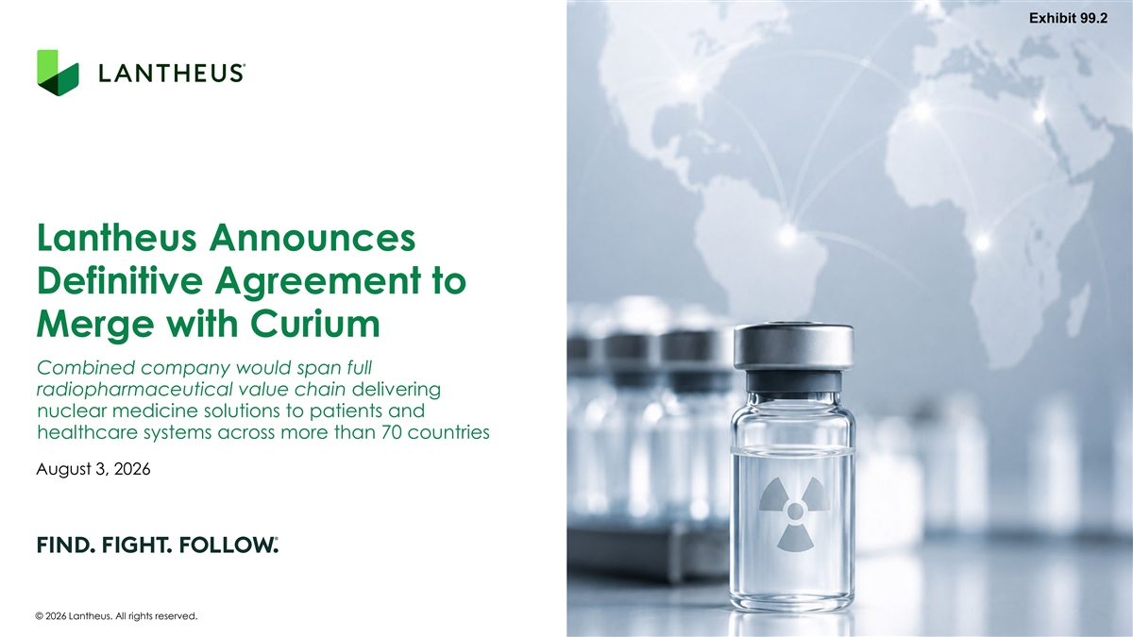
Exhibit 99.2 Lantheus Announces Definitive Agreement to Merge with Curium Combined company would span full radiopharmaceutical value chain delivering nuclear medicine solutions to patients and healthcare systems across more than 70 countries August 3, 2026 © 2026 Lantheus. All rights reserved.

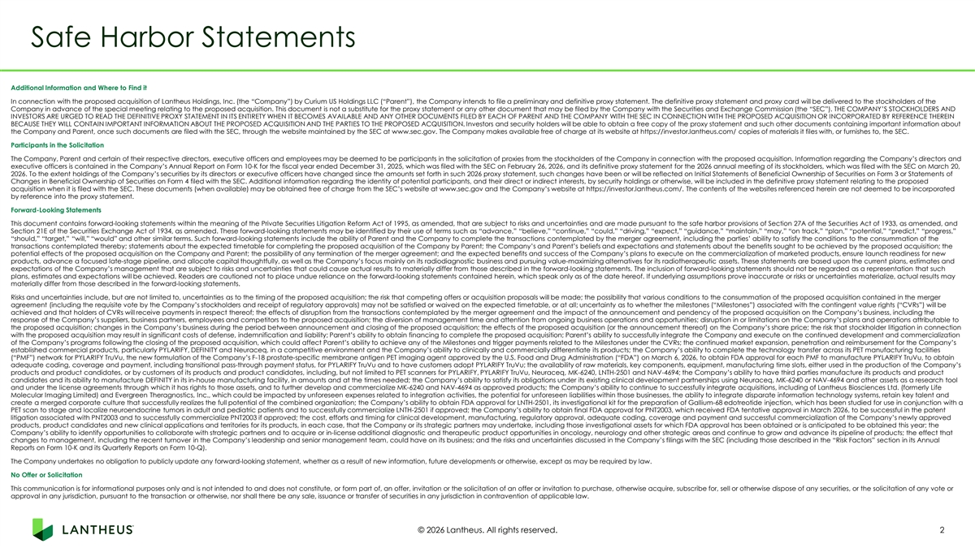
Safe Harbor Statements Additional Information and Where to Find it In connection with the proposed acquisition of Lantheus Holdings, Inc. (the “Company”) by Curium US Holdings LLC (“Parent”), the Company intends to file a preliminary and definitive proxy statement. The definitive proxy statement and proxy card will be delivered to the stockholders of the Company in advance of the special meeting relating to the proposed acquisition. This document is not a substitute for the proxy statement or any other document that may be filed by the Company with the Securities and Exchange Commission (the “SEC”). THE COMPANY’S STOCKHOLDERS AND INVESTORS ARE URGED TO READ THE DEFINITIVE PROXY STATEMENT IN ITS ENTIRETY WHEN IT BECOMES AVAILABLE AND ANY OTHER DOCUMENTS FILED BY EACH OF PARENT AND THE COMPANY WITH THE SEC IN CONNECTION WITH THE PROPOSED ACQUISITION OR INCORPORATED BY REFERENCE THEREIN BECAUSE THEY WILL CONTAIN IMPORTANT INFORMATION ABOUT THE PROPOSED ACQUISITION AND THE PARTIES TO THE PROPOSED ACQUISITION. Investors and security holders will be able to obtain a free copy of the proxy statement and such other documents containing important information about the Company and Parent, once such documents are filed with the SEC, through the website maintained by the SEC at www.sec.gov. The Company makes available free of charge at its website at https://investor.lantheus.com/ copies of materials it files with, or furnishes to, the SEC. Participants in the Solicitation The Company, Parent and certain of their respective directors, executive officers and employees may be deemed to be participants in the solicitation of proxies from the stockholders of the Company in connection with the proposed acquisition. Information regarding the Company’s directors and executive officers is contained in the Company’s Annual Report on Form 10-K for the fiscal year ended December 31, 2025, which was filed with the SEC on February 26, 2026, and its definitive proxy statement for the 2026 annual meeting of its stockholders, which was filed with the SEC on March 20, 2026. To the extent holdings of the Company’s securities by its directors or executive officers have changed since the amounts set forth in such 2026 proxy statement, such changes have been or will be reflected on Initial Statements of Beneficial Ownership of Securities on Form 3 or Statements of Changes in Beneficial Ownership of Securities on Form 4 filed with the SEC. Additional information regarding the identity of potential participants, and their direct or indirect interests, by security holdings or otherwise, will be included in the definitive proxy statement relating to the proposed acquisition when it is filed with the SEC. These documents (when available) may be obtained free of charge from the SEC’s website at www.sec.gov and the Company’s website at https://investor.lantheus.com/. The contents of the websites referenced herein are not deemed to be incorporated by reference into the proxy statement. Forward-Looking Statements This document contains forward-looking statements within the meaning of the Private Securities Litigation Reform Act of 1995, as amended, that are subject to risks and uncertainties and are made pursuant to the safe harbor provisions of Section 27A of the Securities Act of 1933, as amended, and Section 21E of the Securities Exchange Act of 1934, as amended. These forward-looking statements may be identified by their use of terms such as “advance,” “believe,” “continue,” “could,” “driving,” “expect,” “guidance,” “maintain,” “may,” “on track,” “plan,” “potential,” “predict,” “progress,” “should,” “target,” “will,” “would” and other similar terms. Such forward-looking statements include the ability of Parent and the Company to complete the transactions contemplated by the merger agreement, including the parties’ ability to satisfy the conditions to the consummation of the transactions contemplated thereby; statements about the expected timetable for completing the proposed acquisition of the Company by Parent; the Company’s and Parent’s beliefs and expectations and statements about the benefits sought to be achieved by the proposed acquisition; the potential effects of the proposed acquisition on the Company and Parent; the possibility of any termination of the merger agreement; and the expected benefits and success of the Company’s plans to execute on the commercialization of marketed products, ensure launch readiness for new products, advance a focused late-stage pipeline, and allocate capital thoughtfully, as well as the Company’s focus mainly on its radiodiagnostic business and pursuing value-maximizing alternatives for its radiotherapeutic assets. These statements are based upon the current plans, estimates and expectations of the Company’s management that are subject to risks and uncertainties that could cause actual results to materially differ from those described in the forward-looking statements. The inclusion of forward-looking statements should not be regarded as a representation that such plans, estimates and expectations will be achieved. Readers are cautioned not to place undue reliance on the forward-looking statements contained herein, which speak only as of the date hereof. If underlying assumptions prove inaccurate or risks or uncertainties materialize, actual results may materially differ from those described in the forward-looking statements. Risks and uncertainties include, but are not limited to, uncertainties as to the timing of the proposed acquisition; the risk that competing offers or acquisition proposals will be made; the possibility that various conditions to the consummation of the proposed acquisition contained in the merger agreement (including the requisite vote by the Company’s stockholders and receipt of regulatory approvals) may not be satisfied or waived on the expected timetable, or at all; uncertainty as to whether the milestones (“Milestones”) associated with the contingent value rights (“CVRs”) will be achieved and that holders of CVRs will receive payments in respect thereof; the effects of disruption from the transactions contemplated by the merger agreement and the impact of the announcement and pendency of the proposed acquisition on the Company’s business, including the response of the Company’s suppliers, business partners, employees and competitors to the proposed acquisition; the diversion of management time and attention from ongoing business operations and opportunities; disruption in or limitations on the Company’s plans and operations attributable to the proposed acquisition; changes in the Company’s business during the period between announcement and closing of the proposed acquisition; the effects of the proposed acquisition (or the announcement thereof) on the Company’s share price; the risk that stockholder litigation in connection with the proposed acquisition may result in significant costs of defense, indemnification and liability; Parent’s ability to obtain financing to complete the proposed acquisition; Parent’s ability to successfully integrate the Company and execute on the continued development and commercialization of the Company’s programs following the closing of the proposed acquisition, which could affect Parent’s ability to achieve any of the Milestones and trigger payments related to the Milestones under the CVRs; the continued market expansion, penetration and reimbursement for the Company’s established commercial products, particularly PYLARIFY, DEFINITY and Neuraceq, in a competitive environment and the Company’s ability to clinically and commercially differentiate its products; the Company’s ability to complete the technology transfer across its PET manufacturing facilities (“PMF”) network for PYLARIFY TruVu, the new formulation of the Company’s F-18 prostate-specific membrane antigen PET imaging agent approved by the U.S. Food and Drug Administration (“FDA”) on March 6, 2026, to obtain FDA approval for each PMF to manufacture PYLARIFY TruVu, to obtain adequate coding, coverage and payment, including transitional pass-through payment status, for PYLARIFY TruVu and to have customers adopt PYLARIFY TruVu; the availability of raw materials, key components, equipment, manufacturing time slots, either used in the production of the Company’s products and product candidates, or by customers of its products and product candidates, including, but not limited to PET scanners for PYLARIFY, PYLARIFY TruVu, Neuraceq, MK-6240, LNTH-2501 and NAV-4694; the Company’s ability to have third parties manufacture its products and product candidates and its ability to manufacture DEFINITY in its in-house manufacturing facility, in amounts and at the times needed; the Company’s ability to satisfy its obligations under its existing clinical development partnerships using Neuraceq, MK-6240 or NAV-4694 and other assets as a research tool and under the license agreements through which it has rights to those assets, and to further develop and commercialize MK-6240 and NAV-4694 as approved products; the Company’s ability to continue to successfully integrate acquisitions, including of Lantheus Biosciences Ltd. (formerly Life Molecular Imaging Limited) and Evergreen Theragnostics, Inc., which could be impacted by unforeseen expenses related to integration activities, the potential for unforeseen liabilities within those businesses, the ability to integrate disparate information technology systems, retain key talent and create a merged corporate culture that successfully realizes the full potential of the combined organization; the Company’s ability to obtain FDA approval for LNTH-2501, its investigational kit for the preparation of Gallium-68 edotreotide injection, which has been studied for use in conjunction with a PET scan to stage and localize neuroendocrine tumors in adult and pediatric patients and to successfully commercialize LNTH-2501 if approved; the Company’s ability to obtain final FDA approval for PNT2003, which received FDA tentative approval in March 2026, to be successful in the patent litigation associated with PNT2003 and to successfully commercialize PNT2003 if approved; the cost, efforts and timing for clinical development, manufacturing, regulatory approval, adequate coding, coverage and payment and successful commercialization of the Company’s newly approved products, product candidates and new clinical applications and territories for its products, in each case, that the Company or its strategic partners may undertake, including those investigational assets for which FDA approval has been obtained or is anticipated to be obtained this year; the Company’s ability to identify opportunities to collaborate with strategic partners and to acquire or in-license additional diagnostic and therapeutic product opportunities in oncology, neurology and other strategic areas and continue to grow and advance its pipeline of products; the effect that changes to management, including the recent turnover in the Company’s leadership and senior management team, could have on its business; and the risks and uncertainties discussed in the Company’s filings with the SEC (including those described in the “Risk Factors” section in its Annual Reports on Form 10-K and its Quarterly Reports on Form 10-Q). The Company undertakes no obligation to publicly update any forward-looking statement, whether as a result of new information, future developments or otherwise, except as may be required by law. No Offer or Solicitation This communication is for informational purposes only and is not intended to and does not constitute, or form part of, an offer, invitation or the solicitation of an offer or invitation to purchase, otherwise acquire, subscribe for, sell or otherwise dispose of any securities, or the solicitation of any vote or approval in any jurisdiction, pursuant to the transaction or otherwise, nor shall there be any sale, issuance or transfer of securities in any jurisdiction in contravention of applicable law. © 2026 Lantheus. All rights reserved. 2

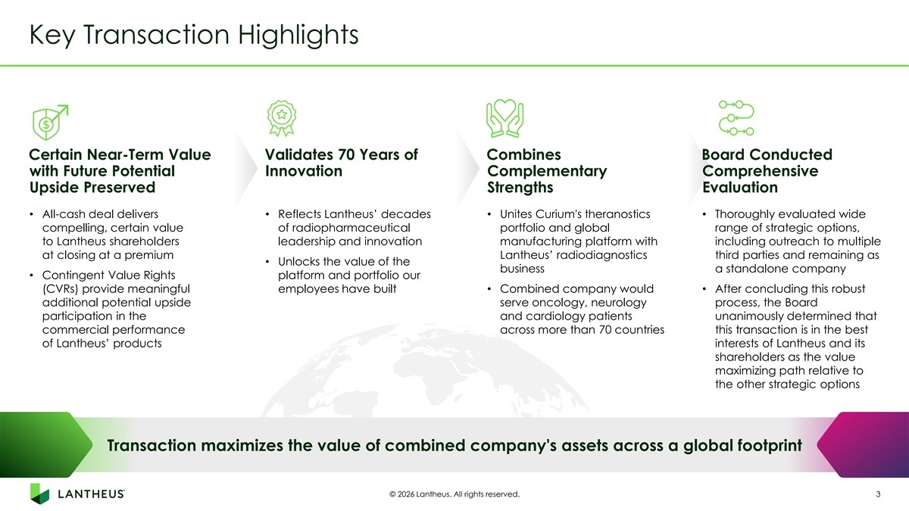
Key Transaction Highlights Certain Near-Term Value Validates 70 Years of Combines Board Conducted with Future Potential Innovation Complementary Comprehensive Upside Preserved Strengths Evaluation • All-cash deal delivers • Reflects Lantheus’ decades • Unites Curium's theranostics • Thoroughly evaluated wide compelling, certain value of radiopharmaceutical portfolio and global range of strategic options, to Lantheus shareholders leadership and innovation manufacturing platform with including outreach to multiple at closing at a premium Lantheus’ radiodiagnostics third parties and remaining as • Unlocks the value of the business a standalone company • Contingent Value Rights platform and portfolio our (CVRs) provide meaningful employees have built • Combined company would • After concluding this robust additional potential upside serve oncology, neurology process, the Board participation in the and cardiology patients unanimously determined that commercial performance across more than 70 countries this transaction is in the best of Lantheus’ products interests of Lantheus and its shareholders as the value maximizing path relative to the other strategic options Transaction maximizes the value of combined company's assets across a global footprint © 2026 Lantheus. All rights reserved. 3

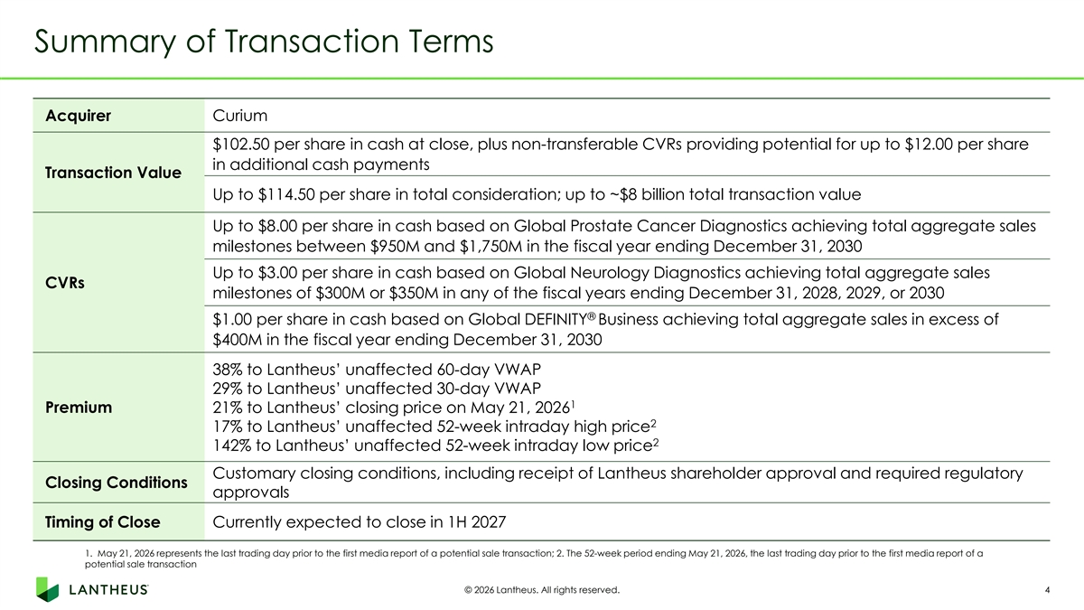
Summary of Transaction Terms Acquirer Curium $102.50 per share in cash at close, plus non-transferable CVRs providing potential for up to $12.00 per share in additional cash payments Transaction Value Up to $114.50 per share in total consideration; up to ~$8 billion total transaction value Up to $8.00 per share in cash based on Global Prostate Cancer Diagnostics achieving total aggregate sales milestones between $950M and $1,750M in the fiscal year ending December 31, 2030 Up to $3.00 per share in cash based on Global Neurology Diagnostics achieving total aggregate sales CVRs milestones of $300M or $350M in any of the fiscal years ending December 31, 2028, 2029, or 2030 ® $1.00 per share in cash based on Global DEFINITY Business achieving total aggregate sales in excess of $400M in the fiscal year ending December 31, 2030 38% to Lantheus’ unaffected 60-day VWAP 29% to Lantheus’ unaffected 30-day VWAP 1 Premium 21% to Lantheus’ closing price on May 21, 2026 2 17% to Lantheus’ unaffected 52-week intraday high price 2 142% to Lantheus’ unaffected 52-week intraday low price Customary closing conditions, including receipt of Lantheus shareholder approval and required regulatory Closing Conditions approvals Timing of Close Currently expected to close in 1H 2027 1. May 21, 2026 represents the last trading day prior to the first media report of a potential sale transaction; 2. The 52-week period ending May 21, 2026, the last trading day prior to the first media report of a potential sale transaction © 2026 Lantheus. All rights reserved. 4

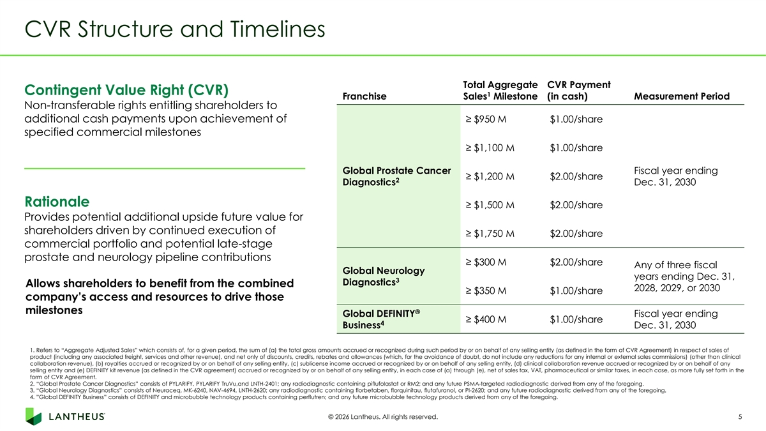
CVR Structure and Timelines Total Aggregate CVR Payment Contingent Value Right (CVR) 1 Franchise Sales Milestone (in cash) Measurement Period Non-transferable rights entitling shareholders to additional cash payments upon achievement of ≥ $950 M $1.00/share specified commercial milestones ≥ $1,100 M $1.00/share Global Prostate Cancer Fiscal year ending ≥ $1,200 M $2.00/share 2 Diagnostics Dec. 31, 2030 Rationale ≥ $1,500 M $2.00/share Provides potential additional upside future value for shareholders driven by continued execution of ≥ $1,750 M $2.00/share commercial portfolio and potential late-stage prostate and neurology pipeline contributions ≥ $300 M $2.00/share Any of three fiscal Global Neurology years ending Dec. 31, 3 Diagnostics Allows shareholders to benefit from the combined 2028, 2029, or 2030 ≥ $350 M $1.00/share company’s access and resources to drive those milestones ® Global DEFINITY Fiscal year ending ≥ $400 M $1.00/share 4 Business Dec. 31, 2030 1. Refers to “Aggregate Adjusted Sales” which consists of, for a given period, the sum of (a) the total gross amounts accrued or recognized during such period by or on behalf of any selling entity (as defined in the form of CVR Agreement) in respect of sales of product (including any associated freight, services and other revenue), and net only of discounts, credits, rebates and allowances (which, for the avoidance of doubt, do not include any reductions for any internal or external sales commissions) (other than clinical collaboration revenue), (b) royalties accrued or recognized by or on behalf of any selling entity, (c) sublicense income accrued or recognized by or on behalf of any selling entity, (d) clinical collaboration revenue accrued or recognized by or on behalf of any selling entity and (e) DEFINITY kit revenue (as defined in the CVR agreement) accrued or recognized by or on behalf of any selling entity, in each case of (a) through (e), net of sales tax, VAT, pharmaceutical or similar taxes, in each case, as more fully set forth in the form of CVR Agreement. 2. “Global Prostate Cancer Diagnostics” consists of PYLARIFY, PYLARIFY TruVu,and LNTH-2401; any radiodiagnostic containing piflufolastat or RM2; and any future PSMA-targeted radiodiagnostic derived from any of the foregoing. 3. “Global Neurology Diagnostics” consists of Neuraceq, MK-6240, NAV-4694, LNTH-2620; any radiodiagnostic containing florbetaben, florquinitau, flutafuranol, or PI-2620; and any future radiodiagnostic derived from any of the foregoing. 4. ”Global DEFINITY Business” consists of DEFINITY and microbubble technology products containing perflutren; and any future microbubble technology products derived from any of the foregoing. © 2026 Lantheus. All rights reserved. 5

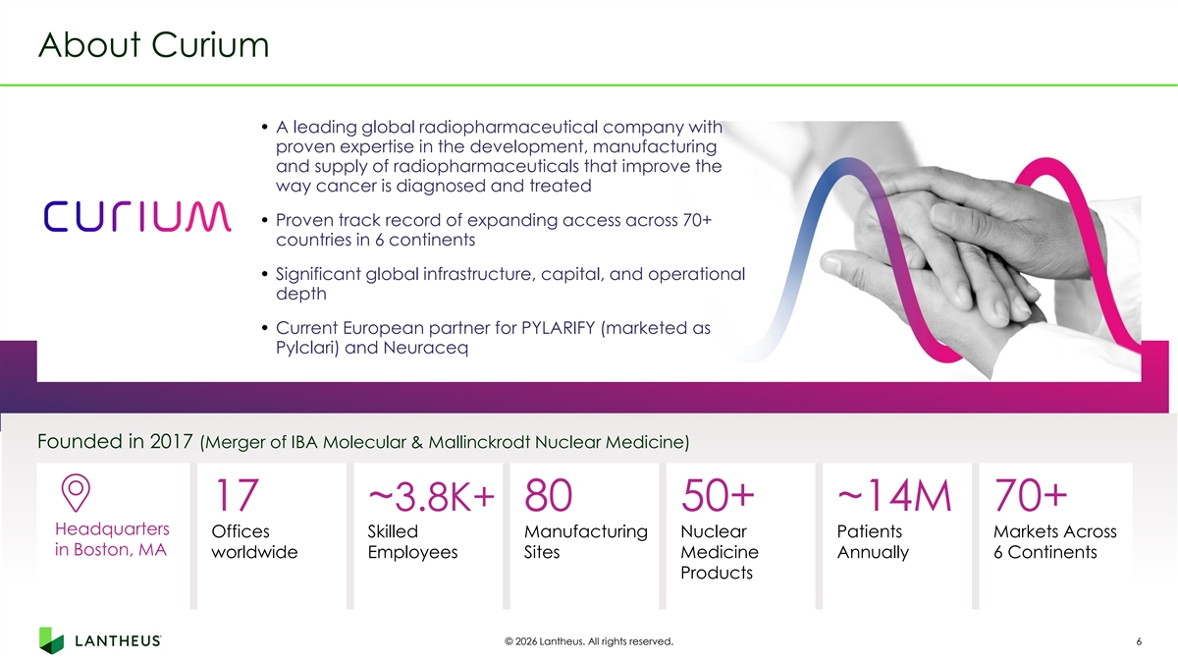
About Curium • A leading global radiopharmaceutical company with proven expertise in the development, manufacturing and supply of radiopharmaceuticals that improve the way cancer is diagnosed and treated • Proven track record of expanding access across 70+ countries in 6 continents • Significant global infrastructure, capital, and operational depth • Current European partner for PYLARIFY (marketed as Pylclari) and Neuraceq Founded in 2017 (Merger of IBA Molecular & Mallinckrodt Nuclear Medicine) 17 ~3.8K+ 80 50+ ~14M 70+ Headquarters Offices Skilled Manufacturing Nuclear Patients Markets Across in Boston, MA worldwide Employees Sites Medicine Annually 6 Continents Products © 2026 Lantheus. All rights reserved. 6

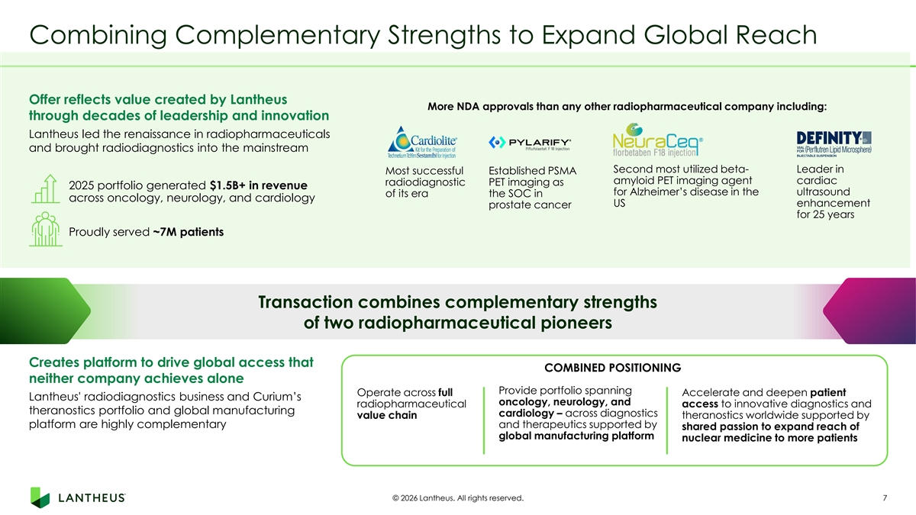
Combining Complementary Strengths to Expand Global Reach Offer reflects value created by Lantheus More NDA approvals than any other radiopharmaceutical company including: through decades of leadership and innovation Lantheus led the renaissance in radiopharmaceuticals and brought radiodiagnostics into the mainstream Second most utilized beta- Leader in Most successful Established PSMA amyloid PET imaging agent cardiac radiodiagnostic PET imaging as 2025 portfolio generated $1.5B+ in revenue for Alzheimer’s disease in the ultrasound of its era the SOC in across oncology, neurology, and cardiology US enhancement prostate cancer for 25 years Proudly served ~7M patients Transaction combines complementary strengths of two radiopharmaceutical pioneers Creates platform to drive global access that COMBINED POSITIONING neither company achieves alone Provide portfolio spanning Accelerate and deepen patient Operate across full Lantheus' radiodiagnostics business and Curium’s oncology, neurology, and radiopharmaceutical access to innovative diagnostics and theranostics portfolio and global manufacturing cardiology – across diagnostics value chain theranostics worldwide supported by platform are highly complementary and therapeutics supported by shared passion to expand reach of global manufacturing platform nuclear medicine to more patients © 2026 Lantheus. All rights reserved. 7

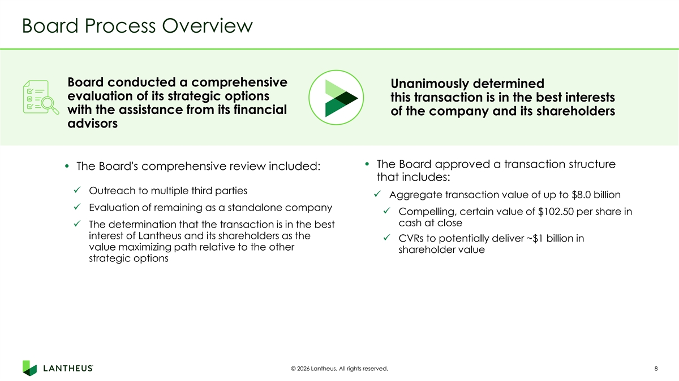
Board Process Overview Board conducted a comprehensive Unanimously determined evaluation of its strategic options this transaction is in the best interests with the assistance from its financial of the company and its shareholders advisors • The Board approved a transaction structure • The Board's comprehensive review included: that includes: ✓ Outreach to multiple third parties ✓ Aggregate transaction value of up to $8.0 billion ✓ Evaluation of remaining as a standalone company ✓ Compelling, certain value of $102.50 per share in cash at close ✓ The determination that the transaction is in the best interest of Lantheus and its shareholders as the ✓ CVRs to potentially deliver ~$1 billion in value maximizing path relative to the other shareholder value strategic options © 2026 Lantheus. All rights reserved. 8

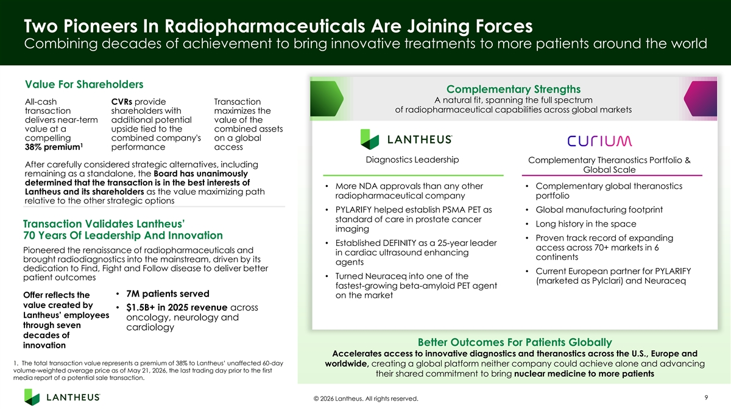
Two Pioneers In Radiopharmaceuticals Are Joining Forces Combining decades of achievement to bring innovative treatments to more patients around the world Value For Shareholders Complementary Strengths A natural fit, spanning the full spectrum All-cash CVRs provide Transaction of radiopharmaceutical capabilities across global markets transaction shareholders with maximizes the delivers near-term additional potential value of the value at a upside tied to the combined assets compelling combined company's on a global 1 38% premium performance access Diagnostics Leadership Complementary Theranostics Portfolio & After carefully considered strategic alternatives, including Global Scale remaining as a standalone, the Board has unanimously determined that the transaction is in the best interests of • More NDA approvals than any other • Complementary global theranostics Lantheus and its shareholders as the value maximizing path radiopharmaceutical company portfolio relative to the other strategic options • PYLARIFY helped establish PSMA PET as • Global manufacturing footprint standard of care in prostate cancer • Long history in the space Transaction Validates Lantheus’ imaging 70 Years Of Leadership And Innovation • Proven track record of expanding • Established DEFINITY as a 25-year leader access across 70+ markets in 6 Pioneered the renaissance of radiopharmaceuticals and in cardiac ultrasound enhancing continents brought radiodiagnostics into the mainstream, driven by its agents dedication to Find, Fight and Follow disease to deliver better • Current European partner for PYLARIFY • Turned Neuraceq into one of the patient outcomes (marketed as Pylclari) and Neuraceq fastest-growing beta-amyloid PET agent • 7M patients served Offer reflects the on the market value created by • $1.5B+ in 2025 revenue across Lantheus’ employees oncology, neurology and through seven cardiology decades of Better Outcomes For Patients Globally innovation Accelerates access to innovative diagnostics and theranostics across the U.S., Europe and 1. The total transaction value represents a premium of 38% to Lantheus’ unaffected 60-day worldwide, creating a global platform neither company could achieve alone and advancing volume-weighted average price as of May 21, 2026, the last trading day prior to the first their shared commitment to bring nuclear medicine to more patients media report of a potential sale transaction. 9 © 2026 Lantheus. All rights reserved.

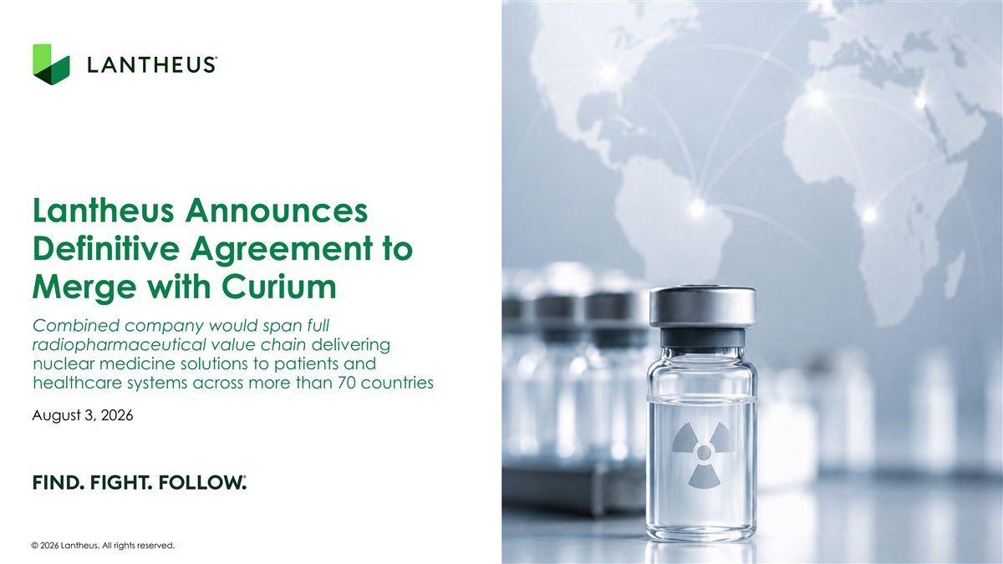
Lantheus Announces Definitive Agreement to Merge with Curium Combined company would span full radiopharmaceutical value chain delivering nuclear medicine solutions to patients and healthcare systems across more than 70 countries August 3, 2026 © 2026 Lantheus. All rights reserved.

