Table of Contents

UNITED STATES
SECURITIES AND EXCHANGE COMMISSION
Washington, D.C. 20549

SCHEDULE 14A
(Rule 14a-101)
INFORMATION REQUIRED IN PROXY STATEMENT
SCHEDULE 14A INFORMATION
Proxy Statement Pursuant to Section 14(a) of the
Securities Exchange Act of 1934

Filed by the Registrant ☒ Filed by a party other than the Registrant ☐
Check the appropriate box:

☐ | Preliminary Proxy Statement

☐ | Confidential, for Use of the Commission Only (as permitted by Rule 14a-6(e)(2))

☐ | Definitive Proxy Statement

☒ | Definitive Additional Materials

☐ | Soliciting Material Pursuant to §240.14a-12
LANTHEUS HOLDINGS, INC.
(Name of Registrant as Specified in its Charter)
Not applicable.
(Name of Person(s) Filing Proxy Statement, if other than the Registrant)
Payment of Filing Fee (Check all boxes that apply):
☒ |  | No fee required.
☐ |  | Fee paid previously with preliminary materials.
☐ |  | Fee computed on table in exhibit required by Item 25(b) per Exchange Act Rules 14a-6(i)(1) and 0-11.

Table of Contents
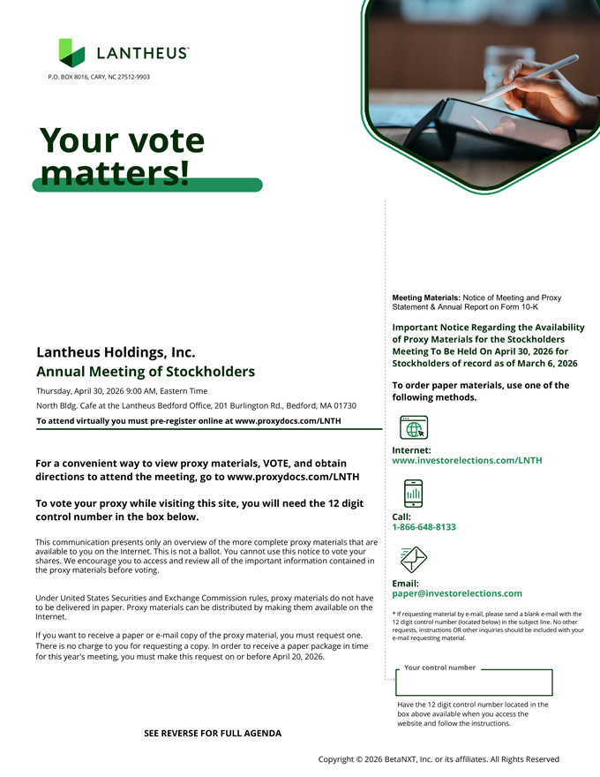
Your control number Your vote matters! Meeting Materials: Notice of Meeting and Proxy Statement & Annual Report on Form 10-K Important Notice Regarding the Availability of Proxy Materials for the Stockholders Meeting To Be Held On April 30, 2026 for Stockholders of record as of March 6, 2026 To order paper materials, use one of the following methods. Internet: www.investorelections.com/LNTH Call: 1-866-648-8133 Email: paper@investorelections.com * If requesting material by e-mail, please send a blank e-mail with the 12 digit control number (located below) in the subject line. No other requests, instructions OR other inquiries should be included with your e-mail requesting material. Have the 12 digit control number located in the box above available when you access the website and follow the instructions. Copyright © 2026 BetaNXT, Inc. or its affiliates. All Rights Reserved Lantheus Holdings, Inc. Annual Meeting of Stockholders Thursday, April 30, 2026 9:00 AM, Eastern Time North Bldg. Cafe at the Lantheus Bedford Office, 201 Burlington Rd., Bedford, MA 01730 To attend virtually you must pre-register online at www.proxydocs.com/LNTH For a convenient way to view proxy materials, VOTE, and obtain directions to attend the meeting, go to www.proxydocs.com/LNTH To vote your proxy while visiting this site, you will need the 12 digit control number in the box below. This communication presents only an overview of the more complete proxy materials that are available to you on the Internet. This is not a ballot. You cannot use this notice to vote your shares. We encourage you to access and review all of the important information contained in the proxy materials before voting. Under United States Securities and Exchange Commission rules, proxy materials do not have to be delivered in paper. Proxy materials can be distributed by making them available on the Internet. If you want to receive a paper or e-mail copy of the proxy material, you must request one. There is no charge to you for requesting a copy. In order to receive a paper package in time for this year’s meeting, you must make this request on or before April 20, 2026. styleINA P.O. BOX 8016, CARY, NC 27512-9903 58184-002 S E E R E V E R S1E 9FOMR aFUr2LL6 A 1GE8N:3DA8 Page 1

Table of Contents
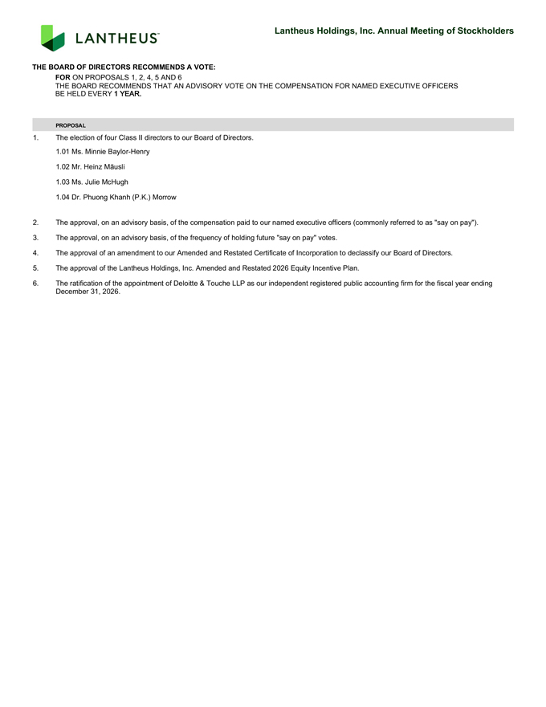
PROPOSAL 1. The election of four Class II directors to our Board of Directors. 1.01 Ms. Minnie Baylor-Henry 1.02 Mr. Heinz Mäusli 1.03 Ms. Julie McHugh 1.04 Dr. Phuong Khanh (P.K.) Morrow 2. The approval, on an advisory basis, of the compensation paid to our named executive officers (commonly referred to as “say on pay”). 3. The approval, on an advisory basis, of the frequency of holding future “say on pay” votes. 4. The approval of an amendment to our Amended and Restated Certificate of Incorporation to declassify our Board of Directors. 5. The approval of the Lantheus Holdings, Inc. Amended and Restated 2026 Equity Incentive Plan. 6. The ratification of the appointment of Deloitte & Touche LLP as our independent registered public accounting firm for the fiscal year ending December 31, 2026. THE BOARD OF DIRECTORS RECOMMENDS A VOTE: FOR ON PROPOSALS 1, 2, 4, 5 AND 6 THE BOARD RECOMMENDS THAT AN ADVISORY VOTE ON THE COMPENSATION FOR NAMED EXECUTIVE OFFICERS BE HELD EVERY 1 YEAR. Lantheus Holdings, Inc. Annual Meeting of Stockholders 58184-002 19Mar26 18:38 Page 2

