SEC Form 4

FORM 4

Check this box if no longer subject to
- Section 16. Form 4 or Form 5 obligations may continue. See Instruction 1(b).

UNITED STATES SECURITIES AND EXCHANGE COMMISSION
Washington, D.C. 20549
 |  | OMB APPROVAL
STATEMENT OF CHANGES IN BENEFICIAL OWNERSHIP
 |  | OMB Number: | 3235-0287
 |  | Estimated average burden
Filed pursuant to Section 16(a) of the Securities Exchange Act of 1934 |  | hours per response: | 0.5
or Section 30(h) of the Investment Company Act of 1940
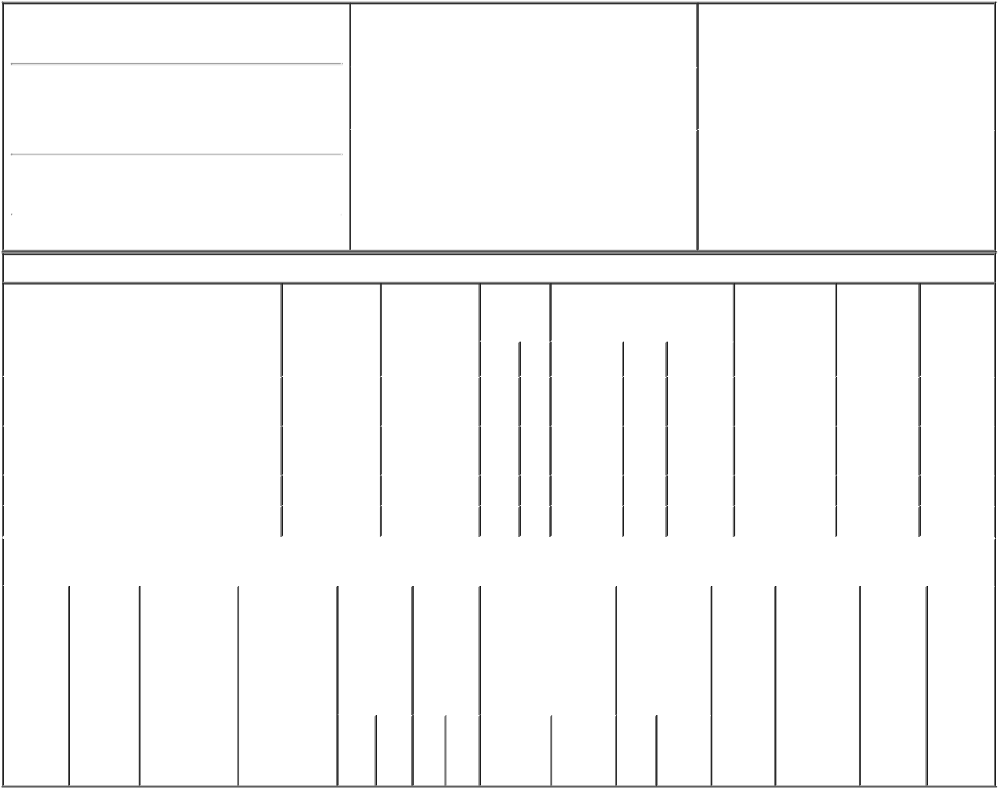

1. Name and Address of Reporting Person*
Burgstahler David F

(Last) (First) (Middle)

C/O AVISTA CAPITAL HOLDINGS, L.P.

65 E. 55TH STREET, 18TH FLOOR

(Street)
 | NEW YORK | NY | 10022
 | (City) | (State) | (Zip)

2. |  | Issuer Name and Ticker or Trading Symbol |  | 5. | Relationship of Reporting Person(s) to Issuer
 | Lantheus Holdings, Inc. [ LNTH ] |  |  | (Check all applicable)
 |  |  |  |  | X Director | 10% Owner
 |  |  |  |  | Officer (give title | Other (specify
3. |  | Date of Earliest Transaction (Month/Day/Year)
 |  |  |  |  | below) | below)
09/07/2017
4. |  | If Amendment, Date of Original Filed (Month/Day/Year) |  | 6. | Individual or Joint/Group Filing (Check Applicable
Line)
X Form filed by One Reporting Person

Form filed by More than One Reporting
Person

Table I - Non-Derivative Securities Acquired, Disposed of, or Beneficially Owned

 | 1. Title of Security (Instr. 3) |  |  | 2. Transaction |  | 2A. Deemed |  | 3. | 4. Securities Acquired (A) or |  |  |  | 5. Amount of |  |  | 6. Ownership | 7. Nature of
 |  |  |  | Date |  | Execution Date, |  | Transaction | Disposed Of (D) (Instr. 3, 4 and 5) Securities |  |  |  |  |  |  | Form: Direct | Indirect
 |  |  |  | (Month/Day/Year) |  | if any |  | Code (Instr. |  |  |  |  | Beneficially |  |  | (D) or Indirect | Beneficial
 |  |  |  |  |  | (Month/Day/Year) |  | 8) |  |  |  |  | Owned Following |  |  | (I) (Instr. 4) | Ownership
 |  |  |  |  |  |  |  |  |  |  |  |  | Reported |  |  |  | (Instr. 4)
 |  |  |  |  |  |  |  | Code V | Amount | (A) or | Price |  | Transaction(s)
 |  |  |  |  |  |  |  |  |  | (D) |  |  | (Instr. 3 and 4)
 | Common Stock |  |  | 09/07/2017 |  |  |  | S | 88,543 | D | $16.56⁽¹⁾ |  |  | 247,253 |  | I | See
 |  |  |  |  |  |  |  |  |  |  |  |  |  |  |  |  | footnote⁽²⁾
 | Common Stock |  |  | 09/07/2017 |  |  |  | S | 14,415 | D | $16.56⁽¹⁾ |  |  | 38,269 |  | I | See
 |  |  |  |  |  |  |  |  |  |  |  |  |  |  |  |  | footnote⁽³⁾
 | Common Stock |  |  |  |  |  |  |  |  |  |  |  |  | 13,248 |  | D
 | Common Stock |  |  |  |  |  |  |  |  |  |  |  |  |  | 1,562 | I | By trust⁽⁴⁾
 |  |  | Table II - Derivative Securities Acquired, Disposed of, or Beneficially Owned
 |  |  |  | (e.g., puts, calls, warrants, options, convertible securities)
 | 1. Title of | 2. | 3. Transaction | 3A. Deemed | 4. |  | 5. Number | 6. Date Exercisable and |  | 7. Title and |  | 8. Price of |  |  | 9. Number of 10. |  | 11. Nature
 | Derivative | Conversion | Date | Execution Date, | Transaction |  | of | Expiration Date |  | Amount of |  | Derivative |  |  | derivative | Ownership | of Indirect
 | Security | or Exercise | (Month/Day/Year) | if any | Code (Instr. |  | Derivative | (Month/Day/Year) |  | Securities |  | Security |  |  | Securities | Form: | Beneficial
 | (Instr. 3) | Price of |  | (Month/Day/Year) | 8) |  | Securities |  |  | Underlying |  | (Instr. 5) |  |  | Beneficially | Direct (D) | Ownership
 |  | Derivative |  |  |  |  | Acquired |  |  | Derivative |  |  |  |  | Owned | or Indirect | (Instr. 4)
 |  | Security |  |  |  |  | (A) or |  |  | Security (Instr. 3 |  |  |  |  | Following | (I) (Instr. 4)
 |  |  |  |  |  |  | Disposed |  |  | and 4) |  |  |  |  | Reported
 |  |  |  |  |  |  | of (D) |  |  |  |  |  |  |  | Transaction(s)
 |  |  |  |  |  |  | (Instr. 3, 4 |  |  |  |  |  |  |  | (Instr. 4)
 |  |  |  |  |  |  | and 5)
 |  |  |  |  |  |  |  |  |  |  | Amount
 |  |  |  |  |  |  |  |  |  |  | or
 |  |  |  |  |  |  |  |  |  |  | Number
 |  |  |  |  |  |  |  | Date | Expiration |  | of
 |  |  |  |  | Code | V | (A) (D) | Exercisable | Date | Title | Shares

Explanation of Responses:

- The price reported in Column 4 is a weighted average price. These shares were sold in multiple transactions at prices ranging from $16.50 to $16.725, inclusive. The Reporting Person undertakes to provide to Lantheus Holdings, Inc., any security holder of Lantheus Holdings, Inc., or the staff of the Securities and Exchange Commission, upon request, full information regarding the number of shares sold at each separate price within the range set forth in footnote (1) to this Form 4.

- Represents shares of the Issuer held by Avista Capital Partners, L.P. ("ACP"). Avista Capital Partners GP, LLC ("ACP GP") is the general partner of ACP. Mr. Burgstahler is a member of the investment committee of ACP GP. By virtue of these relationships, Mr. Burgstahler may be deemed to share voting and dispositive power with respect to the shares of common stock held by ACP. Mr. Burgstahler expressly disclaims beneficial ownership of any such securities, except to the extent of his pecuniary interest therein.

- Represents shares of the Issuer held by Avista Capital Partners (Offshore), L.P. ("ACP Offshore"). ACP GP is the general partner of ACP Offshore. Mr. Burgstahler is a member of the investment committee of ACP GP. By virtue of these relationships, Mr. Burgstahler may be deemed to share voting and dispositive power with respect to the shares of common stock held by ACP Offshore. Mr. Burgstahler expressly disclaims beneficial ownership of any such securities, except to the extent of his pecuniary interest therein.

- The Reporting Person disclaims beneficial ownership of such shares except to the extent of his pecuniary interest therein.

Remarks:

By: /s/ David Burgstahler |  | 09/11/2017
** Signature of Reporting Person |  | Date

Reminder: Report on a separate line for each class of securities beneficially owned directly or indirectly.

* If the form is filed by more than one reporting person, see Instruction 4 (b)(v).

- Intentional misstatements or omissions of facts constitute Federal Criminal Violations See 18 U.S.C. 1001 and 15 U.S.C. 78ff(a). Note: File three copies of this Form, one of which must be manually signed. If space is insufficient, see Instruction 6 for procedure.
Persons who respond to the collection of information contained in this form are not required to respond unless the form displays a currently valid OMB Number.

