Filed by Lantheus Holdings, Inc.

Pursuant to Rule 425 of the Securities Act of 1933

and deemed filed pursuant to Rule 14a-12

of the Securities Exchange Act of 1934

Subject Company: Progenics Pharmaceuticals, Inc.

Commission File No.: 000 – 23143

Lantheus Holdings, Inc. provided the following list of talking points to certain of its employees on January 10, 2020.

Change Management & Communications:

Commercial Talking Points

January 2020

Lantheus products and corporate logo display are registered trademarks of Lantheus Medical Imaging, Inc.

© Lantheus Medical Imaging, Inc. All rights reserved

Safe Harbor Statements

Important Information For Investors And Stockholders

This document does not constitute an offer to sell or the solicitation of an offer to buy any securities or a solicitation of any vote or approval in any jurisdiction in which such offer, solicitation or sale would be unlawful prior to appropriate registration or qualification under the securities laws of such jurisdiction. No offering of securities shall be made except by means of a prospectus meeting the requirements of Section 10 of the U.S. Securities Act of 1933, as amended.

In connection with the proposed transaction, Lantheus Holdings filed with the Securities and Exchange Commission (“SEC”) a registration statement on Form S-4 on November 12, 2019 that includes a joint proxy statement of Lantheus Holdings and Progenics that also constitutes a preliminary prospectus of Lantheus Holdings. The registration statement has not yet become effective. After the registration statement is declared effective by the SEC, a definitive joint proxy statement/prospectus will be mailed to stockholders of Lantheus Holdings and Progenics. INVESTORS AND SECURITY HOLDERS OF LANTHEUS HOLDINGS AND PROGENICS ARE STRONGLY ENCOURAGED TO READ THE JOINT PROXY STATEMENT/PROSPECTUS AND OTHER DOCUMENTS THAT ARE FILED OR WILL BE FILED WITH THE SEC CAREFULLY AND IN THEIR ENTIRETY BECAUSE THEY CONTAIN OR WILL CONTAIN IMPORTANT INFORMATION. Investors and security holders are able to obtain free copies of the registration statement and the joint proxy statement/prospectus and other documents filed with the SEC by Lantheus Holdings or Progenics through the website maintained by the SEC at https://www.sec.gov.

Copies of the documents filed with the SEC by Lantheus Holdings are or will also be available free of charge on Lantheus Holdings’ website at https://www.lantheus.com/ or by contacting Lantheus Holdings’ Investor Relations Department by email at ir@lantheus.com or by phone at (978) 671-8001. Copies of the documents filed with the SEC by Progenics are or will also be available free of charge on Progenics’ internet website at https://www.progenics.com/ or by contacting Progenics’ Investor Relations Department by email at mdowns@progenics.com or by phone at (646) 975-2533.

Certain Information Regarding Participants

Lantheus Holdings, Progenics, and their respective directors and executive officers may be considered participants in the solicitation of proxies in connection with the proposed transaction. Information about the directors and executive officers of Lantheus Holdings is set forth in its Annual Report on Form 10-K for the year ended December 31, 2018, which was filed with the SEC on February 20, 2019, its definitive proxy statement for its 2019
annual meeting of stockholders, which was filed with the SEC on March 15, 2019, and its Current Report on Form 8-K, which was filed with the SEC on March 25, 2019. Other information regarding the participants of Lantheus Holdings in the proxy solicitation and a description of their direct and indirect interests, by security holdings or otherwise, are contained in the preliminary joint proxy statement/prospectus filed with the SEC on November 12,

2019 and will be contained in the definitive joint proxy statement/prospectus and other relevant materials to be filed with the SEC regarding the proposed transaction when they become available.

Information about the directors and executive officers of Progenics is set forth in its Annual Report on Form 10-K for the year ended December 31, 2018, which was filed with the SEC on March 15, 2019 and amended on April 30, 2019, and its definitive proxy statement for its 2019 annual meeting of stockholders, which was filed with the SEC on May 30, 2019. Other information regarding the participants of Progenics in the proxy solicitations and a description of their direct and indirect interests, by security holdings or otherwise, are contained in the preliminary joint proxy statement/prospectus filed with the SEC on November 12, 2019 and will be contained in the definitive joint proxy statement/prospectus and other relevant materials to be filed with the SEC regarding the proposed transaction when they become available. You may obtain these documents (when they become available) free of charge through the website maintained by the SEC at https://www.sec.gov and from Investor Relations at Lantheus Holdings or Progenics as described above.

Cautionary Statement Regarding Forward-Looking Statements

This document contains forward-looking statements within the meaning of the Private Securities Litigation Reform Act of 1995 that are subject to risks and uncertainties and are made pursuant to the safe harbor provisions of

Section 27A of the Securities Act of 1933, as amended, and Section 21E of the Securities Exchange Act of 1934, as amended. Such statements are based upon current plans, estimates and expectations that are subject to various risks and uncertainties. The inclusion of forward-looking statements should not be regarded as a representation that such plans, estimates and expectations will be achieved. Words such as “anticipate,” “expect,”

“project,” “intend,” “believe,” “may,” “will,” “should,” “plan,” “could,” “target,” “contemplate,” “estimate,” “predict,” “potential,” “opportunity,” “creates” and words and terms of similar substance used in connection with any discussion of future plans, actions or events identify forward-looking statements. All statements, other than historical facts, including the expected timing of the closing of the merger; the ability of the parties to complete the merger considering the various closing conditions; the expected benefits of the merger, such as efficiencies, cost savings, synergies, revenue growth, creating shareholder value, growth potential, market profile, enhanced competitive position, and financial strength and flexibility; the competitive ability and position of the combined company; and any assumptions underlying any of the foregoing, are forward-looking statements. Important factors that could cause actual results to differ materially from Lantheus Holdings’ and Progenics’ plans, estimates or expectations could include, but are not limited to: (i) Lantheus Holdings or Progenics may be unable to obtain stockholder approval as required for the merger; (ii) conditions to the closing of the merger may not be satisfied; (iii) the merger may involve unexpected costs, liabilities or delays; (iv) the effect of the announcement of the merger on the ability of Lantheus Holdings or Progenics to retain and hire key personnel and maintain relationships with customers, suppliers and others with whom Lantheus Holdings or Progenics does business, or on Lantheus Holdings’ or Progenics’ operating results and business generally; (v) Lantheus Holdings’ or Progenics’ respective businesses may suffer as a result of uncertainty surrounding the merger and disruption of management’s attention due to the merger; (vi) the outcome of any legal proceedings related to the merger; (vii) Lantheus Holdings or Progenics may be adversely affected by other economic, business, and/or competitive factors; (viii) the occurrence of any event, change or other circumstances that could give rise to the termination of the merger agreement; (ix) risks that the merger disrupts current plans and operations and the potential difficulties in employee retention as a result of the merger; (x) the risk that Lantheus Holdings or Progenics may be unable to obtain governmental and regulatory approvals required for the transaction, or that required

governmental and regulatory approvals may delay the transaction or result in the imposition of conditions that could reduce the anticipated benefits from the proposed transaction or cause the parties to abandon the proposed transaction; (xi) risks that the anticipated benefits of the merger or other commercial opportunities may otherwise not be fully realized or may take longer to realize than expected; (xii) the impact of legislative, regulatory,

competitive and technological changes; (xiii) expectations for future clinical trials, the timing and potential outcomes of clinical studies and interactions with regulatory authorities; and (xiv) other risks to the consummation of the merger, including the risk that the merger will not be consummated within the expected time period or at all. Additional factors that may affect the future results of Lantheus Holdings and Progenics are set forth in their respective filings with the SEC, including each of Lantheus Holdings’ and Progenics’ most recently filed Annual Report on Form 10-K, subsequent Quarterly Reports on Form 10-Q, Current Reports on Form 8-K and other filings with the SEC, which are available on the SEC’s website at www.sec.gov. Readers are urged to consider these factors carefully in evaluating these forward-looking statements, and not to place undue reliance on any forward-looking statements. Readers should also carefully review the risk factors described in other documents that Lantheus Holdings and Progenics file from time to time with the SEC. The forward-looking statements in this document speak only as of the date of these materials. Except as required by law, Lantheus Holdings and Progenics assume no obligation to update or revise these forward-looking statements for any reason, even if new information becomes available in the future.

www.lantheus.com | 3

Frequently Asked Questions (FAQs)
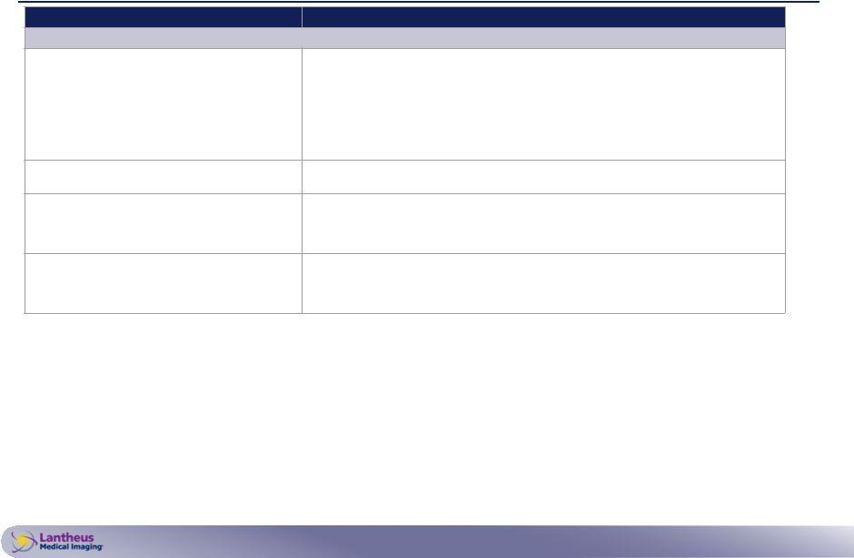

Questions

Questions Received From Employees

Why are Lantheus and Progenics combining? Why does this make sense?

When will this acquisition take place?

What changes should I expect?

Will Canada and Puerto Rico have access to AZEDRA?

Guided Answers

As we’ve indicated in our public filings:

- Our organizations today have complementary strengths and deliver a diverse set of products, but one shared value is a continued commitment to innovation and patient care.
- Lantheus’ proven commercial, manufacturing, and operational excellence positions us well to optimize the combined company’s innovative diagnostic and radiopharmaceutical portfolio.
- The transaction will diversify revenue streams, enhance cash flow generation, as well as position our combined company for sustainable and long-term, profitable growth.

As we’ve indicated in our public filings, we expect to complete the acquisition in the first quarter of 2020.

Leaders from Lantheus and Progenics are working together as part of the Integration Management Office (IMO) to determine key changes for each function – both for Day 1, in the near-term, and over the long-term. We are committed to doing our best to communicate consistently, candidly, and frequently on any integration updates.

Through the global Managed Access Program (in collaboration with Progenics and Clinigen Group), patients outside the United States can continue to access AZEDRA. Through this partnership, we will continue to deliver the right medicine to our patients globally and sustain our commitment to patient care.

www.lantheus.com | 4

Frequently Asked Questions (FAQs), cont.
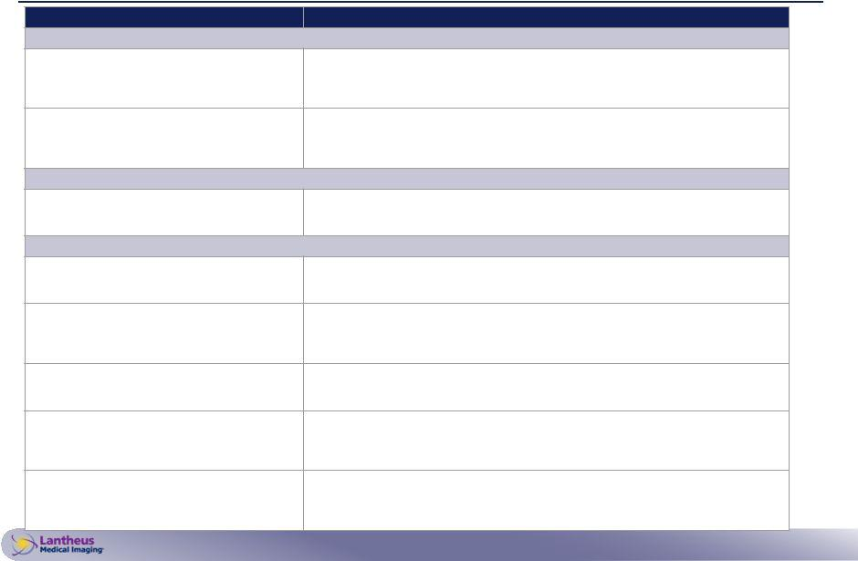

Questions Guided Answers

Questions Received From Current Business Partners (e.g., LASH, Cardinal and UPPI radiopharmacies)

Will this impact the current agreement that my company has with Progenics?

Will this impact the current agreement that my company has with Lantheus?

No. Current contracts with Progenics will remain in place for the duration of their existing contractual period. As part of normal business practice, all contracts are evaluated at the end of the designated term. Any renewals or changes to contracts would be re-negotiated by impacted parties at that time.

No. Current contracts with Lantheus will remain in place for the duration of their existing contractual period. As part of normal business practice, all contracts are evaluated at the end of the designated term. Any renewals or changes to contracts would be re-negotiated by impacted parties at that time.

Questions Received From Future Business Partners (e.g., PETNET and Sofie PMF)

Does Progenics have the ability to negotiate and sign the agreements we are currently working on to prepare for PyL commercialization?

Yes, Progenics will continue to operate as a standalone business until the close date. Current business plans to prepare for PyL commercialization remain in effect.

Questions Received From Customers (e.g., Hospitals, KOLs, Advocacy Groups, Professional Organizations (CORAR, SNMMI)

Will this change how I access and pay for AZEDRA?

Will this impact the AZEDRA purchase agreement (e.g., contract) that my institution has for AZEDRA?

Will there be any immediate changes to AZEDRA availability?

Who should we communicate with during this period of time (e.g., Lantheus or Progenics?)

Will there be any changes to our local rep?

There are no changes at this time to the process for accessing and paying for AZEDRA. You will continue to work with the AZEDRA Service Connection at 844-AZEDRA1 and your local Progenics RBD. Patient access and patient care are - and will remain - top priorities.

No. Current contracts for AZEDRA will remain in place for the duration of their existing contractual period. As part of normal business practice, all contracts are evaluated at the end of the designated term. Any renewals or changes to contracts would be re-negotiated by impacted parties at that time.

No, there will not be any changes to AZEDRA availability. AZEDRA manufacturing and distribution will continue to proceed based on existing business plans. You can continue to check AZEDRA availability by calling the AZEDRA Service Connection at 844-AZEDRA1.

You should continue working with your current point of contact at each of the respective companies. Lantheus and Progenics will continue to operate as separate businesses through the close date. Any potential changes to your points of contact will be proactively communicated to ensure all customers, patients and stakeholders know how to contact Progenics or Lantheus.

No. You should continue working with your current local representative at each of the respective companies. Lantheus and Progenics will continue to operate as separate businesses through the close date. Any potential changes to your local representative will be proactively communicated post close date.

www.lantheus.com | 5

